A Comprehensive Report on the Human Resources and Human Resource Needs in the Road Building and Heavy Construction Industry in BC

Presented to:
Joint Adjustment Committee
BC Road Builders and Heavy Construction Association
307-8678 Greenall Ave.
Burnaby, BC V5J 3M6

Roslyn Kunin & Associates, Inc. (RKA, Inc.)
3449 West 23rd Avenue
Vancouver, BC V6S 1K2
Voice: (604) 736-0783 / Fax: (604) 736-0789
Rkunin@Rkunin.com
http:/www.rkunin.com/

April 2005

Acknowledgements
Roslyn Kunin and Associates, Inc. (RKA) would like to thank the BC Road Builders and Heavy Construction Association and especially the Joint Adjustment Committee chaired by Greg Tolliday for their guidance and support of this project.
We want to especially thank all those who took the time to answer our questions via survey, focus group and interview. You took scarce time away from your demanding work to provide the current, relevant information without which this report would not have been possible. Your views are reflected in this report, but your anonymity is protected.
Thanks also to the Operating Engineers Local 115, Construction & Specialized Workers Local 1611, CLAC, the BC Government Employees’ Union and Teamsters Local 213 who were very co-operative about sharing information with us to help us better understand the occupations in the industry.

Table of Contents
Acknowledgements ii
Executive Summary 1
Chapter 1 Introduction 4
Background 4
Purpose of Study 4
Layout of Report 4
Chapter 2 Methodology and Process Used 5
Process Used – Primary Research 5
Sources of Data – Secondary Research 5
Chapter 3 Report on Industry 7
Structure of the Industry 7
Industry Classification 7
Employment 9
Unionization 11
Firm Size 11
Economic Conditions Affecting the Industry 13
Cyclical Nature of the Industry 13
Dependence on Government Funding 15
Population Growth 16
Occupations in the Industry 17
Introduction 17
Description of Occupations in the Industry 19
Management Occupations 19
Grademan and Heavy Equipment Operators 24
Asphalt Lay-Down Occupations 32
Sealcoating 36
Asphalt Recycling 37
Plant Operator and Related 38
Pipelaying 41
Truck Drivers 42
Highway and Bridge Maintenance Group 43
Crane and Similar Operators 45
Concrete Related 47
Warehouse 50
Marine 50
Marine Surveyors 52
Others 53
Labourers 59
Skill Requirements 61
Superintendents and Supervisory 62
The Working Level 66
Grademen and Heavy Equipment Operators 68
COEJATC National Standards 71
Asphalt Lay-down Occupations 75
Sealcoating 77
Asphalt Recycling 78
Plant Operators and Related 79
Pipelaying Occupations 81
Truck Drivers 83
Specific to Highway and Bridge Maintenance Group 85
Crane and similar operators 88
Warehouse 90
Marine 91
Blasting 92
Others 93
Labourers 97
Wage Information 103
Management Occupations 105
Grademen and Heavy Equipment Operators 106
Asphalt Lay-down Occupations 107
Sealcoating 108
Asphalt Recycling 109
Plant Operators and related 110
Pipelaying Occupations 111
Truck Drivers 112
Specific to Highway and Bridge Maintenance Group 113
Crane and Similar Operators 114
Concrete Related 115
Warehouse 116
Marine 117
Others 118
Labourers 120
Training Requirements 122
Training Techniques 122
Training Availability at Present 124
Sources of Skilled Workers 127
On-the-Job Training 127
The Pool of New Entrants 128
Development of Staff Within Companies 129
Training, Including Schools 130
Other Sources 130
Supply of Skills and Workers 130
Changes Affecting Skill Requirements 134
Market Changes 134
Maintenance Sector Changes 134
Computerization 134
Skills and Technological Change 135
The Impact of Expense on Training 136
Non-technological changes – Quality control processes 136
Non-technological changes – Liability 136
Computers and Youth 137
Supply Projections 137
Ideas for Addressing Skill Shortages 144
Recommendations from Interviewees 144
Urgency 145
Promotion / Informing the Public 145
Promotion / Demonstration In the Schools 146
Association Action / Responsibility 146
Association Action / Responsibility Jointly with Others 147
Some Ideas about Improving Training Practices 148
Recommendations on Training Content 149
Certification: Ideas and Stipulations 149
Improving Practices within Companies 150
Wages and Incomes 152
Immigration and Relocation 152
Original / Isolated Ideas 152
Traditional Approach; More of It 153
Chapter 4 Summary of Findings & Conclusions 154
Chapter 5 Recommendations 156
Appendix A -- A Summary of Interviewees’ Ideas about Training 160
Appendix B – Recommendations from Interviewees 163

Executive Summary
The BC Road Builders and Heavy Construction Association via their Joint Adjustment Committee has asked Roslyn Kunin & Associates, Inc. (RKA) to prepare this report examining skill shortages in this sector and generating the basic information upon which training and recruitment plans and an overall human resource strategy could be built.
To gather the relevant information, RKA conducted an initial focus group, surveyed managers in the supply and service sector of the industry and completed 90 interviews of people working at all levels in road building and maintenance. This primary research was supplemented with statistical data.
We describe the industry and its components looking at economic conditions, size of firms, growth patterns, etc.
Occupations in fourteen major groups are then examined in detail. We include, where available and relevant, job duties, existing job descriptions from DOT, sources of future job descriptions now being compiled, level and location of shortages, how job titles fit into the National Occupational Classification (NOC) and alternate titles for the jobs.
Detailed skill requirements are then outlined for each occupational category and for specific jobs. It is noteworthy that in addition to the specific skills, a very high level of generic skills are required including soft skills like time management and people skills and a much higher level of academic skills than is usually associated with the industry. Among these are mathematics, high level literacy (reading plans, etc.) and computer knowledge. Wage information is shown by occupation.
The report then looks at specific training requirements. Sources of both training and skilled workers are presented in detail. Informal and on-the-job training are described as are current sources of workers. Non-traditional workers such as immigrants and women are noted as potential sources.
Summary Table I tabulates shortages in the industry by occupation, by geographic area, and by the severity of the shortage for both the road building and the maintenance sectors of the industry.

Summary Table I Occupational Shortage by Geographic Area and Severity for Road Building and Maintenance Sectors
 | Construction Sector |  |  |  | Maintenance Sector
Occupation | LM | VI | I | N | LM | VI | I | N
Operations Manager |  |  |  |  |  |  | M | M
Superintendent | M | S |  | M |  |  | S | S
Foreman | S | S | M | M |  |  | M | S
Grademan | S | M | M
Equipment Operator | M |  | M |  |  |  | M | M
Grader Operator | S | S | S |  |  |  | S | S
Excavator Operator | S | S | S |  |  |  |  | S
Hoe, Backhoe Operator | M | M | S
Loader Operator | S
Bulldozer Operator | S
Bobcat Operator |  |  | S
Packer Operator |  | M |  |  |  |  | M
Paver Operator | S | S | S
Screedman | S | S | S | M
Asphalt Raker | S | S | M
Roller Operator | S | S | S
Asphalt Grinder Operator |  |  | S
Asphalt Plant Operator | M | M | M | M
Crusher Plant Operator |  | S
Pipeshooter | S
Pipelayer | S | S
Truck Driver | M | S |  |  |  |  | M | M
Bridgeman | M |  |  |  |  |  | M | S
Crane Operator | M
Dredge Operator | S
Cement Mason | S | M
Curb Machine Operator |  | S
Nozzleman – Potman |  | M | M
Tugboat Captain | M
Deckhand | M
Marine Surveyor | S
Surveying Technician
Ironworker | M
Driller | S | M | M
High Scaler |  |  | S
Blaster | M |  | M
Heavy Duty Mechanic | S |  | M |  |  |  | S | S
Carpenter | S | M
Welder | S
Labourer | S | S |  |  |  |  | S | S
Small Tool Operator | M
“Entry Level” | S | M | M | M |  |  | S | S

We then turn to factors affecting skill requirements such as the economy, demography, restructuring in the maintenance sector and changing technology including computerization. It was often mentioned in our research that the computer sector is now attracting the youth who would in the past have entered the construction industry.
On the supply side, we consider current and projected age distributions in the population and projected labour demand in the industry. The low levels of immigrant and visible minority workers in the industry is noted, given that these groups will be a very large component of future labour force growth.
We conclude the report by analyzing all the ideas for addressing skill shortages that arose in the course of our research. From these and the above, we compiled recommendations around such areas as the urgent need for action, promoting the industry in schools and to the public, improving training practices and content, certification, wages, and simply doing more of what we are doing now.
Detailed data on which this report is based is provided in appendices.

Chapter 1 Introduction

Background
Established in 1996, the BC Road Builders and Heavy Construction Association now represents 185 firms that pay over 70% of the wages in the industry in BC. In January 2005 the Association engaged Roslyn Kunin and Associates, Inc. (RKA) of Vancouver, British Columbia, to undertake an intensive study of the BC road building and heavy construction industry. Focusing on the member companies of the Association, it was to be a study of labour and skills requirements relevant to the road construction, road maintenance, road building and maintenance service sectors, and heavy construction. The tasks included the identification of specific skills, job descriptions, income ranges, education and training requirements and careers. The research set out in this report is the outcome, and is aimed at resulting in training and other initiatives to improve the supply of skilled labour for companies in the industry.

Purpose of Study
The objectives of this project are to research and describe the skills that make up the road building and heavy construction industry in BC with particular attention to identifying current and anticipated (5-10 years) skill shortages in the sector. The resulting report will be used as a basis to determine training, recruitment and other human resource initiatives that will comprise a human resource strategy for the industry.

Layout of Report
The general layout of this report is as follows. In Chapter 2, we outline the methodology with which we conducted analysis of human resources and skills needs for the road building and heavy construction industry, and sources of data. Chapter 3 is a comprehensive report on the industry, and Chapter 4 summarizes our findings and conclusions. Finally, in Chapter 5, we present recommendations on priorities for action to address skill shortages, training needs in the industry, and recruitment and retention.

Chapter 2 Methodology and Process Used
We have relied mainly on primary research to gather information pertaining to occupations in the industry, descriptions of work activities and responsibilities, skills requirements, identification of skill shortages, identification of training needs, and identification of issues affecting the supply of skilled labour in the industry. We have used a combination of interviews, surveys, and focus group, with the support of the Association and members of the Joint Adjustment Committee. Employers and employees were engaged at a variety of levels in providing information and perspectives to the research.
We have also relied upon secondary research for data in support of primary research. We have conducted extensive searches on the Internet for occupation definitions and descriptions. We have utilized information on wage rates for occupations available from collective agreements, and on occupations from standard occupational description and classification systems, as well as data from statistical agencies such as Statistics Canada and BC Stats.

Process Used – Primary Research
As set out in our research proposal, we have conducted focus group/in-depth interviews involving four levels of respondents – Adjustment Committee members and senior managers of the construction and maintenance sectors of the industry, superintendents, foremen, and individual workers.
In all, we have conducted one focus group session at the beginning of the project, an on-site presence at the “Road Works Ahead” transportation conference (February 2005) in Richmond, BC, and 90 in-depth phone/personal interviews, each one representing a number of initial and follow-up calls. We have had five meetings with union officials. We have made two attempts to get the participation of each Construction and Maintenance Sector member of the Association by contacting senior managers. We have also sent out survey questionnaires to all senior managers in the service and supply sector members of the Road Builders and Heavy Construction Association.

Sources of Data – Secondary Research
Four main sources of data have been utilized. We have relied upon Labour Force Survey (LFS) data to describe existing employment growth in the construction industry. Also, we have utilized data from the Canadian Occupational Projection System (COPS) to describe projected labour demand for certain occupational groups. We have used standard sources of occupational analysis, description and classification to supplement information gained in our interviews. Finally, population forecasts for overall population and selected age groups have been used throughout the report.
Labour Force Survey is a household survey carried out monthly by Statistics Canada. It is from the survey that the official labour market information such as unemployment rate is calculated. The Labour Force Survey divides the working-age population (aged 15 years and over) into three categories: employed, unemployed, and not in the labour force.
The Canadian Occupational Projection System (COPS) is developed to forecast the state of the economy by the Human Resources Development Canada (HRDC) in close consultation with partners in provincial governments. In BC, the Ministry of Advanced Education is the provincial partner. COPS provides long-term projections of employment demand by industry for BC based on Labour Force Survey historical data from Statistics Canada combined in a complex national and provincial forecasting model.
The COPS model includes a variable occupational coefficient matrix which reflects changes over time in the mix of occupations within an industry group. These vary due to technological and organizational shifts for a known historical period with a projection for the future. Occupational projections are developed by multiplying industry employment forecasts by this variable coefficient matrix.
The particular forecast scenario used to derive industry and occupational employment demand for the purposes of this report is the “2003 Unique Reference Scenario” of the COPS demand Model. In this forecast, overall employment demand for BC is projected to grow on average at 1.4 per cent per year between 2001 and 2011.
BC-level population projections are provided by BC Stats, usually updated in January/February each year. The most recent forecast, forecast 04/12, provides forecasts of the size as well as age and sex structure of the population of British Columbia from 2005 to the year 2031.

Chapter 3 Report on Industry

Structure of the Industry
In this section, we will describe the road building and heavy construction industry in terms of how it is classified in standard industry classification, as well as its characteristics.

Industry Classification
Three main areas of business activities:
Construction – consisting of firms engaged in grading, paving, highway rehabilitation, bridge building, utilities construction, pile driving, rock blasting, aggregate production, asphalt and concrete manufacturing, excavation, mine site preparation, forestry road construction, dams and other heavy construction projects.
Maintenance – consisting of firms engaged in providing road and bridge maintenance services on a contractual basis for the Ministry of Transportation and Highways.
Service and Supply – consisting of firms engaged in supplying goods and services to the road building and heavy construction activities. They include accountants, auctioneers, chemical and explosive suppliers, consulting engineers, equipment dealers, insurance and financial services companies, law firms, safety consultants, training schools, and others.
Based on membership information available from the BC Road Builders and Heavy Construction Association, between construction and maintenance sectors, 75% belong to the former and 26% belong to the latter.
The above description of the industry is more consistent with what the BC Road Builders and Heavy Construction Association represents. However, it differs from standard industry classification of the construction sector, which allows for relatively consistent comparison of statistical information available from agencies such as Statistics Canada.
The following is a concordance table showing how components of the standard industry classification (1997 North American Industry Classification System, or NAICS) compare with the definition of the industry we adopt in this report.
Table 1 Concordance Table between NAICS and Industry Components in this Report
1997 NAICS | Industry Classification in this Report
23 Construction
231 Prime Contracting  2311 Land Subdivision and Land Development  23111 Land Subdivision and Land Development  2312 Building Construction  23121 Residential Building Construction  23122 Non-Residential Building Construction  2313 Engineering Construction  23131 Highway, Street and Bridge Construction  23132 Water and Sewer Construction  23133 Oil and Gas Pipelines and Related Industrial Complexes Construction  23139 Other Engineering Construction  2314 Construction Management  23141 Construction Management | No  No  No  Yes  Yes  No  Yes  Some
232 Trade Contracting  2321 Site Preparation Work  23211 Site Preparation Work  2322 Building Structure Work  23221 Forming Work  23222 Concrete Pouring and Finishing Work  23223 Structural Steel and Precast Concrete Erection Work  23224 Crane Rental Services  23225 Framing and Rough Carpentry Work  23229 Other Building Structure Work  2323 Building Exterior Finishing Work  23231 Masonry Work  23232 Glass and Glazing Work  23233 Roofing and Related Work  23234 Metallic and Other Siding Work  23239 Other Building Exterior Finishing Work  2324 Building Interior Finishing Work  23241 Drywall and Plaster Work  23242 Terrazzo and Tile Work  23243 Carpet and Resilient Flooring Work  23244 Insulation Work  23245 Building Painting and Paperhanging Work  23246 Finish Carpentry and Wood Flooring Work  23249 Other Building Interior Finishing Work  2325 Building Equipment Installation  23251 Electrical Work  23252 Plumbing, Heating and Air-Conditioning Installation  23253 Automatic Sprinkler System Installation  23254 Commercial Refrigeration Installation  23255 Elevator and Escalator Installation  23259 Other Building Equipment Installation  2329 Other Special Trade Contracting  23291 Fencing and Interlocking Stone Contracting  23292 Residential and Commercial Paving Contracting  23299 All Other Special Trade Contracting | Yes  Some  Some  No  No  No  No  No  No  No  No  No  No  No  No  No  No  No  No  No  No  No  No  No  No  No  No  No
48-49 Transportation and Warehousing
488 Support Activities for Transportation  4884 Support Activities for Road Transportation  48841 Motor Vehicle Towing  48849 Other Support Activities for Road Transportation | No  Some
Source: Statistics Canada, RKA
Based on this Table, the road building and heavy construction industry as represented by the Association would consist of most of “2313 Engineering Construction”, some in “2314 Construction Management”, and all of “2321 Site Preparation Work”. In addition to these components in the Construction industry as defined by NAICS, the industry classification in our current report also includes some in “4884 Support Activities for Road Transportation” which represents those companies engaged in snow clearing and removal activities.
In the section to follow, we present statistical information available from the Census on the applicable codes above, to provide a picture of the size of the BC road building and heavy construction industry.

Employment
In Table 2, we will show data available from the 2001 Census indicating the number of persons in the construction labour force, employed, unemployed, and not in the labour force, by sub-sector. That allows us to derive the percentage of employed in each sub-sector in overall construction employment as well as unemployment rate in each of the sub-sectors.
Table 2 Labour Force Characteristics of Workers in Construction, and Support Activities for Road Transportation

1997 NAICS | In the Labour Force | Employed | Employed as % of Overall Construction | Unemployed | Unemployment Rate | Not in the Labour Force
All Industries | 2,014,600 | 1,883,975 |  | 130,625 | 6.5% | 195,195
23 Construction | 118,700 | 106,225 |  | 12,470 | 10.5% | 106,30
231 Prime Contracting | 50,125 | 44,140 | 41.6% | 5,980 | 11.9% | 4,710
2311 Land Subdivision and Land Development | 2,445 | 2,285 | 2.2% | 165 | 6.7% | 175
2312 Building Construction | 31,775 | 28,340 | 26.7% | 3,430 | 10.8% | 3,075
2313 Engineering Construction | 14,510 | 12,240 | 11.5% | 2,275 | 15.7% | 1,270
2314 Construction Management | 1,390 | 1,280 | 1.2% | 110 | 7.9% | 190
232 Trade Contracting | 68,575 | 62,085 | 58.4% | 6,490 | 9.5% | 5,920
2321 Site Preparation Work | 6,740 | 5,995 | 5.6% | 750 | 11.1% | 625
2322 Building Structure Work | 8,760 | 7,860 | 7.4% | 900 | 10.3% | 640
2323 Building Exterior Finishing Work | 9,430 | 8,300 | 7.8% | 1,130 | 12.0% | 995
2324 Building Interior Finishing Work | 18,860 | 17,125 | 16.1% | 1,740 | 9.2% | 1,695
2325 Building Equipment Installation | 22,255 | 20,515 | 19.3% | 1,735 | 7.8% | 1,735
2329 Other Special Trade Contracting | 2,530 | 2,285 | 2.2% | 245 | 9.7% | 235
488 Support Activities for Transportation | 18,155 | 17,005 |  | 1150 | 6.3% | 1,355
4884 Support Activities for Road Transportation | 3,825 | 3,430 |  | 395 | 10.3% | 370
Source: Census 2001, Statistics Canada
Based upon the Table, we estimate that total employment in the road building and heavy construction industry as defined in this report amounted to 18.3 per cent of overall construction employment in British Columbia, or approximately 19,440 persons in the province in 2001.
Overall, construction employment accounted for 5.6 per cent of total employed people in BC in 2001. The size of the construction labour force, consisting of both employed and unemployed, accounted for a slightly larger share, or 5.9 per cent, of the total labour force in the province. Construction is an important labour contributor to the provincial economy, as shown in the comparison we made here, which is equivalent to saying that approximately one in every 17 persons in the labour force is in construction.
However, the construction industry is also more cyclical, with fluctuating business activities on a yearly basis, than the general economy. This is indicated by the much higher than general unemployment rate within the construction industry in 2001. The road building and heavy construction industry had an even leaner year in 2001 as unemployment rates in these sub-sectors were even higher than for construction as a whole.

Unionization
The majority of companies we interviewed indicated that they have a unionized crew. Of a total of 38 companies that participated in our interviews, only six companies indicated that they did not have a unionized crew. Still, they emphasized that wage rates they offer are competitive with those with a unionized crew. It was beyond the scope of this study to investigate the values of benefits packages, pension-matching, etc., which are not reflected in the hourly rates.

Firm Size
Small (under 20 employees) and medium sized companies (with 20-49 employees) account for over half of business establishments across all industries in British Columbia. It is a similar case with construction industry as a whole. However, there is a growing trend in the economy towards establishments without employees (typically known to the industry as owner-operator sub-contractors, or sub-trades). In the construction industry where skilled tradespersons dominate, there are even higher percentages of establishments without employees. At the other end of the scale, however, only a small percentage of businesses have 50 and more employees.
These comparisons are shown in the two charts that follow.
Figure 1
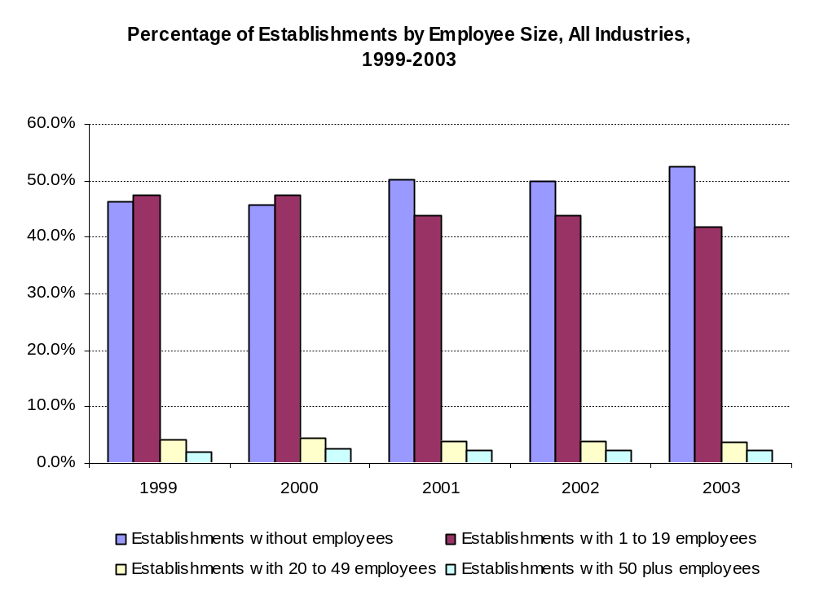
Source: Business Register, Statistics Canada
Figure 2 (next page)
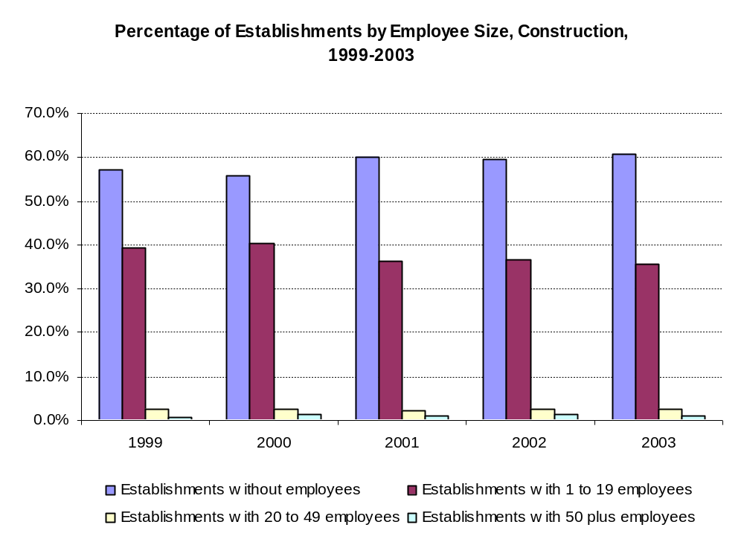
Source: Business Register, Statistics Canada

Economic Conditions Affecting the Industry
In this section, we will describe economic factors affecting the overall level of construction activities and employment growth in the industry.

Cyclical Nature of the Industry
Even more than the general economy, construction activities are very sensitive to the ups and downs of the economy. With residential housing, demand is usually determined by changes in interest rates, population growth, employment growth, and changes in consumer life style and preferences. Commercial building construction activities are usually determined by interest rates, level of business activities in the local area, and perceived proximity to attractive capital and investment. Road building and heavy construction activities are usually associated with “mega projects” such as the expansion of the Sky Train in 2000/2001, the Sea-to-Sky Highway upgrade project and the expansion of the Vancouver Convention and Exhibition Centre currently underway, and the proposed Richmond-Airport-Vancouver Rapid Transit Project. Once these (and concurrent public works projects) are completed, the employment demand for workers in this sector will drop dramatically unless other major projects are started in the interim. On the other hand, those working in public works maintenance are less affected by economic changes as they are always needed to maintain roads, streets, highways and bridges, as well as to carry out upkeep activities in cities and towns.
The graph that follows shows employment growth in the construction industry, including prime contracting and trade contracting (see NAICS definitions in earlier section), and how it compares with overall employment growth in all industries in the province.
Figure 3
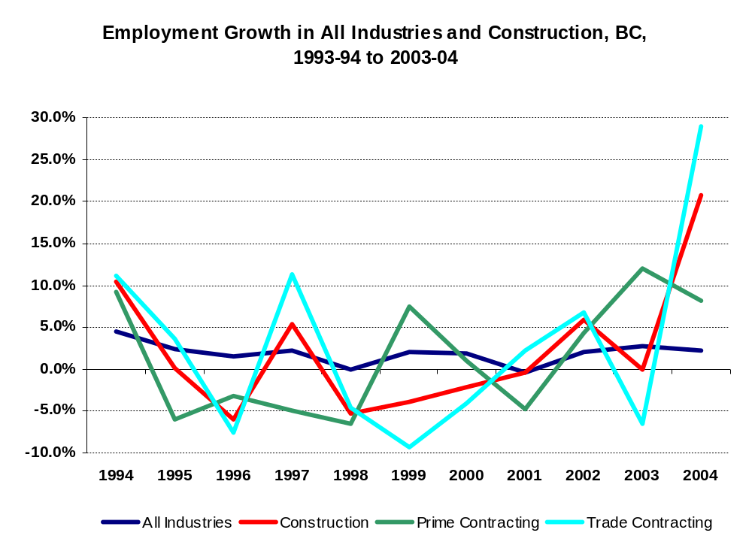
Source: Labour Force Survey (unpublished data), Statistics Canada

In British Columbia, the construction industry grew rapidly from 1986 to 1995. Between 1996 and 1999, construction activities declined due to weaker population growth, slower economic growth and weaker labour markets. Based on our interviews, many respondents suggested that road building and heavy construction activities have remained relatively stable during the past few years, although many, especially those companies based in the Lower Mainland, believe that the level of activities will increase from now to at least year 2010, to accommodate the demands brought by the 2010 Vancouver/Whistler Winter Olympic Games.

Dependence on Government Funding
As mentioned in the previous section, those working in public works maintenance are less affected by economic changes as they are always needed to maintain roads, streets, highways and bridges, as well as to carry out upkeep activities in cities and towns. As such, they rely on public funding for work. Similarly, with other major infrastructure projects such as the Sea-to-Sky Highway upgrade project and the Richmond-Airport-Vancouver Rapid Transit Project, the source of investment is also from public general revenue.
As governments at all levels struggled to reduce debt and hold the line on taxes, investment in infrastructure was reduced. Again, this weighed heavily on the industry in the late nineties, but the situation has shown signs of improvement since 2002 and in the years ahead. In February 2003 the provincial government announced a $1.3 billion multi-year plan to build an integrated and competitive transportation system throughout BC. An effective highway system is reliable and allows goods and services to move through the province efficiently. Rehabilitation, such as repaving, extends the life of our existing provincial highways and bridges and keeps maintenance costs to reasonable levels. Some of these major projects, in addition to the Sea-to-Sky Highway upgrade and Richmond-Airport-Vancouver Rapid Transit Project, are Kicking Horse Pass highway upgrade, Kelowna Bridge, Port Mann Bridge twinning, Fraser Crossing upgrade.
While the road building and heavy construction activities show signs of optimism for further employment growth in the near future, at least one sector of the industry, namely, the road maintenance companies, feel reliance on government funding is having an adverse impact on their businesses. (More on this in section “Changes Affecting Skills Requirement”.) According to our interviews with respondents in this sector, the sector has experienced cuts of around 10 per cent in working-level wages. This is in addition to some reduction of its workforce which is included with the current round of contract negotiation. This adverse impact can pose serious challenges to the sector’s ability to maintain a qualified workforce and to attract skilled workers in the future.

Population Growth
In the long run, population growth is the ultimate determining factor in the demand for transportation network and heavy construction projects. A healthy population growth brings about demand for goods and services, including roads and other infrastructure such as schools, hospitals, colleges and universities. Not only the size, but also the structure of the population, will determine the types of services required.
In British Columbia, population growth was strong in the late eighties and early nineties due to strong growth in immigration. During the second half of the last decade, however, population growth was moderate due to slow employment growth, as inter-provincial out-migration outpaced in-migration. This situation has improved over the past few years as the provincial economy gradually turned around. Population growth is expected to continue, although quite moderately, in the province till 2031. This is shown in the graph that follows.
Figure 4

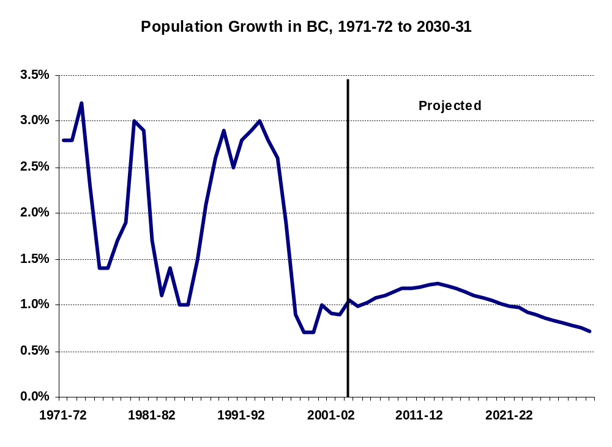
Source: estimates by Statistics Canada, projections by BC Stats Forecast 04/12

Occupations in the Industry

Introduction
In researching the industry for this study, RKA identified around 60 occupations in the road building and heavy construction industry, which are listed in the following groupings:
Management Occupations
Operations Manager
Estimator
Superintendent
Foreman
Shop Foreman (Mechanics)
Foreman (Carpenters)
Grademen and Heavy Equipment Operators
Grademan
Instrument Person
Equipment Operator or "Machine Operators"
Grader Operator
Excavator Operator
Scraper Operator
Hoe or Backhoe Operator
Loader Operator
Dozer or "Cat" Operator
Bobcat Operator
Packer Operator or Compactor Operator
Asphalt Lay-down Occupations
Paver Operator
Screed Operator
Raker
Roller Operator (Breakdown Rollers, Rubber-Tired Rollers, Finish Rollers)
Sealcoating
Sealcoating Personnel: Spreader Operator, Spotter
Distributor Operator
Broom Operator
Asphalt Recycling
Pre-Heater Operator
Asphalt Grinder Operator
Reclaimer or Reclaim Operator
Grinder, Mixperson
Plant Operators and Related
Asphalt Plant Operator (Apprenticeable)
Crusher Operator (Crusher Plant or Asphalt Plant)
Wash Plant Operator
Groundman or Plant Helper
Pipelaying Occupations
Pipeshooter
Pipelayer
Top Man
Shoring Labourer
Truck Drivers
Truck Driver
Truck Driver Up To 5 Tons
Truck Driver Multi Axle
Lowbed Driver
Truck and Trailer Driver
Articulated Dump Truck Driver
Specific to Highway and Bridge Maintenance Group
Piledrivers and Bridgeworkers (Bridgeman) (Apprenticeable)
Shouldering Trailer Operator
Sign Maintenance Person
Highway Maintenance, Various Equipment; Snowplough Operator, Sweeper Operator, Etc.
Crane and Similar Operators
Crane Op. (Apprenticeable)
Dredging Operator
Concrete Related
Cement Masons or Finishers (Apprenticeable)
Curb Machine Operator or Gomaco Operator
Concrete Pump Operator
Nozzleman-Potman
Warehouse
Warehouseperson (Apprenticeable)
Marine
Tugboat Captains, Skipper
Deckhand
Marine Surveyor
Deck Engineer
Surveying Technician

Others
Ironworker (Steel Rebar Placer) (Apprenticeable)
Driller
Blaster, Powderperson etc.
High Scaler
Heavy Duty Mechanic (Apprenticeable)
Serviceman
Carpenter (Apprenticeable)
Plumber (Apprenticeable)
Electrician (Apprenticeable)
Welder
Labourers
Labourer
Skilled labourer, and see signman, concrete, plant helper, others: dumpman, stake jockey, etc summer student
Small Tool Operator – other names; depends on tools
Flagger (Traffic Control Person)
Scale Operator (quasi-clerical)
“Entry level” – a term for different kinds of labourers and entry level trades people

Description of Occupations in the Industry
In this section, we will provide descriptions of tasks and responsibilities of the occupational titles we have come across during our interviews.

Management Occupations
A number of management occupations were identified in our interviews. The titles and descriptions that we heard about were similar in all regions, in both the Construction and Maintenance Sectors:
Operations Manager
Estimator
Superintendent
Foreman
Shop Foreman (Mechanics)
Foreman (Carpenters)

Operations Manager
The description of the occupation generally matches that in the National Occupational Classification (NOC):
Construction Managers (construction operations managers)
-- plan, organize, direct, control and evaluate the activities of construction companies, or construction departments within companies, under the direction of general managers and other senior managers.
A more precise definition of the job for the Industry needs to recognize
- the overlap with and
- distinctions from
the job described as “superintendent”.
The distinction was made that an “operations manager” has a broader scope, and may, for example, be more involved in estimating and watching for upcoming projects, getting them up and running.
The “superintendent” is more project-based, and when the project starts, the operations manager lets the superintendent take over. An operations manager is described as having a larger role overall for managing cash than a superintendent.
Other titles:
“Operations Coordinator”.
Some overlaps with “superintendent” are recognized in the industry.
“Division Manager” sometimes
“Project Manager” related to operations manager, may have a number of superintendents reporting to him.
Identified to us as a shortage, and future shortage, in the maintenance sector, especially in the Interior and North
Has its own 4-digit code in the NOC, 0711 Construction Managers, where one of the many example titles is “construction operations manager”

Estimator/Junior Estimator
This occupation was identified a few times but not extensively described. Works closely with construction managers and superintendents, sometimes collaboratively with them in preparing estimates.
The description of the occupation generally matches the description given in the National Occupational Classification (NOC):
Construction Estimators
-- analyze costs of and prepare estimates on civil engineering, architectural, structural, electrical and mechanical construction projects.

Other titles:
“Manager/Estimator”
Not identified to us as being in shortage.
Has its own 4-digit code in the NOC, 2234 Construction Estimators

Superintendent
We got extensive descriptions of superintendents in our interviews.
Superintendents
--plan, organize, direct, control and evaluate activities on projects during project lifetime. Responsibilities include project management, accountability for projects, implementation and operation of projects, all day to day decisions from the project’s instigation, scheduling and progress estimates, direction of safety program, obtaining and allocating resources (equipment, materials, human resources)–though not as purchaser–cost control, reviewing and investigating the progress of a project and any problems that occur, input to upper management, input to other crews including mechanical maintenance staff, liaising with customers, coordinating and directing subcontractors, any extra billing or invoicing, documentation of payroll. Major concerns are: safety, efficiency, delivery to project specifications, quality control, employee development. Identified as the person in charge of projects, delegating responsibility and authority for planning and overseeing work to foremen. May participate in estimating; participate in project planning and oversee all scheduling matters. With senior managers, may plan and coordinate staffing for projects. Responsible for compliance with government regulations, environmental issues, dealing with inspectors, ensuring approvals, dealing with outside agencies, licensing and permits, etc. In some companies looks after job specifications.

Other titles:
“Road superintendent” –similar, and may patrol roads regularly to identify work needed and to inspect work, in the maintenance sector
“Senior road foreman”, similar to “road superintendent”
“Bridge manager”, “bridge superintendent” --much the same as road superintendent, but with a focus on bridge maintenance and repair
“Road supervisor” – similar to road superintendent
“Project superintendent”
“Area superintendent” (with multiple foremen)
“Site superintendent”

Identified to us as a present and future shortage in the North, in both construction and maintenance sectors, in the Lower Mainland in the construction sector, and as a high priority shortage in the Interior in the maintenance sector, and on Vancouver Island in the construction sector.
The NOC includes construction superintendents in the 4-digit coding 0711 Construction Managers (above).
A more precise definition of the job for the Industry needs to take into account the overlap with, and distinctions from, the jobs described as “manager” (of various kinds).
In speaking to RKA, people in the industry drew the distinction that “operations managers” have a broader scope, and may, for example, be more involved in estimating and watching for upcoming projects, getting them up and running. The “superintendent” is more project-based, and when the project starts, the operations manager lets the superintendent take over.

Foreman
We got extensive descriptions of foremen in our interviews.
Foremen
-- direct and co-ordinate the activities of workers in the industry on a day-to-day basis. Responsibilities include: ensuring safety; receiving the directions of superintendents; organizing and planning on a short term basis to ensure the work is carried out to specification; training employees; ensuring materials and equipment are available and organized; daily scheduling and dispatching of workers; administering and ensuring time reporting including overtime; ensuring proper use and servicing of equipment; preparing foreman’s reports, situation reports and other administrative duties up to the level of verbal discipline of staff. Foremen are identified as the person in charge on the worksite, second in charge to the superintendent, and remain on the worksite when superintendents are absent. Though carrying out superintendents’ instructions, foremen are more directly involved in the work; and commonly are working foremen, who work alongside the crew. Foremen may take the place of workers absent from the crew, and equally take the place of superintendents absent from the worksite. Foremen perform quality control over portions of the work. They handle problems on the worksite, communicate issues to the superintendent, discuss plans for proceeding with the superintendent, identify human resource management problems for the superintendent to resolve, organize the worksite to use resources efficiently and carry out the superintendent’s intentions over the short term, prepare some paper work for clients; and communicate with stakeholders, including taking care of community relations.
Because of the job-specific nature of their responsibilities, and because they are often working foremen, they are usually linked to particular kinds of crews by specialty knowledge of the crew’s work. Titles often reflect this, e.g. paving foreman, road foreman, grade foreman, pipe foreman, plant foreman, etc.
Because they can be truly interchangeable, not just with workers, but with superintendents, their duties and responsibilities sometimes overlap or blur with others, and titles will sometimes reflect that. Occasionally “superintendent” and “foreman” may be interchangeable terms in a given company. Or a “foreman” title may imply that the person performs worker duties as well, e.g. a “grade foreman” may be responsible for the proper grade and for “grademan” duties.
See specific occupations where foreman’s duties are often involved; e.g. “grademan”
Foremen as well as superintendents oversee the work of subcontractors who may do work that is identical to work performed by the company’s own employees. They often describe this supervisory work as similar to supervising their own employees.

Other titles:
“pipe foreman”
“paving foreman”
“grade foreman”
“grademan (road supervisor)”
“bridge foreman, bridge superintendent”
“paving superintendent”
“road foreman”
“working road foreman”
“paving plant foreman”
“screedman-foreman”
“grading foreman”
“crusher foreman”
“asphalt foreman”
“asphalt plant foreman” (also asphalt plant operator)
“crusher plant foreman” (also crusher plant operator)
“lead hands”
“trade supervisors”
“trade senior supervisors”

Identified to us as a shortage in the Interior and in the North, in both construction and maintenance sectors, and as a priority shortage in the Lower Mainland and on Vancouver Island in the construction sector.
Has its own 4-digit code in the NOC, 7217 Contractors and Supervisors, Heavy Construction Equipment Crews
Supervisors in this group direct and co-ordinate the activities of workers classified in the following groups: Crane Operators (7371), Drillers and Blasters – Surface Mining, Quarrying and Construction (7372), Heavy Equipment Operators (Except Crane) (7421), Longshore Workers (7451), Material Handlers (7452), Public Works Maintenance Equipment Operators (7422), Railway Track Maintenance Workers (7432) and Water Well Drillers (7373).

Shop Foreman (Mechanics)
The NOC includes shop foremen in the 4-digit coding 7216 Contractors and Supervisors, Mechanic Trades

Foreman (Carpenters)
The NOC includes shop foremen in the 4-digit coding 7215 Contractors and Supervisors, Carpentry Trades.
Identified to us as a priority shortage in construction in the Lower Mainland.

Grademan and Heavy Equipment Operators
A significant group of occupations were identified in our interviews. The titles and descriptions that we heard about were similar in all regions, predominantly, but not exclusively, in the construction sector:
Grademan
"Machine operator"
Grader operator
Excavator operator
Hoe or backhoe operator
Dozer or "cat" operator
Loader operator
Bobcat operator
Packer Operator

Grademan
Grademen
--use surveying instruments to establish the correct grade for parts of heavy construction projects, and achieve the correct grade by directing the operators of heavy equipment to adjust the grade by moving earth, gravel, and other materials
--as such, shares some of the duties and skill requirements of the occupation in the NOC 2254.2 “Land Survey Technicians”
Other titles:
“surveyor”
“grade layout person”
“instrument person”
“instrument man/woman – surveying”
--and the titles that blend this job with foreman, discussed under foreman, above, e.g.:
“grade foreman”
“grademan (road supervisor)”
“working road foreman”
“grading foreman”

Identified to us as a shortage a number of times in the Lower Mainland, in the construction sector as well as in a supply and service company and a non-member company; also it was identified as a priority shortage in the Lower Mainland. It was identified as a shortage occupation by construction sector companies in the Interior and on Vancouver Island.
The NOC appears to place this occupation squarely in the foreman category, including it in the 4-digit code 7217 Contractors and Supervisors, Heavy Construction Equipment Crews, where “foreman/woman, grading equipment operators”, is one of many “example titles”.
The (American) Dictionary of Occupational Titles does likewise, as can be seen in the definition:
CODE: 859.137-010
TITLE(s): SUPERVISOR, GRADING (construction) alternate titles: supervisor, excavating

Supervises and coordinates activities of workers engaged in excavating and grading right-of-way for construction of projects, such as highways, streets, drainage ditches, and dams: Measures distances from reference points to locate boundaries of construction site. Directs work crews engaged in operating vehicles and machines to dump, scrape, and spread dirt. Verifies curvature of graded surface, using hand level. Performs other duties as described under SUPERVISOR (any industry) Master Title. May supervise bituminous paving crew [SUPERVISOR, ASPHALT PAVING (construction)].
However, this occupation does have some of the duties and skill requirements of the occupation in the NOC 2254.2 Land Survey Technicians, for which one of the NOC titles, “instrument man/woman – surveying” is a title sometimes used in the heavy construction industry in BC.

Instrument Person
Usually a grademan or pipeshooter; see above

Heavy Equipment Operator
A large and important cluster of occupations in the road building and heavy construction sector fall under the general heading of “equipment operators” or “machine operators”, or just “operators”.
The group is so important that various pieces of equipment from it have lent their names to titles for specific occupations (which follow).
At the same time there is some expectation for equipment operators to be multi-skilled, especially as they gain experience in the industry, and for employers to seek multi-skilled operators. So the names swing back and forth between equipment-specific and the generic “operators”.
The NOC gives a single coding to all heavy equipment operators (except crane) and a very general definition, as follows:
7421 Heavy Equipment Operators (Except Crane)
Heavy equipment operators operate heavy equipment used in the construction and maintenance of roads, bridges, airports, gas and oil pipelines, tunnels, buildings and other structures; in surface mining and quarrying activities; and in material handling work.
The NOC goes on to specify what an operator potentially does, i.e. “to operate heavy equipment such as backhoes, bulldozers, loaders and graders to excavate, move, load and grade earth, rock, gravel and other materials during construction and related activities”, “bulldozers and heavy dredging, paving and surfacing equipment to deepen waterways, reclaim earth fill, lay, spread and compact concrete, asphalt and other surface materials during highway and road construction; and in operating power shovels to excavate rock, ore and other materials from open-pit mines, strip mines, quarries and construction pits”, “to move, load and unload cargo and to clear brush and stumps before logging activities using bulldozers and other heavy equipment”, and finally, “conducting pre-operational checks on equipment and in cleaning, lubricating and refilling equipment.”
Other titles
“operating engineer”
“operator”
“machine operator”
“combination operator”
“operator (able to use bobcat, roller, backhoe, grader, excavator)”

RKA heard frequent mentions of equipment operators in the generic or multi-skilled sense, from locations throughout the province, and from both maintenance and construction sectors. Also the occupation in the same general sense was identified as a shortage several times by maintenance companies in the North and in the Interior, and by construction companies in the Interior and Lower Mainland.
The NOC gives heavy equipment operators the 4-digit coding 7421 Heavy Equipment Operators (Except Crane)

Grader Operator
Grader operators
-- operate heavy equipment machines called graders, rubber-tired vehicles equipped with a large blade used to create a flat surface. Typically have three axles, with the engine and cab situated above the rear axles at one end of the vehicle and a third axle at the front end of the vehicle, with the blade in between. The operator regulates the height and angle of grader blades to level surfaces to requirements. The grader's purpose is to "finish grade" (refine, set precisely) the "rough grading" performed by heavier engineering vehicles such scrapers and bulldozers. Graders are commonly used in maintenance of unpaved roads and road construction to prepare the base course to create a wide flat surface for the asphalt to be placed on.

Other titles:
“Finish Grade Operator”
“Rough Grade Operator”
“Grader”
“Finish Grader”
“Grademan” – sometimes called that, allowing for confusion with instrument person occupation

Mentioned as a priority shortage occupation by construction companies in the Lower Mainland, the Interior, and Vancouver Island, and by maintenance companies in the Interior and the North.
The NOC includes grader operators in the 4-digit coding 7421 Heavy Equipment Operators (Except Crane)

Excavator Operator
Excavator operators
-- operate heavy equipment machines called excavators, large excavating equipment consisting of a backhoe-style bucket and cab mounted on a pivot or turntable atop an undercarriage with tracks or wheels; used in road building, utilities excavation, pipe-laying, and land clearing. Operators select specific attachments, and work in close proximity to other people and equipment. Often the bucket can be replaced with other tools like a breaker, a grapple or an auger. Excavators are usually employed together with loaders and bulldozers.
Note: the term excavator is sometimes used as a general term for any piece of digging equipment. Tracked excavators are sometimes called trackhoes.
A Gradall is a large excavator with hydraulically powered, telescoping boom instead of the jointed boom of conventional excavators.
Excavators are used in many roles:
Digging of trenches, holes, foundations etc.
General grading/landscaping
Heavy lift, e.g. lifting and placing of pipes
River dredging etc.

Other titles:
“Excavator Operator - Finish Grade”
“Excavator Operator - Bulk Grade”
“Excavator Operator – Rough”
“Gradall Operator”
“Hydraulic Excavator Operator”
Excavator operators are in great demand, though as the alternate titles above reflect, the degree of skill, resulting in greater efficiency, determines the degree of demand. Interviewees told RKA, “we would always hire (or could always use) a good one”. It is generally agreed that the skill leading to accuracy and efficiency is developed over a long time using the equipment, or “seat time”.
Identified frequently to us as a shortage, and future shortage, in the construction sector in the Lower Mainland, the Interior and Vancouver Island, and in the maintenance sector in the North.
It was named as a high priority shortage in both sectors and all locations mentioned above.
The NOC includes excavator operators in the 4-digit coding 7421 Heavy Equipment Operators (Except Crane)

Scraper Operator
Scraper operators
-- operate heavy equipment machines called scrapers, large rubber-tired earthmovers with a large vertically moveable hopper on the rear and a sharp horizontal front edge. The hopper can be hydraulically lowered and raised. When the hopper is lowered, the front edge cuts downwards into the soil and fills the hopper. When the hopper is full it is raised, and closed with a vertical blade. The scraper can transport its load to the fill area where the blade is raised, the back panel of the hopper is hydraulically pushed forward and the soil load tumbles out.
The (American) DOT has the following description:

CODE: 850.683-038 TITLE(s): SCRAPER OPERATOR (construction)
Operates tractor-drawn or self-propelled scraper to move, haul, and grade earth on construction sites, such as roadbeds, ditch banks, and water reservoirs: Moves switches, levers, and pedals to control loading gate on bucket (scraper), to adjust depth of cut, to raise and close filled bucket for hauling, and to spread or dump earth.
Mentioned very seldom during our interviews, this is nonetheless a skilled occupation
The NOC includes scraper operators in the 4-digit coding 7421 Heavy Equipment Operators (Except Crane)

Hoe or Backhoe Operators
Backhoe operators
-- operate heavy equipment machines called backhoes, rubber-tire-mounted digging equipment which dig by pulling toward machine, a digging bucket on the end of an articulated arm. Backhoe operators use a variety of attachments to dig trenches, load heavy materials, vibrate and break rock or concrete, back-fill excavations and scoop and dump materials. Operators select specific attachments, and work in close proximity to other people and equipment.

Other titles:
“hoe operator”
“rubber tired backhoe operator”
“mainline operator” (pipe and utility laying)
“service hoe operator” (pipe and utility laying)

Mentioned in several places throughout BC, the occupation was identified as a priority shortage by a construction company in the Interior and as a shortage by construction companies in Vancouver Island and the Lower Mainland.
The NOC includes backhoe operators in the 4-digit coding 7421 Heavy Equipment Operators (Except Crane)

Bulldozer Operators
Bulldozer operators
-- operate heavy equipment machines called bulldozers, dozers, or cats, powerful crawler-track machines for pushing earth or rocks; consist of heavy, broad steel blade or plate mounted on the front of a tractor, used in road building, utilities excavation, pipe-laying, and land clearing. Bulldozer operators clear and level land on construction, mining and forestry sites and push other equipment to provide traction. The term bulldozer is sometimes used to refer to any heavy engineering vehicle although the term officially relates only to the dozer blade installed on a tractor. The most common usage of the term bulldozer is to denote a tractor (most often tracked) equipped with a blade.
The (American) Dictionary of Occupational Titles has some useful detail in its description of the operator’s work:
Fastens attachments to tractor with clevis or wedge-pin hitches. Connects hydraulic hoses, belts, mechanical linkage, or power takeoff shaft to tractor to provide power to raise, lower, or tilt attachment. Moves levers to control tool bars, carriers, and disks. Moves levers and depresses pedals to maneuver tractor and raise, lower, and tilt attachment to clear right-of-way. Feels lever and listens for stalling action of engine to estimate depth of cut. Drives bulldozer in successive passes over terrain to raise or lower terrain to specified grade following markings on grade stakes or hand signals. Greases, oils, and performs minor repairs on tractor, using grease gun, oilcans, and handtools. When required to work to close tolerances, may be designated Fine-Grade-Bulldozer Operator (any industry).

Other titles:
“Dozer Operator”
“Caterpillar Operator”
“Cat Operator”
“Crawler Operator” or “Crawler Tractor Operator”
“D5, D6, D7, D8, D9, D10” (Cat sizes)
“Cat Skinner”
“Dozer Operator - Finish Grade”
“Dozer Operator - Bulk Grade”
“Bulldozer Driver”

Identified several times to us as a priority shortage in the construction sector in the Lower Mainland.
The NOC includes bulldozer operators in the 4-digit coding 7421 Heavy Equipment Operators (Except Crane)

Loader Operator
Loader operators
-- operate heavy equipment machines called loaders, which are usually rubber-tired vehicles using a wide square tilting bucket on the end of movable arms to lift and move material. The loader assembly may be a removable attachment or permanently mounted. Often the bucket can be replaced with other devices or tools. Loaders are used mainly for uploading sand, dirt and mud into trucks, clearing rubble and digging, though a loader cannot dig very deep below the level of its wheels, as a backhoe can. Their deep bucket can store about 3-5 cubic meters (exact number varies with the model) of earth. The front loader's bucket capacity is much bigger than the bucket capacity of a backhoe loader. In construction areas, mainly when fixing a road in a middle of a city, loaders are also used to transport building materials - such as bricks, metal bars and digging tools - over short distances.
Skid loaders, or skid steers, are compact, low capacity machines used typically for earth moving during construction and landscaping in limited spaces – can be a bobcat loader.

Other titles:
“Loaderman”
“Loader Operator – [differentiated according to class of loader]”
“Loader”
“Front end loader”
“Front loader”
“Shovel”
“Skid Loader”
“Backhoe Loader”
“Wheel Loader”

Mentioned around the province, loader operators are identified as in shortage and in priority shortage by construction companies in the Lower Mainland.
The NOC includes loader operators in the 4-digit coding 7421 Heavy Equipment Operators (Except Crane)

Bobcat Operator
Bobcat operators
-- operate heavy equipment machines called bobcats, more compact rubber-tired or track-mounted earthmoving/loading/excavating equipment used in particular in landscaping, road building, and related activities.
Mentioned in several places throughout BC, the occupation was identified as a priority shortage by a construction company in the Interior.
The NOC includes bobcat operators in the 4-digit coding 7421 Heavy Equipment Operators (Except Crane)

Packer Operator
Packer operators
-- operate heavy equipment machines called packers, which may be heavy vehicles with drum roller wheels, and resemble the rollers used in asphalt work. Their purpose is to pack loose material such as earth, gravel, sand, as a base for road work, in landscaping, or in pipe-laying.
The (American) DOT gives a description of rollers which includes the packing function:
Drives heavy rolling machine (road roller) to compact earth fills, subgrades, flexible base, and bituminous surface to grade specifications preparatory to construction of highways, streets, and runways: Moves levers, depresses pedals, turns handwheels, and pushes throttle to control and guide machine. Drives machine in successive overlapping passes over surface to be compacted. Determines speed and direction of machine, based on knowledge of compressibility of material under changing temperatures, so that ridges are not formed by excessive pressure. Pushes hand roller and pounds surfaces, using hand tamp, or guides portable power roller over areas not accessible to road roller.
Some packing is done with tamping machines, and using such equipment takes us into the category of small tool operators (see below).

Other titles:
“Packer”
“Compactor Operator”
“Subgrade-Roller Operator (construction)” (DOT)
“Packer-Tamper”
“Rollerman”
“Mechanical Tamping Machine operator”
“Dozer Compactor Operator”

See also Roller Operators in the asphalt series in this study
Mentioned under this title, packer, throughout the province by both construction and maintenance companies and as a shortage in the Interior in the maintenance sector. The distinction between packer and roller appears to be made to differentiate the higher degree of knowledge (skill) needed as a paving roller operator.
The NOC, like the (American) DOT, does not make reference to packer operators at all, but it does include roller operators in the 4-digit coding 7421 Heavy Equipment Operators (Except Crane)

Asphalt Lay-Down Occupations
Paver Operator
Screed Operator
Raker
Roller Operator (Breakdown rollers, rubber-tired rollers, finish rollers)

Another very significant group of occupations is concerned with laying down asphalt. Chiefly in the Construction sector, the titles and descriptions that we heard about were similar in all regions. Equipment Operators in the asphalt lay-down field operate paving equipment used to apply asphalt to a specified surface:
Paver Operator
Paver operators
-- Operate large machines that spread and level hot-mix paving material on subgrade of highways and streets with the aid of stakes and level gauges; drive and control the machines, connect attachments, etc.
A complete description is given in the (American) DOT:
CODE: 853.663-010
TITLE(s): ASPHALT-PAVING-MACHINE OPERATOR (construction) alternate titles: asphalt-spreader operator; bituminous-paving-machine operator; blacktop-paver operator; blacktop spreader; mechanical-spreader operator; paving-machine operator, asphalt or bituminous.
Operates machine that spreads and levels hot-mix bituminous paving material on subgrade of highways and streets: Bolts extensions to screed to adjust width, using wrenches. Lights burners to heat screed. Starts engine and controls paving machine to push dump truck and maintain constant flow of asphalt into hopper. Observes distribution of paving material along screed and controls direction of screed to eliminate voids at curbs and joints. Turns valves to regulate temperature of asphalt flowing from hopper when asphalt begins to harden on screed.

Other titles:
“paver”
“paving-machine operator”
“asphalt spreader operator”
“asphalt street paver operator”
“asphalt-paving machine operator”

Mentioned throughout BC, the occupation was identified as a shortage occupation and a priority shortage by construction companies on Vancouver Island and in the Interior and Lower Mainland,
The NOC includes paver operators in the 4-digit coding 7421 Heavy Equipment Operators (Except Crane)

Screed Operator
Screed Operators
-- operate the controls on the screed, which is attached to the paver vehicle, to control the quantity and consistency of asphalt that is deposited; estimating overall quantity for the project as well as the quantity needed to achieve the correct grade in the finished surface
--distinct from the sealcoating spreader operator (see below)
A description is given in the (American) DOT:
CODE: 853.665-010 TITLE: ASPHALT-DISTRIBUTOR TENDER (construction)
Tends bituminous distributor … that sprays tar, asphalt, road oils, and emulsions over highways, streets, and parking areas: Snaps or screws on spray bars to attain required width of spray. Turns valve to regulate flow of material at specified rate. Moves levers to adjust height of spray bar from road surfaces. Signals … ASPHALT-PAVING-MACHINE OPERATOR (construction) to start and stop truck or paving machine. Observes distribution of material over road surface to ensure uniform distribution. Turns handwheels to set angle and depth of screed. Verifies depth specifications of compacted asphalt, using depth gauge. Monitors flow gauges, tachometer, and temperature gauge. Oils and lubricates equipment.
Because of its high level of skill and responsibility, this occupation like the “grademan” position is often combined with foreman responsibilities. Some titles seen below demonstrate that fact.

Other titles:
“Screedman”
“Asphalt-paving screed operator”
“Paving Screed Operator“
“Screedman-foreman”
“screedman-leadhand”
(sometimes implicit in) “paving foreman”
(See also “foreman” titles)

Identified to us as a shortage occupation many times by the construction sector, on the Lower Mainland, on Vancouver Island, in the North and in the Interior, and as a priority shortage in the Interior, the Lower Mainland, and on Vancouver Island.
The NOC includes screed operators in the 4-digit coding 7421 Heavy Equipment Operators (Except Crane)

Asphalt Raker
Asphalt Rakers
-- use rakes to redistribute the asphalt mix more correctly as it leaves the screed, and to ready it for rolling
Both the NOC and the (American) DOT place rakers in the groupings of general construction helpers, workers, or labourers. However the road building and heavy construction industry in B.C. tends to consider them at least a skilled labourer. In our interviews, RKA heard about their critical importance to a paving crew, in terms of knowledge of how to spread the asphalt, efficient techniques for doing it, and maintaining a good pace. Also, rakers sometimes are equipment operators who may alternate their raking duties with operating various machines, and may hold Class 3 or Class 1 licenses.
Asphalt rakers in this grouping are similar to excavator operators in the grademan/heavy equipment grouping, in that they are highly sought-after, considered very skilled and valuable, and the occupation can provide a career, though a physically demanding one, for specialists who do not pursue foreman responsibilities.

Other titles:
“Rakerman”
“Rakerperson”
“Raker”
“Paving Raker Man”
“Asphalt spreader”

Identified frequently to us as a shortage, and future shortage, in the construction sector in the Lower Mainland and on Vancouver Island and in the Interior, and also by other companies in the sector as a priority shortage in the Lower Mainland and on Vancouver Island.
The NOC includes asphalt rakers in the 4-digit coding 7611 Construction Trades Helpers and Labourers (“Construction trades helpers and labourers assist skilled tradespersons and perform labouring activities at construction sites.”)

Roller Operator (Breakdown rollers, rubber-tired rollers, finish rollers)
The paving process is completed by three distinct stages of rolling according to the decreasing temperature of the asphalt mix: first there is rolling with the breakdown roller, which further breaks down the asphalt mix; then there is rolling with a rubber tired roller; then the final finish is given to the surface by the finish roller.
Roller Operators
-- operate heavy equipment machines called rollers, which may be heavy vehicles with drum roller wheels or multiple rubber tires. Their purpose is to distribute, break down, compress and give a finished surface to the cooling asphalt that has been laid down in the paving process.
The (American) DOT gives a definition of the occupation with a description of some of the desired outcomes:
CODE: 859.683-030 TITLE(s): ROAD-ROLLER OPERATOR (construction)
Drives heavy rolling machine (road roller) to compact earth fills, subgrades, flexible base, and bituminous surface to grade specifications [in] construction of highways, streets, and runways: Moves levers, depresses pedals, turns handwheels, and pushes throttle to control and guide machine. Drives machine in successive overlapping passes over surface to be compacted. Determines speed and direction of machine, based on knowledge of compressibility of material under changing temperatures, so that ridges are not formed by excessive pressure. Pushes hand roller and pounds surfaces, using hand tamp, or guides portable power roller over areas not accessible to road roller.

Other titles:
“Paving Roller Operator”
“Rollerman”
“Asphalt Rollerman”
“Finish Rollerman”
“Roller”
“Asphalt Roller Operator”
“Vibratory Roller Operator”

Mentioned around the province, roller operators are identified by construction sector companies as in shortage in the Interior, Lower Mainland and Vancouver Island, and as a priority shortage on Vancouver Island, the Lower Mainland and the Interior. In some interviews it was the “finish rollerman” that was specified as in demand or in shortage.
The NOC includes roller operators in the 4-digit coding 7421 Heavy Equipment Operators (Except Crane)

Sealcoating
Sealcoating Personnel: spreader operator, spotter
Sealcoating is a specialized way of treating an existing asphalt surface, and sealcoat operation is distinct from the asphalt lay-down occupations above, though it has points in common.
It resembles in some ways the asphalt spreader description cited above in “Paver Operator” and in some ways the occupation cited in the “screed Operator” description, i.e. this one from the (American) DOT:
CODE: 853.665-010
TITLE(s): ASPHALT-DISTRIBUTOR TENDER (construction) alternate titles: oil-distributor tender
Tends bituminous distributor on rear of road-oiling truck that sprays tar, asphalt, road oils, and emulsions over highways, streets, and parking areas: Snaps or screws on spray bars to attain required width of spray. Turns valve to regulate flow of material at specified rate. Moves levers to adjust height of spray bar from road surfaces. Signals ROAD-OILING-TRUCK DRIVER (construction) or ASPHALT-PAVING-MACHINE OPERATOR (construction) to start and stop truck or paving machine. Observes distribution of material over road surface to ensure uniform distribution. Turns handwheels to set angle and depth of screed. Verifies depth specifications of compacted asphalt, using depth gauge. Monitors flow gauges, tachometer, and temperature gauge. Oils and lubricates equipment.

Other titles:
Various functions may be performed in multi-tasking by the sealcoating crew: “spreader operator”, “spotter” for example.
We did not hear sealcoaters identified as a shortage occupation, but we did hear the concern that new entries to the occupation, to be trained and enter a career path in the industry, are in shortage.
The NOC would include sealcoat operators in the 4-digit coding 7421 Heavy Equipment Operators (Except Crane)

Asphalt Recycling
Pre-Heater Operator
Asphalt Grinder Operator
Reclaimer or Reclaim Operator

Pre-Heater Operator
Pre-Heater Operators
-- operate a pre-heater, a self propelled unit equipped with infrared propane fired heaters. The pre-heater dries any surface moisture and increases the asphalt surface temperature by about 100 degrees C.
Mentioned under this title only by construction companies specializing in asphalt recycling. According to interviewees, there are only four companies of this kind across the province. As such this occupation has not been identified as a shortage.
The NOC, like the (American) DOT, does not make reference to pre-heater operators at all, possibly because these are specialized equipment operators. In any case, there is a similar occupation Heater-Planer Operator in the 4-digit coding 7421 Heavy Equipment Operators (Except Crane)

Asphalt Grinder Operator
Asphalt grinder operators
-- operate a machine powered by propane that continues the heating process with infrared heaters, cuts up old asphalt and levels the surface as much as possible. The material is ground to the desired depth and profile, and laid in a windrow. The operator needs to know how propane works, and needs to have general knowledge of hydraulic and electrical circuits and systems. He steers the machine, reads the gauges, listens to the grinder to judge whether material is ground to the desired level, and relays information to other grinder operators.

Other titles:
“Heater-Miller Operator”
“Pyro Paver Machine Operator”

Mentioned under this title only by construction companies specialising in asphalt recycling. According to interviewees, there are only four companies of this kind across the province. Mentioned as a priority shortage by a company in the Interior.
The NOC, like the (American) DOT, does not make reference to asphalt grinder operators at all, possibly because these are specialized equipment operators. In any case, there is a similar occupation Heater-Planer Operator in the 4-digit coding 7421 Heavy Equipment Operators (Except Crane)

Reclaimer or Reclaim Operator
Reclaimer operators
-- operate a machine which has a paver type hopper on the front to accept the virgin asphalt. When virgin material is being added, the new material is metered onto the windrow in front of the first pugmill and then mixed with the recycled material. The machine is also equipped with a computer controlled oil rejuvenating system which decides how much rejuvenator needs to be mixed in addition to any new asphalt.
Other titles:
“Re-Mixer Operator”

Mentioned under this title only by construction companies specializing in asphalt recycling. According to interviewees, there are only four companies of this kind across the province. As such this occupation has not been identified as a shortage.
The NOC, like the (American) DOT, does not make reference to reclaimer operators at all, possibly because these are specialized equipment operators. In any case, there is a similar occupation Heater-Planer Operator in the 4-digit coding 7421 Heavy Equipment Operators (Except Crane)

Plant Operator and Related
Plant Operators, like grademen, screedmen and pipeshooters, are occupations that are sometimes combined with the role of foreman in the BC road building and heavy construction industry. Some alternate titles of the occupations demonstrate that fact.
The (American) DOT lays out the relationship among the plant operation occupations in the construction industry:
CODE: 570.682-014 TITLE: PLANT OPERATOR (concrete prod.; construction)
Operates concrete, asphalt, or sand and gravel plant to batch, crush, or segregate materials used in construction: Moves controls on panelboard or control board to heat, dry, and mix ingredients, such as asphalt, sand, stone, and naphtha, to produce asphalt paving materials; to weigh and mix aggregate, cement, and water to produce concrete; or to control feeding, crushing, and sifting machinery in sand and gravel plant. … May be designated according to type of plant operated as Asphalt-Plant Operator (construction); Concrete-Batch-Plant Operator (concrete prod.; construction); Sand-And-Gravel-Plant Operator (construction); or according to machine function as Crusher Operator (concrete prod.; construction).

Asphalt Plant Operator (apprenticeable)
Crusher Operator (crusher plant or asphalt plant)
Wash Plant Operator
Groundman

Asphalt Plant Operator (apprenticeable)
Asphalt Plant Operator is an apprenticeable trade in BC, listed in the “Operator” (or operating engineer) category
The description following is provided by Industry Training Authority (ITA), at http://www.itabc.ca/TradeProfile.php?TradeProfileID=196
An Asphalt Plant Operator is a person who operates, inspects, services and performs minor repairs on "asphalt" plant structural, mechanical or electrical components and/or related systems. Duties include the safe handling of raw materials and quality control of the Asphalt product.
The ITA also makes the point, which was borne out in our interviews, that in rural areas Asphalt Plant Operators often use portable plants, following the road construction as it happens.
Some more details about activities of an asphalt plant operator are provided in the DOT:
Operates concrete, asphalt, or sand and gravel plant to batch, crush, or segregate materials used in construction: Moves controls on panelboard or control board to heat, dry, and mix ingredients, such as asphalt, sand, stone, and naphtha, to produce asphalt paving materials; to weigh and mix aggregate, cement, and water to produce concrete; or to control feeding, crushing, and sifting machinery in sand and gravel plant. Observes gauges, dials, and operation of machinery to ensure conformance to processing specifications. May repair machinery, using handtools, power tools, and welding equipment.

Other titles:
“Plant foreman”
“Asphalt plant foreman”

Identified to us as a shortage in the construction sector in the Lower Mainland, on Vancouver Island, in the Interior, and in the North.
The NOC includes asphalt plant operators in the 4-digit coding 7421 Heavy Equipment Operators (Except Crane)

Crusher Operator (Crusher Plant or Asphalt Plant)
[similar; less frequency]
See the (American) DOT grouping of all plant operators in construction (above)
Other titles:
“Crusher plant foreman”

Identified to us by the construction sector in several locations, and as a priority shortage (as “crusher plant foreman”) by a construction company on Vancouver Island.
The NOC would include crusher plant operators in the 4-digit coding 7421 Heavy Equipment Operators (Except Crane)

Wash Plant Operator
[similar, less frequency]
See the (American) DOT grouping of all plant operators in construction (above)
Operates a plant to wash gravel, pea-gravel, sand, etc.
Identified to us by construction companies in a few locations.
The NOC would include wash plant operators in the 4-digit coding 7421 Heavy Equipment Operators (Except Crane)

Groundman
[assists plant operator]
“helper”
Identified to us by a construction company plant operator as “helper”
The NOC includes groundman and other plant helpers, under the title Labourer, Asphalt Plant – Construction, in the 4-digit coding 7611 Construction Trades Helpers and Labourers

Pipelaying
In our interviews we learned that pipelaying crews are a significant and skilled group of workers in the utilities part of the construction sector.

Pipeshooter
Pipeshooters
--use surveying instruments, e.g., transit and level, to establish the correct grade for pipelaying in heavy construction projects, and achieve the correct positioning of the pipe by directing the operators of heavy equipment to adjust the trenches by moving earth, gravel, and other materials.
Similar to Grademan (above) but may require greater expertise in using the instruments
The title “pipeshooter” was not familiar to everyone we spoke to in the province, and we were told that the term may have derived from the method of “shooting” lasers to determine the positioning of pipes.

Other titles:
“pipe layout person”
“instrument person”
“instrument man”
“Pipelayer (with instruments)”
--and the titles that blend this job with foreman, discussed under foreman, above, e.g.: “pipe foreman”

Identified to us as a priority shortage occupation, and a shortage occupation, by a number of construction companies in the Lower Mainland.
Neither the NOC nor the (American) DOT have this occupation’s title. The NOC, which implicitly places “grademan” in the foreman category, seems to do the same with the work we heard described as pipeshooter/pipe foreman. There is the title 7217 pipe laying contractor under the 4-digit code 7217 Contractors and Supervisors, Heavy Construction Equipment Crews. (The NOC treats supervisors and contractors in Heavy Construction Equipment the same way).

Pipelayer
Pipelayers
-- are construction workers with skills in the work of laying pipe in utilities construction. They collaborate with equipment operators who prepare the trenches and adjust the positioning of pipes as directed by the pipeshooter (above).
The NOC places this occupation in the Construction Trades Helpers and Labourers classification, code 7611, which includes the titles pipelayer, pipelayer – construction, pipelayer - drainage systems, pipelayer, gas - construction

Other titles
“Top Man” (i.e. not in the trench; often cuts pipe)
“Manholer” term from Local 1611, paired w/ pipelayer
“Topperson”

BC companies consider this occupation quite highly skilled, and indicate that it is in demand, especially for those certified for electric, telephone installation, etc.
Identified to us as a shortage and as a priority shortage by construction companies in the Lower Mainland, and as a priority shortage by a construction company on Vancouver Island.
The NOC includes pipelayers in the 4-digit coding 7611 Construction Trades Helpers and Labourers.

Truck Drivers
Truck Driver
Truck Driver up to 5 Tons
Truck Driver Multi Axle
Articulated Dump Truck driver
Low-bed Driver
Tractor-Trailer Driver

from BC Work Futures NOC 741
Truck Drivers
-- drive commercial vehicles, ranging from pickups to tractor trailers, to transport goods. Some regularly work local routes, whereas others make transcontinental runs. They are employed by transportation companies, municipal governments, manufacturing and distribution companies, retail goods and services companies and the mining industry, or they may be self-employed. This is a very large occupational group.
Work changes depending on specific requirements. Workers who primarily transport large quantities of goods [or heavy equipment] must oversee the loading and unloading of their cargo and make sure it is safe and secure. They are often required to do some or all of the loading themselves, especially if they are transporting hazardous goods.
Articulated dump trucks, or ADTs, are large (typically 30 ton) dump trucks capable of hauling large loads quickly over rough terrain. They are articulated (coupled) between the front and rear frames.
Identified around the province, truck driver was mentioned as a shortage by construction companies in the Lower Mainland, by maintenance companies in the North and the Interior, and as a priority shortage in construction on Vancouver Island – mainly multi-axle drivers.
The NOC place truck drivers for the construction industry mainly in the coding 7411.2 Line-Haul and Local Truck Drivers

Highway and Bridge Maintenance Group
Mainly found in the maintenance sector companies. Plough operator and snowblowers and operator of other highway maintenance equipment [strongly related to truck drivers: Cl.1 or 3 license, etc.]
-- operate dumptrucks, trucks with attachments such as ploughs, or heavy equipment such as graders, to clear, maintain or repair roads for the maintenance sector.
Identified sometimes by the equipment operated, or the attachment.

Other titles:
“plough operator”
“grader”
“sander”
“sweeper”

Identified by maintenance companies around the province, and by some as in demand.
The NOC includes these operators in the 4-digit coding 7422 Public Works Maintenance Equipment Operators, where some example titles include:
7422 highway snowplough operator
7422 highway snow removal equipment operator
7422 maintenance equipment operator - public works
7422 mechanical sweeper operator - public works
7422 salt truck operator - public works
7422 sand spreader operator - public works
7422 sanding truck operator - public works
7422 street sprinkler operator - public works
7422 street sweeper operator - public works
7422 drain roto servicer - public works

Bridgeman (apprenticeable)
Bridgeman or Bridgeworker is an apprenticeable trade in BC, listed in the “Construction” category.
The description following is provided by Industry Training Authority (ITA) at
http://www.itabc.ca/TradeProfile.php?TradeProfileID=97
Piledriver and Bridgeworker -- A Piledriver and Bridgeworker is a person who constructs, installs, repairs or removes all types of deep piles and caisson foundations and other types of marine installations: such as bridges, docks, wharves, tunnels and bulkheads. Skills required are fitting, welding, rigging, formwork and timber/concrete construction, seamanship, heavy-duty equipment operation, and environmentally safe practices.
Piledrivers work mainly in and around marine, estuarine and/or fresh water environments, therefore they need knowledge of tides, water safety, and boat operating procedures. They work off barges or other floating stations, operate cranes, and piledriving equipment, build temporary access structures (such as staircases or gangways), build shoring and support structures, build forms, place concrete, and burn and tack weld. They also build heavy timber or concrete wharves.
Bridgeworkers usually work on road maintenance or railway maintenance crews where they build and repair simple or complex heavy timber and engineered (Bailey or Accro-type) bridges.
Identified by maintenance and construction companies around the province, it was identified as a shortage by construction companies in the Lower Mainland and maintenance companies in the North and the Interior, and as a priority shortage by a maintenance company in the North.
The duties performed by these workers appear to be a blend of occupations coded in NOC as 7421 Heavy Equipment Operators (i.e. driving and using trucks and machines to repair and maintain bridges) as well as 7421 Pile Driving, and 7271 Carpenters. They also perform other work such as that in 7282 Concrete Finishers.

Shouldering Trailer Operator
Described by some maintenance and construction companies. A variation on 7422 Public Works Maintenance Equipment Operators

Signman
--labourers who specialize in the installation, repair and maintenance of highway signs.
Identified to us by maintenance companies
The NOC includes labourers of all kinds in the 4-digit coding 7611 Construction Trades Helpers and Labourers. Signmen are usually required to drive trucks, and may use equipment shared with the occupations 7422 maintenance equipment operator - public works and 7421 Heavy Equipment Operators

Crane and Similar Operators
Our interviews did not bring us in contact with crane operators first hand, but we did hear about their skills and scarcity from other sources, including the Operating Engineers Local 115, the official training provider for the province’s crane operators.

Crane Operator (apprenticeable)
Crane Operator is an apprenticeable trade in BC, listed in the “Operator” category.
The description followings are provided by Industry Training Authority (ITA) at (Hydraulic) http://www.itabc.ca/TradeProfile.php?TradeProfileID=190
A Hydraulic Crane Operator is a person who operates any hoisting device or structure incorporating a power-driven drum and wire rope that is designed for raising, lowering or moving material and is equipped with a hydraulically supported boom capable of moving in the vertical and horizontal plane and mounted on a base or chassis intended to provide mobility. Mobile hydraulic cranes may be crawler (similar to bull dozer mountings) or wheel mounted, but boom trucks, side booms and rail mounted tower or gantry cranes are excluded.
(Mobile) http://www.itabc.ca/TradeProfile.php?TradeProfileID=189#Top
A Mobile Crane Operator (Construction Industry) is a person who operates any hoisting device or structure incorporating a power driven drum and wire rope that is designed for raising, lowering or moving material. The cranes are equipped with a hook and are either cable suspended or hydraulically supported with the capability of moving vertically or horizontally.
Mobile Crane Operators also drive cranes either around the site to position the crane (this is most often the case with track-mounted cranes) or to the site if the crane is part of a truck assembly. They have to place the crane where they can perform lifts safely and they must block and stabilize the crane if it is rubber-mounted. Typically, Crane Operators will work on more than one type of crane but they must be able to operate lattice boom cranes.
All Crane Operators are expected to do routine maintenance work such as cleaning and lubricating cranes.
Crane Operators from BC work futures 7371
Main Duties
Crane operators operate mobile and tower cranes to lift, move, position or place equipment and materials. The nature of the worksite determines their specific duties. At construction sites, they operate pile driving cranes to drive pilings into the ground to provide support for buildings and other structures. They also operate cranes equipped with dredging attachments to dredge waterways and other areas and operate gantry cranes to load and unload ship cargo at port side
In industrial settings, crane operators use bridge or overhead cranes to lift, move and place plant machinery and materials. They also work moving materials and equipment using cranes mounted on boats or barges
Identified to us as in shortage by construction companies in the Lower Mainland
Has its own 4-digit code in the NOC, 7371 Crane Operators

Dredge Operator
Described as a variation on crane operator (see description above) or as an alternate title for heavy equipment operators (7421 dredge operator) in Canada, this occupation is described as follows in the (American) DOT:
CODE: 197.161-010
TITLE(s): DREDGE CAPTAIN (water trans.) alternate titles: dredge operator; dredge runner
Commands vessel equipped with machinery for excavating under water to facilitate building structures in harbors, estuaries, straits, sounds, rivers, lakes, bays, and oceans: Sets course of vessel, using navigational aids, such as charts, area plotting sheets, compass, and sextant, and orders worker at helm to steer ship toward excavation site. … Directs crew engaged in operating deck winches and lowering dredging equipment. Supervises crew engaged in dredging operations. Verifies depth of excavations to ensure that excavations are made according to requirements.

Other Titles:
”Leverman”
“Dredging Operator”

Identified to us as a shortage and a priority shortage by construction companies in the Lower Mainland.
Depending on extent of duties, would fall into NOC coding as a machine operator in the 4-digit coding 7421 Heavy Equipment Operators (Except Crane) or as 7371 Crane Operator

Concrete Related

Concrete Pump Operator
Described in the (American) DOT as follows:
CODE: 849.665-010
TITLE(s): PUMP TENDER, CEMENT BASED MATERIALS (concrete prod.; construction)
Tends one or more machines that pump concrete, grout, or dry mixtures of sand and cement through hoses to fill forms and crevices or to coat surfaces: Positions hose or temporary pipeline and snaps couplings together. Shovels materials into hopper, moves lever to discharge materials from skip into hopper, or signals CONCRETE-MIXING-TRUCK DRIVER (construction) to fill hopper with concrete. Moves controls to start and operate mixer. Starts pump or compressor and turns valves to regulate air pressure and flow of materials through hose. May aim hose nozzle into space to be filled or at surface to be coated. May lubricate and repair machinery. May be designated according to type of machine tended as Cement-Gun Operator (concrete prod.; construction); Concrete-Gun Operator (construction); Concrete-Pump Operator (construction); Grout-Pump Operator (construction).
Large-scale concrete pumping requires large booms, as reflected in an alternate title.
Other Titles:
“Schwing boom pump operator”

Identified to us in several locations in construction, and as a priority shortage by a construction company on Vancouver Island
The NOC gives the alternate title 7611 concrete pump operator in the 4-digit coding 7611 Construction Trades Helpers and Labourers

Cement Mason (apprenticeable)
Cement Mason is an apprenticeable trade in BC, listed in the “Construction” category
The description following is provided by Industry Training Authority (ITA), at http://www.itabc.ca/TradeProfile.php?TradeProfileID=30
Cement Masons – Red Seal -- A Cement Mason is a person who finishes all concrete on concrete construction, such as floors, walls, ceilings, sidewalks, curbs and gutters, whether finished by trowel or float or any other process. They also sack, chip, rub, grind and cure finished concrete work. A Cement Mason will dry pack, grout and finish using and setting machinery, such as engines, generators, air compressors and tanks. Cement Masons will perform all other general work associated with bricklaying.
Cement Masons smooth and finish freshly placed concrete, apply surface treatments, and restore concrete structures. They operate power vibrators to compact concrete and apply hardening and sealing compounds to cure concrete surfaces. They install anchor bolts, steel plates, door sills and other fixtures in freshly placed concrete. Cement Masons also restore concrete surfaces, and repair, resurface and replace damaged sections of floors, walls, roads and other concrete structures.
From BC Work futures 728:
All of these workers prepare surfaces to be covered, including placing openings or special fasteners. They mix ingredients, such as mortar, cement, grout, plaster or stucco, install coverings according to plans and finish surfaces as required.
Cement finishers (cement masons) smooth and finish freshly poured concrete, apply surface treatments, and restore concrete structures. They operate power vibrators to compact concrete and apply hardening and sealing compounds to cure concrete surfaces. They install anchor bolts, steel plates, door sills and other fixtures in freshly poured concrete. They also waterproof, damp-proof and restore concrete surfaces, and repair, resurface and replace damaged sections of floors, walls, roads and other concrete structures.

Other titles:
“Concrete Finisher”
Identified to us by construction companies in several locations, as a shortage by a construction company on Vancouver Island (cement finisher) and as a priority shortage by a construction company in the Lower Mainland.
The NOC gives cement masons the 4-digit coding 7282 Concrete Finishers

Curb Machine Operator
The (American) DOT has the following description:
CODE: 853.683-010
TITLE(s): CURB-MACHINE OPERATOR (construction)
Drives and operates curbing machine to extrude concrete and asphalt curbing on parking lots: Reads specifications to determine location, width of base, and shape of curbing to be installed. Lays string between reference points and sprays paint along string to form curb-machine guide marks. Brushes cement and water mix onto pavement to provide bond between curbing and pavement. Selects and installs specified curb-forming die into machine, using handtools. Fills hopper of machine with asphalt or concrete mix, using shovel. Starts machine motor, engages clutch, and guides machine that extrudes curbing along guidelines. Smoothes edges of curbing, using trowel, and cuts expansion joints in curbing at specified intervals, using edger. Maintains and repairs machine, using mechanics' handtools. Drives curbing machine onto truck trailer and drives truck to transport machine to job site.

Other titles:
“Gomaco operator”
Described to us by a number of construction companies, it was described as an extreme shortage occupation by a construction company on Vancouver Island.
The NOC places this occupation under the title 7421 concrete-paving machine operator in the 4-digit coding 7421 Heavy Equipment Operators (Except Crane)

Nozzleman – Potman
A variation on the Cement Pump Operator occupation (above), instead using Shot-crete or Gunite, needed in stabilization work. See the description (above) under that title from the (American) DOT.
From the Cement Association of Canada:
Shotcrete is mortar or small-aggregate concrete that is pneumatically projected onto a surface at high velocity. Also known as "gunite" and "sprayed concrete," shotcrete was developed in 1911 and its concept is essentially unchanged even in today's use. The relatively dry mixture is consolidated by the impact force and can be placed on vertical or horizontal surfaces without sagging.
Identified to us by several companies in BC, and as a shortage occupation by construction companies in the Interior and on Vancouver Island.
The NOC gives the alternate title 7611 Cement Gun Nozzle Operator under the 4-digit coding 7611 Construction Trades Helpers and Labourers

Warehouse

Parts person or Warehouse Person (apprenticeable)
Warehouseperson is an apprenticeable trade in BC, listed in the “Other” category.
The description following is provided by Industry Training Authority (ITA) at http://www.itabc.ca/TradeProfile.php?TradeProfileID=165
-- An Industrial Warehouseperson is a person who orders, stores, inventories and distributes repair and replacement parts/materials used in: raw material processing, construction, plant and road maintenance, machinery and mechanical maintenance and repair and such other materials and supplies normally stored in an industrial warehouse concept.
Inventory systems used by these workers are becoming increasingly computerized and they will require some technical knowledge and familiarity with computers.
Identified to us in several locations in the maintenance sector
The NOC gives warehousemen the coding 1472 industrial warehouse person under 1472 Storekeepers and Parts Clerks.

Marine
We had no first-hand contact with marine workers, but did hear about them from managers and superintendents in their companies

Tugboat Captain
BC Work Futures 2273 Deck Officers
Deck officers of water transport command and operate ships or other self-propelled vessels, such as barges or oil rigs, to transport passengers and cargo. They plan and execute safe navigational passage using navigational aids, determine geographical position using navigational instruments and charts, and guide vessels in rivers, canals, and other confined or hazardous waters and waterways. They also maintain vessels' navigational instruments and equipment, direct and oversee loading and unloading of cargo, supervise and coordinate activities of deck crews, and record vessels' progress, crews' activities, and weather and sea conditions in the ship's log.

Other titles:
“Skipper”

Identified to us as a shortage by a construction company in the Lower Mainland
The NOC gives captains the coding 2273 Deck Officers, Water Transport

Deckhand
The (American) DOT gives the following description:
CODE: 911.687-022
TITLE(s): DECKHAND (water trans.)
Performs any combination of following duties aboard watercraft, such as dredges, ferryboats, scows, and river boats: Handles lines to moor vessel to wharves, tie up vessel to another vessel, or rig towing lines. Sweeps and washes decks, using broom, brushes, mops, and firehose. Lowers and mans lifeboat in case of emergencies. Stands steering watches or lookout watches while underway. …. Loads or unloads material from barges, scows, and dredges. Paints lifeboats, decks, and superstructure of vessel, using brush. Lubricates machinery and equipment. Splices and repairs cables and ropes, using handtools. Examines cables that holds vessels in tow and tightens cables to ensure vessels are snug.
From BC Work Futures Deckhand 743
The duties of these workers vary, but there are some common ones. They regulate traffic, repair transportation equipment and control entrances at various locations. They operate servicing vehicles and equipment. These workers may also handle cargo and passenger baggage and perform other support duties.
Deck workers stand watch and steer ships and other marine transport under the direction of an officer. They are responsible for operating and repairing deck equipment, such as winches, cranes, derricks and hawsers. These workers clean and paint deck surfaces, handle mooring lines and repair ropes, wire, and cables.
Identified to us as a shortage by construction companies in the Lower Mainland.
The NOC gives deckhands the coding 7433 Deck Crew, Water Transport

Marine Engineer (apprenticeable)
Marine Engineer is an apprenticeable trade in BC, listed in the “Marine” category.
The description following is provided by Industry Training Authority (ITA) at http://www.itabc.ca/TradeProfile.php?TradeProfileID=43
A Marine Engineer is a person who is responsible for the operation, inspection, maintenance and overhaul of all machinery and systems on board ships. This includes diesel, steam hydraulic, pneumatic and electrical machinery and equipment.
These workers operate main engines, machinery and all auxiliary equipment aboard ships, such as boilers, steering and deck machinery, motors, pumps, generators and condensers. They stand engine room watch, monitoring and noting performance of engines, machinery and all auxiliary equipment. They inspect and conduct maintenance and emergency repair to engines, machinery and all auxiliary equipment. They supervise and coordinate activities of engine room crew, and they maintain records and prepare reports on engine performance and failures
Mentioned by a few construction companies in the Lower Mainland
Depending on the level of skill, the NOC places Marine engineers in the coding 2148.4 Marine and Naval Engineers or 2232.1 Mechanical Engineering Technologists

Chief Engineer
See Marine Engineer

Marine Surveyors
The (American) DOT has the following description:
CODE: 018.167-046 TITLE(s): SURVEYOR, MARINE (profess. & kin.) alternate titles: surveyor, hydrographic
Makes surveys of harbors, rivers, and other bodies of water to determine shore lines, topography of bottom, or other items for such purposes as determining navigable channels, and securing data for construction of breakwaters, piers, and other marine structures.
Mentioned to us as a priority shortage by a construction company in the Lower Mainland
The NOC has no title for this occupation, but it could fall under the alternate title 2154 Port Surveyor, in the 4-digit coding 2154 Land Surveyors

Surveying Technician
The NOC has the following description:
Land survey technicians participate in surveys to determine the exact locations and relative positions of natural features and other structures on the earth's surface, underground and underwater.
Mentioned to us as a shortage by supply and service sector companies in the Lower Mainland.
The NOC gives surveying technicians the coding 2254.2 Land Survey Technicians

Others

Ironworker (Steel Rebar Placer) (apprenticeable)
Ironworker is an apprenticeable trade in BC, listed in the “Metal” category.
The description following is provided by Industry Training Authority (ITA) at:
http://www.itabc.ca/TradeProfile.php?TradeProfileID=12
An Ironworker is a person who welds, burns, rivets, drills, fits and fabricates structural shapes and plates in the erection of structural steel for buildings and bridges. Duties include rigging, placing machinery and the detailing, placing and tying of reinforcing steel.
Ironworkers build and repair structural ironwork for a variety of projects. A method widely used by Ironworkers is concrete reinforcing materials or "rebar" - where the Ironworkers cut, shape and tie iron rods, then position them inside a form so that concrete can be placed around it.
Mentioned to us as a shortage occupation by construction companies in the Lower Mainland
The NOC gives ironworkers the coding 7264 Ironworkers

Driller
The NOC and BC Work Futures give the following description:
Drillers operate mobile drilling machines to bore blast holes in open-pit mines and quarries and to bore holes for blasting and for building foundations at construction sites.
Drillers drive and operate tracked or truck-mounted rotary drilling, air-track or other drilling machines. They bore large blast holes to specified depths at staked positions in open-pit mines or quarries. They also operate drilling machines to drill blast holes in rock at road or other construction sites for building foundations or pilings.

Other titles:
“Construction Driller“
“Foundation Drill Operator“
“Open-Pit Driller“
“Rotary Drilling Machine Operator”

Mentioned to us as a shortage by construction companies on Vancouver Island and in the Interior, and a priority shortage in construction in the Lower Mainland.
The NOC gives drillers the coding 7372.1 Drillers - Surface Mining, Quarrying and Construction

Blaster (powder ticket)
NOC and BC Work Futures give the following description:
Blasters fill blast holes with explosives and detonate the explosives to break up ore and rock or to demolish structures. They are employed by mining, quarrying and construction companies and by drilling and blasting contractors.
Blasters read instructions or diagrams, lay out drill patterns and figure out the depth and diameter of blast holes. They perform mathematical calculations required to determine rock vibration and other related factors. They do field tests to determine the type and quantity of explosives required. They set up primer charges using detonators, fuses and other materials. They load explosives, connect detonation systems and detonate charges. An important additional responsibility is the handling, storage and transportation of explosives and accessories according to regulations. They also must make sure that safety procedures are observed.

Other titles:
“Blaster, Surface Mining”
“Construction Blaster”
“Open-Pit Blaster”
“Powderman”
“Powderperson”

Mentioned by construction companies as a shortage in the Lower Mainland and in the Interior
The NOC gives drillers the coding7372.2 Blasters - Surface Mining, Quarrying and Construction

High Scaler
High scalers, as described by the (American) DOT, are blasters who scale heights to do their work:
CODE: 859.261-010 TITLE(s): BLASTER (any industry) alternate titles: firer; shooter
Assembles, plants, and detonates charges of industrial explosives to loosen earth, rock, stumps, or to demolish structures to facilitate removal: Examines mass, composition, structure, and location of object to be blasted, estimates amount and determines kind of explosive to be used, and marks location of charge holes for drilling. Assembles primer (blasting cap and fuse or electric squib and booster charge) and places primer with main charge in hole or near object to be blasted. Covers charge with mud, sand, clay, or other material and tamps firm to improve detonation and confine force of blast. Signals to clear area of personnel and equipment. Lights fuse or connects wires from charge to battery or detonator to detonate charge. May operate jackhammer, hand drill, or electric drill to bore holes for charges. May climb cliffs or banks to plant explosive charge, using ropes and safety harness, and be designated High Scaler (construction).

Other titles:
“Scaler”
“Rock Scaler”

Mentioned by construction companies (blasting) as an extreme shortage in the Interior.
The NOC would, if it mentioned them, place high scalers in the coding 7372.2 Blasters - Surface Mining, Quarrying and Construction

Heavy Duty Mechanic (apprenticeable)
Heavy duty mechanic is an apprenticeable trade in BC, listed in the “Automotive/Vehicles” category.
The description following is provided by Industry Training Authority (ITA) at:
http://www.itabc.ca/TradeProfile.php?TradeProfileID=11
A Heavy Duty Equipment Mechanic is a person who maintains, manufactures, overhauls, reconditions and repairs equipment powered by internal combustion engines or electricity. Examples of serviced equipment are graders, loaders, shovels, tractors, trucks, forklifts, drills, wheeled and tracked vehicles of all types used in construction, logging, sawmill, manufacturing, mining and other similar industries.
Workers in this trade work on industrial and construction vehicles (like bulldozers or mining trucks) as well as heavy-duty equipment used in construction, forestry, material handling, landscaping, and land clearing.
Mentioned as a shortage occupation by construction companies in the Lower Mainland and in the Interior, and as a priority shortage by construction companies in the Lower Mainland, and by maintenance companies in the Interior and in the North
The NOC gives Heavy Duty Mechanics the coding 7312 Heavy-Duty Equipment Mechanics

Serviceman
The title “Serviceman” refers to the servicing of equipment, as opposed to mechanical repairs, i.e. fuelling, changing filters, greasing, minor repairs, etc. One interviewee estimated that work on construction equipment was 80 percent servicing, and only 20 percent mechanical repairs. A serviceman can assist a mechanic, or some jobs are called “Mechanic / Serviceman”

Carpenter (apprenticeable)
Carpenter is an apprenticeable trade in BC, listed in the “Construction” category.
The description following is provided by Industry Training Authority (ITA) at:
http://www.itabc.ca/TradeProfile.php?TradeProfileID=4
Carpenters – Red Seal -- A Carpenter is a person who performs all work in connection with the assembly and erection of falsework and forms for concrete, wood and metal frame construction, and installs interior and exterior finishing metals for residential, commercial and industrial projects, while conforming to plans, specifications and local building codes. Other trade skills include layout, rigging/signalling, cutting/welding and the erection and dismantling of scaffolding.
Mentioned as a shortage by construction companies in the Lower Mainland and Vancouver Island, and as a priority shortage by construction companies in the Lower Mainland, including mention of a “bridge carpenter”
The NOC gives carpenters the coding 7271 Carpenters

Plumber (apprenticeable)
Plumber is an apprenticeable trade in BC, listed in the “Piping” category.
The description following is provided by Industry Training Authority (ITA) at: http://www.itabc.ca/TradeProfile.php?TradeProfileID=17
Plumbers – Red Seal --
A Plumber is a person who installs, alters or repairs any plumbing system and including all work usually done by a journeyperson Plumber governed by the BC Plumbing Code.
These workers use plans to install their pipes properly. They select the type and size of pipe required for a project and measure, shape and join pipes according to the project specifications. In some cases, they modify structures to accommodate the pipes. Once the pipes are in place, they test systems for leaks. After installation, they maintain pipes to prevent or repair leaks. Their areas of specialization come in knowing the particular characteristics of the substances being carried. Handling water is very different from handling steam, or chemicals, or natural gas.
Plumbers will also braze and sometimes weld metal. Residential plumbing is very different from industrial or commercial work.
Plumbers install, repair and maintain pipes, fixtures and other plumbing equipment used for water distribution and waste water disposal in residential, commercial and industrial buildings.
Mentioned chiefly by construction companies in the Lower Mainland
The NOC gives plumbers the coding 7251 Plumbers

Electrician (apprenticeable)
Electrician is an apprenticeable trade in BC, listed in the “Electrical and Electronics” category.
The description following is provided by Industry Training Authority (ITA) at: http://www.itabc.ca/TradeProfile.php?TradeProfileID=80
Electricians – Red Seal
-- An Electrician is a person who installs, constructs, alters, repairs, maintains, commissions, tests, and services, calibrates, and operates related electrical and electronic systems in any premise, place, building or structure. They ensure that all electrical connections are safe and meet the electrical code.
Mentioned chiefly by construction companies in the Lower Mainland
The NOC gives electricians the codings 7241 Electricians (Except Industrial and Power System) and 7242 Industrial Electricians

Welder (apprenticeable)
Welder is an apprenticeable trade in BC, listed in the “Metal” category.
The description following is provided by Industry Training Authority (ITA) at: http://www.itabc.ca/TradeProfile.php?TradeProfileID=203
A – Red Seal -- A Welder Level 'A' is a person who has advanced work experience and training, including skills and abilities to weld all materials, including specialized alloys, by any manual welding process, in any position, and such other work as is usually done by a Level 'A' Welder. Since Welders usually work in concert with other trades and industries, extensive on-the-job experience in essential in achieving a Level 'A' certification.
B – Red Seal -- A Welder Level 'B' is a person who has training in and is capable of welding ferrous and non-ferrous metals in all positions, on both plate and/or pipe, using SMAW, GTAW, and FCAW processes. These Welders qualify to test for Portable Pressure Welding Procedure tests in British Columbia (PWP), and such other work as is usually done by a Level B Welder. Since Welders usually work in concert with other trades and industries, on-the-job experience in essential in achieving a Level B certification.
C -- A Welder Level 'C' is a person who has training in and is capable of welding various steel and aluminum parts using the SMAW, GMAW and FCAW processes, in the fabrication, construction, erection and repair of components or structures, in plate and structural applications.
In general, Welders use manual or semi-automatic welding equipment to fuse metal pieces together. They use flame-cutting, brazing and soldering equipment. Heat is applied to the pieces to be joined, melting and fusing them to form a permanent bond. They use metal shaping machines such as brakes, shears and other metal straightening and bending machines. They generally plan work from drawings or by analyzing damaged metal, using their knowledge of welding and metals. Welders may specialize in certain types of welding such as custom fabrication, ship building and repair, pressure vessel welding, pipeline construction welding, structural construction welding or machinery and equipment repair welding.
Mentioned as a priority shortage by a construction company in the Lower Mainland.
The NOC gives welders the coding 7265.1 Welders

Labourers
BC Work Futures gives the following description:
These workers carry out a range of tasks, depending on their specific work assignment. In many cases their job titles describe their specific responsibilities. Generally, these are junior positions in which the workers are usually directed by those with specialized training and experience.
Labourers and helpers perform a broad array of work that is needed to make the work of more skilled employees flow smoothly. They load, unload and move construction and other materials around the worksite, or they unload materials and goods from trucks. They remove rubble and other garbage at construction sites and tend or feed equipment, such as mixers, compressors and pumps. They dig and fill holes where heavy equipment is not practical, dig ditches and trenches using shovels and other hand tools, or they may use rakes to level out a piece of ground before it is paved or planted. They often help in the routine maintenance and repair of equipment.
Many of these workers work on construction and road building sites, and work for municipalities and other governments maintaining streets and public areas. These workers often mix, pour and spread materials, such as concrete and asphalt. They also help heavy equipment operators by signalling them to guide the equipment or by attaching equipment to trucks. They may operate pneumatic hammers, vibrators and tampers, if they are directed to do so. Flagpersons direct traffic at or near construction sites.

Other titles:
“Signalperson”
“Watchperson”
“Stakeperson”
“Shovel/Stake Person”
“Chainperson”
“Rodperson”
“Dumpperson”
“Swamper”
“Weight Scales (Scaleperson)”

Identified as a shortage by construction companies on Vancouver Island and in the Lower Mainland, and as a priority shortage by Construction companies on Vancouver Island and in the Lower Mainland, and by maintenance companies (auxiliary labourers) in the Interior and in the North
The NOC gives construction labourers the 4-digit coding 7611 Construction Trades Helpers and Labourers

Small Tool Operator
-- labourer who operates small tools such as jackhammers, tampers, and many others

Other titles:
“Power and electric tool operator (i.e. Power Saw, Chipper, Tamper)”

Part of the group “Labourers” above; an alternate title
Identified as a shortage by construction companies in the Lower Mainland
The NOC includes tool operators in the 4-digit coding 7611 Construction Trades Helpers and Labourers

Traffic Control (Flagger)
Flaggers
-- regulate traffic to prevent conflicts between the movement of pedestrians, vehicles, workers and work zone equipment. They may also slow traffic passing close to workers or equipment. It is the responsibility of the traffic control person to effectively communicate with the travelling public by using traffic control motions and signals that are precise and deliberate so that the meaning of signals can be clearly understood.

Other titles
“Flagperson”
“Traffic Control Person”
“Flagman/woman”

- a separate category of labourer (above) but highly visible in the BC industry, and usually named separately. Training is subject to Workers Compensation Board approval via BC Safety Network training.
Mentioned frequently in interviews with members of the construction industry. Often an “entry level” position for those who go on to receive further training.
The NOC includes flaggers under the title Flagman / woman, in the 4-digit coding 7611 Construction Trades Helpers and Labourers

Scale Operator (quasi-clerical)
A labourer (see above)
An alternate title
One of RKA’s interviews was with a scale operator.
The NOC would include all construction labourers in the 4-digit coding 7611 Construction Trades Helpers and Labourers

“Entry Level”
“Entry Level” is not an occupational category, but it is a conceptual category that many in the construction industry use to group any new entrants to the industry. It is mostly applied to labourers, but sometimes applies to skilled entrants whose skills are not yet adapted to the special conditions and requirements of the industry.
The term “entry level” and similar labels, were used frequently by interviewees when describing shortages.
Mentioned as a priority shortage by construction companies in the Lower Mainland and by maintenance companies in the Interior and the North, and as a shortage category by construction companies on Vancouver Island, in the Interior, and in the North.

Skill Requirements
In RKA’s interviews, respondents gave a great deal of information on the skills needed at the supervisory (foreman) level and higher.
These occupations are a central focus in managing operations in road building and heavy construction. Also, they tend to reflect a higher level of development of skills found in the working-level occupations in the industry.
The interpenetration of requirements at management and working levels in this industry is quite striking. We were told in our interviews that
- managers must have working-level skills and information, while
- there is a constant effort to find and develop skills in workers which make them into foremen.
Supervisory and higher level skills have links with “generic” skills and “entry level” skills of workers.

Superintendents and Supervisory

Superintendent
In interviews, when RKA asked about the skills needed by superintendents, a number of themes emerged. Thirty senior managers commented, and sixteen superintendents also described skills necessary to do their work. The following is a list of the most frequently identified skills. All material is from senior managers, unless superintendents are named as the source. The skills are numbered, and numbers 1 through 8 are listed in order of importance, according to frequency of mention by our respondents:
1. Knowledge of the industry
At the top of the list is knowledge of the construction industry itself, sometimes described as:
- background in the industry,
- thorough knowledge of the processes and practices in the industry, or more simply
- “knowing what we are doing”.
We heard about
- “knowledge of construction including what the equipment can do,”
- “very good working knowledge of our business and those of the subcontractors that [the superintendent] orchestrates”,
- “understanding of the abilities of the people”,
- “know[ing] how to operate equipment,”
- “experienced in and knowledgeable in all activities”,
- “knowledge of the actual work done in the industry.”
A superintendent said that when problems come up and you know all the processes, you know how to problem-solve, don't need to call experts such as an engineer or inspector.
2. Ability to communicate
The next most important factor was skill in communicating. Sometimes a distinction was made between “verbal and written skills”; or the ability to write was cited separately. “Good verbal communication”, “good command of language” was perhaps given a little more weight, but we were told that, increasingly, ability to communicate in writing, or in “letters and memos”, is gaining importance. Skill in communicating was mentioned by 13 senior managers, but 5 others cited “people skills” or ability for “contacting people, interacting…” (See that skill below). Three superintendents also mentioned communications skills.
That weights this cluster of skills about evenly with knowledge of the industry. If we added such factors as motivating people or developing staff, then these human interaction factors would exceed the “knowledge of the industry” in importance. However, many interviewees said “leadership ability” or “ability to command respect” entails a good understanding of the industry.
These findings are in keeping with the more general findings of the 2004 survey conducted by the BC Road Builders and Heavy Construction Association on labour demand. It contained the following listing:
1. Skills Our Employers Are Looking For
#1 Teamwork
#2 Speaking/Listening
#2 Interpersonal
#2 Leadership
#3 Planning/Prioritizing
#4 Numeracy
#4 Problem Solving
3. Ability to organize
After industry knowledge and communicating / people skills, senior managers next most often cited the ability to organize. It may also be implicit in other skills that were named: “able to run projects,” “able to prioritize based on variables,” “problem solving”, or time management ability.
4. “People” skills
“Human relations,” “skill in handling people”, “HR skills” were mentioned very frequently. “Negotiating” was mentioned. [See also comments on “yellers and screamers”, under 3. in the Foreman’s Skills section, below]
5. Leadership skills
Ability to “gain respect”, “take a larger view of things, see the forest not the trees,” “take charge and set things up,” make “people want to produce,” “ability to capture new technologies”. “[Being] highly motivated and a self-starter”. “[Being] firm but fair, likeable.” One superintendent described the ability to make innovations as an important skill.
A number of business and administrative skills were also cited in various combinations. Here are other skills that superintendents are said to need:
6. Knowledge of plans, specifications and procedures, especially “quality”, and ISO
One manager spoke of the ability to “keep proper notes, deal with ministries and public”. A superintendent spoke of a greatly increased “paperburden” and the need for skill and efficiency in handling it.
7. Knowledge of contracts
“Understand contractual relationships, [among] prime contractor, our company, and subcontractors…,” ability to “ensure compliance with government regulations”
8. Computer skills
“Spreadsheets, letters, memos,” “run scheduling software,” “run a computer system/handheld device/ISO system” “mix and match new technology with the street smarts that used to define the job”. Three of seven superintendents mentioned computer skills, two saying they need more training to be more productive.
9. Payroll and compensation issues; knowledge and ability to manage them.
10. Ability to run the safety program
11. Ability to ensure staff development and training. One superintendent said that ability to “guide and teach” employees allows him to “get by with a less experienced workforce”.
12. Planning skills
13. Budgeting skills; good command of financial concerns, especially costs
14. Judgment and tact

Foreman
In RKA’s interviews, some spoke of similarity of foremen’s skills to Superintendents’; or that they “mirror” superintendents’ skills.
One manager described how some foremen may not opt to go further in management (while some even avoid becoming foremen, preferring a career in a skilled trade). A foreman, he said “may have a limited education but really good practical skills.” Some similarities show up in the list below, but differences too. Senior Managers who discussed foremen’s skills numbered 27, and 5 superintendents and 10 foremen contributed to these descriptions, with comments from several workers. Again, numbers 1 through 8 are listed in order of importance, according to frequency of mention by our respondents:
1. Knowledge of the industry
As with superintendents’ skills, knowledge of the construction industry itself was mentioned most often. For foremen, the critical knowledge is the specific technical area of the crew that the foreman leads. Special mention was made of the knowledge and ability to maintain equipment, whether performed by the foreman or delegated.
2. Leadership skills and motivational ability
Said one manager, “Foremen need to know at least as much about rights and equity and modern ways of motivating and getting productivity as [many of] their own operators now know”. Sometimes the leadership ability of the foreman was framed in terms like “aggressive”, “push”, “productive”. A foreman is expected to “direct”, and one manager paired the phrases “Strong personality; a commitment to efficiency”.
3. “People” skills
Many said foremen need “people skills”. Others spoke of general “supervisory” ability or the ability to keep things running “smoothly”. Workers, too, said that a foreman should “get along with the crew; be open-minded, not always ‘right’; willing to compromise”. A worker said that “rudeness” would be one of the only reasons he would quit a job, and we heard one phrase often enough to think that it has some special significance in the industry: that is “yellers and screamers”. Enough people describe the bad-old-days practice of “yelling and screaming” at workers that it may have some currency even now.
On balance, no one we spoke to said it happened in their current job. But in a labour market short on workers, it is worth emphasizing what workers told us; that any manager, from foreman level up, who substitutes “yelling and screaming” for human relations skills, is inviting resignations by the workforce.
4. Communications
Oral communications skills were emphasized over written; but a good level of written ability is also mentioned. A couple of times “talking to the superintendent” was singled out as a function of the foreman, moving information between working level and management. Foremen emphasized communication, or written English; some, that there was a lot of paperwork, but in the context of administration rather than communication. One foreman emphasized “listening” as a key skill.
5. Ability to be a “working foreman”
Not just knowledgeable, the working foreman is both able and willing to work alongside the crew, and does so as part of the daily work. The skills and ability of a foreman to do this were mentioned numerous times.
6. Ability to run the safety program
Five senior managers said that the foreman needs the skills to run (implement, enforce were some terms used) the safety program.
7. Ability to organize
Some said foremen need organizational skills. Others mentioned related abilities; work planning skills, the ability to allocate resources, and the ability to anticipate problems. “Problem-solving” skills were mentioned several times.
8. Computer Skills and Math skills
Some indicated a need for more computer skills in foremen. Two foremen mentioned a need for math skills, though a working “grade foreman”, who himself uses surveying instruments, was not one of them.
9. Skills in Training and development of staff.
Also mentioned was the ability to identify tradespeople who would make good foremen. Several workers wished that foreman would “tell us more”, as well as do more training. They thought that foremen do not always share information they consider “obvious”, until a problem occurs.
10. Various administrative skills
“Administration; time cards etc.” Foremen are less responsible than superintendents “for dealing with crew issues, discipline, conflicts, tardiness, leave, though the foreman is part of the discussion with [superintendent or senior foreman] in those.”
11. Knowledge of plans and specifications
12. Ability to work under high pressure.

The Working Level

Generic Skills for the Workforce
Some skills in the road building and heavy construction industry are mentioned so frequently, and in so many contexts, that they apply generally, to all or many occupations, and can be called “generic” for the industry.
We start out by listing them here, ahead of the skills (and abilities) for specific occupations. Note that we will also list special attributes wanted in “entry level” workers (at the end of all occupations, below). The “generic skills” have a basis in entry-level requirements.
Everything in this list came to us from our interviews of managers, superintendents, foremen and workers. They consider all of the following important; we did not find it in books or invent it. We have not attempted to rank these skills and abilities:
Strength, endurance, stamina
- At entry level and while gaining experience, (described as necessary for most careers in this industry), there is physical labour, and it often includes shoveling, raking, etc.
- Many jobs are not particularly physical in their most important processes;
- The environment and equipment do impose strenuous activity from time to time; these can be “rugged working conditions”;
- Supervisory staff frequently describe a physical component to their work, including grabbing a shovel from time to time;
- Ability is needed to work long hours at times, and sometimes for many days running;
- Ability is needed to work in all weather conditions

Mechanical aptitude
- Mechanical dexterity. Understanding of equipment. This understanding is very important for safety as well as career advancement.
- An aptitude for mechanical repairs and maintenance

Conceptual understanding of construction
- Skill in understanding precise specifications, which are increasingly the standard for finished work in the industry, and modifying one’s work according to the specifications
- Knowledge of drawings
- Organizing equipment / material / work; quality control; performance and work reporting

Good communication skills
- Skill in receiving new ideas, such as instructions from a new supervisor, or suggestions in a new situation, about alternate ways of doing tasks.
This skill was one of the most frequently emphasized, often called “an open mind”-- and it was sometimes described as the marker of intelligence, since “intelligence” was a requirement described for entry level workers or others who had potential to be trained and promoted.

Skill in learning
- paying attention and demonstrating quickly that a task or technique has been learned.

Skill in controlling one’s own time and work habits
- ability to work without supervision.
Many supervisors prefer to do “no babysitting”. One senior manager told us there are “lots of people with “ ’qualifications‘ but who lack the desire to work”. Intelligence and work ethic: "If you have a good work ethic you are intelligent".

Some basic academic skills (a foreman told us that all workers, not just foremen, need them)
- Math skills
- Reading skills (e.g. for reading equipment manuals, mixing instructions, etc.)
- Writing skills sufficient for performance and work reporting areas as controlling material costs becomes more of a requirement for everyone in a work team.

Skill with computerized equipment, control systems, etc. A superintendent said to us that computer abilities are increasingly important “in people very close to labourers”, another that “computer skills are an asset at all levels”

“Life” skills
- Punctuality
- Relating to others; getting along well with others of diverse backgrounds and skill levels. A foreman said that the “crew needs to be made of people who can fit in because we travel together. Need to be: flexible, open-minded, pleasant, agreeable, willing to bring energy to jobs”
- “Common sense”, including a continuing safety awareness
- Money management skills (needed by workers in an industry characterized by months of layoff and months of extremely high income). One foreman highlighted lack of money management skills as a problem in some workers
- Ability to get to and from work. While not a “skill”, owning transportation is seen by some supervisors as essential to working in the industry
- Ability to travel for work is often required in the industry; workers need to be clear about their ability to meet that condition

Grademen and Heavy Equipment Operators

Grademan
See Generic Skills, above
- Skill in “transferring the benchmark (established by surveyor) to finished product”, i.e., using the design drawings as basis for measurement and for giving directions for building a roadbed (or other grade) through use of the levels and laser instruments;
- Skill in interacting with and directing equipment operators (e.g. excavators, graders) to build to the required measurements of the grade;
- Skill in planning, under direction of a superintendent, how to carry out the work.
- Skill in remaining extremely productive under pressure;
- Skill in working with extremes of pressure and responsibility, such as decisions for which the cost of mistakes can be very large for the company;
- Skill in managing stress, remaining well rested and in good health to ensure clear thinking and a methodical response to the pressures of the job;
- Skill with numbers and with use of the instruments; and skill in reading the blueprints.
A superintendent emphasized in an interview that “a pipe foreman or grade foreman (both instrument people) need large amounts of knowledge and experience to make decisions [that guide the whole operation]; there is danger and liability in damage and spoiled work. Mistakes can cost the company 80, 90, 100,000 dollars in one day.”

Instrument Person
See Generic Skills, above
- Very similar to Grademan, above, (terminology differs from company to company) with an emphasis on the use of surveying instruments to establish grade or similar measurements.

Pipeshooter
(grouped below, with other pipe crew occupations; closely related to Grademan and Instrument Person)

Surveying Technician
See Generic Skills, above
– related to Instrument Person, but more specialized as working under the direction of surveyors. Usually part of a subcontracted crew, e.g. when a surveying company is contracted to survey a site prior to the beginning of construction.

"Machine Operator"
“Machine Operators” or “Equipment Operators” is a term used all the time in the industry, and many of the skill descriptions were provided in that general context. Numerous skills for specialized equipment operators, named according to the type of equipment, were also described, and those descriptions begin with Grader Operators, below.
See Generic Skills, above
- Basic driving skills:
- Class 3 or Class 1 license with air ticket

The general category of Heavy Equipment Operators is so important to this industry that we heard very many comments on skills for “operators”. A summary statement came from one superintendent, describing an ideal operator: “one with good mechanical and operator skills who works carefully and produces well while maintaining the equipment and being flexible”.
Here are some particular skills that our interviewees identified for us:
Effectiveness and efficiency of operating:
- Skill in making moves with equipment that are “productive and efficient” (according to one senior manager) Examples given by a supervisor: able to take a whole scoop with the bucket “instead of just scratching” Demonstrated ability to “run a ditch, grade to a stake, put a nice crown in a road… not scratch, not flat grade.” Some operators mentioned using sound cues as well as visual cues.

- Skill in understanding "what you're doing out there" according to one foreman (high quality product according to specs, no damage). According to another supervisor: “how to excavate, how to drop pipe in a hole….” According to another: “capable of delivering to tougher specs on end-product.” A machine operator said “it’s not just running the machine; it’s knowing what you’re doing with it too.”
- Skill in reading plans and designs; good understanding of plans
- Skill of prioritizing of activities according to contract; (as directed by supervisor)
- Awareness of grade; at a higher level of development, skill in “carrying grade”, or finishing “to grade”. A machine operator spoke of “knowing grades, elevation, the crown on roads – by feel and by sight. [not having laser equipment] – do it by sight, by reckoning.”
Equipment handling:
- Skill in checking equipment (pre-trip inspections for basic maintenance)
- Ability to secure special attachments to equipment,
- Ability to perform minor repairs to equipment
- Skills in proper operation and handling of equipment, e.g. “shifting properly” and avoiding harm to equipment
- Skill in diagnosing mechanical problems, including the use of sound cues developed through familiarity with equipment
- Skill in setting computer controls for equipment operation, quantities of materials, etc.; skill for older workers in adapting to electronic controls
- Skill in operating machines in more confined spaces
- Skill in controlling equipment and vehicles in difficult circumstances, e.g., snow, rough terrain
- Skill in avoiding damage or accidents while operating equipment
Understanding of hazardous materials, (such as gained in WHMIS training)
Skill in communicating (including receiving communication) – “not set in his ways”, “open mind” are phrases used by supervisory staff to describe operators.
Skill in operating two-way radios and other communication equipment,
Writing skills: Operators are required to do diaries; writing not traditionally their skill. Especially in the maintenance sector, there is recent growth in “paperwork” for operators who may not have done it in the past; also multi-tasking (interruption) while operating equipment.
Multi-tasking abilities, a key skill for operators according to one superintendent: “Lacking in a lot of workers nowadays”. This is a variation on the ability to work under pressure, when two or more priorities are competing for attention. Particularly critical in safety matters: the need to “be level-headed, not emotional”.
Multi-skilled operators (more than one equipment specialty) are highly sought after

COEJATC National Standards
An initiative to develop Canada-wide operating standards for 29 kinds of heavy equipment is nearing completion. The Construction Sector Council is working with the Canadian Operating Engineers Joint Apprenticeship and Training Council (COEJATC) to develop national occupational standards for operating engineer occupations. (See the CSC website at http://www.csc-ca.org/english/whatwedo_4.html) These standards are extremely detailed, use a DACUM approach, and have been developed with input from BC. The standards are expected to be available later in April or May.

Grader Operator
See Generic Skills and Machine Operator Skills, above.
An emphasis on:
- Effectiveness and Efficiency Skills
- Equipment Handling Skills
Skills described by one manager: “…can grade --productive and efficient with all of his moves ---easy to communicate with --not set in his ways. [Efficiency explained as:] knowledge of plans; able to read designs etc. no babysitting needed.”
A superintendent talked about skills as follows: “Some say they can grade or excavate, etc; but they have to demonstrate that they can: run a ditch; grade to a stake; put a nice crown in a road; not scratch, not flat grade, etc.”
A finish grader operator described some of his skills: “grading on a gravel road, cut out washboard, ruts, spread it back; shape the road at the same time. Keep the profile. Keep the good gravel; not put it in the ditch; cast out undesirable material but don’t block culverts. Roadbuilding; do the base work with cats scraping behind them. Might be doing final grade, going right up to stakes. Prep for asphalt: could be ditching (cleaning ditches) sloping on a backslope, spreading for gravel trucks, cleaning the right of way.”
A foreman in the maintenance sector looks for operators “able to do several different jobs in road maintenance, able to work in all adverse weather: skill in deploying equipment and dedication to the task. We have some people who can use graders for snow removal, but for grading itself, just wouldn't have the knowledge.”
(from an advertisement for a grader operator): “able to grade to stake”.

Excavator Operator
See Generic Skills and Machine Operator Skills, above.
An emphasis on:
- Effectiveness and Efficiency Skills
- Equipment Handling Skills
Highly developed skills in important processes, e.g. as one superintendent explained, an excavator who can be ”as unsupervised as possible. …Some say they can grade or excavate … but I can see that they can't pull ditches. [Need to be able to] take a whole scoop with the bucket; instead just scratching. … demonstrate that they can: run a ditch, grade to a stake, put a nice crown in a road; not scratch, not flat grade, etc.” An excavator operator explained, “[Skills in] running and manoeuvring the machine: common sense knowledge, such as: where to start, foresight to know what the job should look like. Using grade stakes and the laser eye.” Another operator: “Not just running the machine; know what you're doing with it too. … Have to have a mechanical inclination for motors, … be able to service them, diagnose from sounds, etc.”
Skills in running grade. Another superintendent says “Good excavators…can run grades and be efficient. “
Understanding of hazardous materials, (such as gained in WHMIS training)
Higher level skills more sought after, e.g., not just loading skills but skill in trenching; the skill to “excavate well; knowing how to drop pipe in a hole.”
Types of work Experience (from a job advertisement for excavators): “Sloping and banking, Backfilling, Ditching, Excavating, Land clearing, Stock piling, Stripping, Sub-grade excavating, Trenching”

Scraper Operator
See Generic Skills and Machine Operator Skills, above.
An emphasis on:
- Effectiveness and Efficiency Skills
- Equipment Handling Skills
Similar skills to excavator skills above; skill in both scraping with the front of the machine, and handling of the loaded hopper, dumping it, etc. Skill in coordinating both the movement of the machine and the hydraulic manipulation of the hopper to move large quantities of earth efficiently according to specifications. Skill in handling equipment and attachments well, spreading to correct depth, manoeuvring scraper well on difficult terrain.
Skill in performing scraper functions: stripping, excavating, loading, hauling, dumping, spreading. Good understanding of safety requirements.

Hoe or Backhoe Operator
See Generic Skills and Machine Operator Skills, above.
An emphasis on:
- Effectiveness and Efficiency Skills
- Equipment Handling Skills
- Understanding of hazardous materials, (such as gained in WHMIS training)
Skills described by one superintendent: “At the high skill end, need less space, can operate in tighter confinement. Must be able to avoid bad consequences which can cost huge money, e.g., breaking a gas line or a high pressure sewage/gas line. Safety; avoid WCB-involved mishaps. … Industry has brought in high tech equipment; but workers need to be literate. Computer abilities…”
Another superintendent emphasized specialized skills, e.g. “Some dig almost exclusively mainline; service hoe operators. [There are] operators to load trucks from a pile; mainly dozer operator. [Others have] more skills like trenching”
A backhoe operator described some of his skills: “be well aware of your surroundings and know where everybody is. Before any job starts we have to have paperwork of all utilities in the ground. Call before you dig. Lot of expense and danger if errors such as taking out fibre optics - or break a gasline, and the neighbourhood gets evacuated. The test for skills is: show you can do it. Show you can run it.”
Skill in contributing to such work as
Fine grading and finishing, Landscaping, Sloping and banking, Backfilling, Demolition, Ditching, Excavating, Haul road maintenance, Land clearing, Rough grading, Stock piling, Stripping, Stumping, Sub-grade excavating, Sub-grade rolling, Trenching, Material handling (from an advertisement for road construction backhoe operator)

Dozer or "Cat" Operator
See Generic Skills and Machine Operator Skills, above.
An emphasis on:
- Effectiveness and Efficiency Skills
- Understanding of hazardous materials, (such as gained in WHMIS training)
A Dozer operator described his skills as: “Excavations; pipe work; mainline digging, servicing. Putting the pipe in, backfilling and hole packing. Knowledge of the construction needed; what has to be done, so no babysitting required. How much rock to use, how hard to pack it. [These skills are] not in the courses, which are all the basics, about the machine; basic running, basic maintenance.”
Skill in contributing to such work as
Fine grading and finishing, Landscaping, Sloping and banking, Asphalt finishing, Backfilling, Ditching, Excavating, Haul road maintenance, Land clearing, Rough grading, Stock piling, Stripping, Stumping, Sub-grade excavating, Sub-grade rolling, Trenching, Material handling
(from an advertisement for road construction dozer operators).

Loader Operator
See Generic Skills and Machine Operator Skills, above
An emphasis on:
- Effectiveness and Efficiency Skills
- Equipment Handling Skills
- Understanding of hazardous materials, (such as gained in WHMIS training)
A loader operator (also multi-skilled) describes general skills: “I know the equipment; I feel when something is going wrong with the machine. Must not dig power lines, water lines, hit vehicles or other equipment or people.”

Bobcat Operator
See Generic Skills and Machine Operator Skills, above.
An emphasis on:
- Effectiveness and Efficiency Skills
- Skill in contributing to such work as
Fine grading and finishing, Sloping and banking, Backfilling, Ditching, Excavating, Rough grading, Stock piling, Sub-grade excavating, Trenching, Material handling (from an advertisement for Bobcat Operator)

Packer Operator
Compactor Operator
See Generic Skills and Machine Operator Skills, above.
Higher skill levels are required for operators of similar equipment as “rollers”; in Asphalt Lay-down Occupations, below.

Asphalt Lay-down Occupations

Paver Operator
See Generic Skills and Machine Operator Skills, above.
An emphasis on:
- Effectiveness and Efficiency Skills
- Equipment Handling Skills
- Understanding of hazardous materials, (such as gained in WHMIS training)
A paver operator describes some of his skills: “Control the truck in front of you. Control the gates, the speed, keep your eyes on things; that there is no malfunction, that asphalt is coming out, the augers are working; keep a straight line. The screed controls the width and thickness of the road. 1 or 2 screed operators attached to the back of the paver. Screed men do 90 percent of the work handling the depth and the width.”

Screed Operator
See Generic Skills and Machine Operator Skills, above.
An emphasis on:
- Effectiveness and Efficiency Skills
- Equipment Handling Skills
- Understanding of hazardous materials, (such as gained in WHMIS training)
- Skill in working to exacting specifications
- Skill in estimating and controlling amounts of materials to be used
As a superintendent described, using automatic controls to govern quantity and thickness, estimating and keeping in mind the correct quantity needed for the whole job”.
- Ability to work in difficult conditions (heat and fumes).
A worker described: “The screed controls the width and thickness of the road. 1 or 2 screed operators attached to the back of the paver. Screed men do 90 percent of the work handling the depth and the width.”
The Screed Operator may often be foreman of a paving crew.

Rakers
This is not an equipment operating occupation but a skilled manual labour one, in the context of the paving-machine operation.
Nevertheless, other qualifications often apply, such as Class 3 driver’s license, or Traffic Control Person certification, for performing ancillary jobs.
Many of the generic skills for workers in the industry apply.
An emphasis on:
- Strength, endurance, stamina
- Conceptual understanding of construction
- Efficiency skills
- Understanding of hazardous materials, (such as gained in WHMIS training).
- Skill in working to exacting specifications
- Skill in estimating and controlling amounts of materials to be used (in manually distributing laid-down asphalt with rakes)
- Ability to work in difficult conditions (heat and fumes)
- High levels of physical stamina to perform repetitive work for long hours during short seasons
- Skill in controlling one’s own time and work habits
- Skill in techniques that permit keeping pace with the moving paving equipment while still adequately redistributing asphalt, a task which is crucial to getting the correct finish of the road surface.
A rakerman says: “there are a few techniques; the more you do it the better you get. Hard if behind an old paver or badly run screed, or a lousy mix, or operator is bad controlling the screws at the back of the screed. Then you cannot take extra time to rake it. Can't always blame problems on the rakerman. Can be tiring, especially heavier mix, bigger rock.”

Roller Operators (Breakdown rollers, rubber-tired rollers, finish rollers)
See Generic Skills and Machine Operator Skills, above.
An emphasis on:
- Effectiveness and Efficiency Skills
- Equipment Handling Skills
- Skill in working to exacting specifications
- Skill in estimating and controlling amounts of materials to be used
- Understanding of hazardous materials, (such as gained in WHMIS training).
Skill in operating rollers at increasing levels of finish;
- Breakdown rollers (the first process)
- Rubber-tired rollers (the second process)
- Finish rollers
Beginning especially at the rubber-tired roller stage, there is a demand for skills in being applied and careful with the finish of the asphalt, according to exacting specifications that are found in the industry
A finish rollerman describes his work: ”When asphalt is down to the right temperature, hit it with roller, bring it to 100 percent. Looks easy, but get in and try it. Flatness, grade; get sod out, roll it ready.” He also emphasized the importance of getting along with others in the crew.

Sealcoating
Sealcoating is somewhat related to asphalt lay-down, and requires somewhat similar skills. But it is a distinct process, and those we interviewed in the industry indicated that skills can only be gained in the sealcoating industry, through experience.
Skills in estimating and judging final product are especially significant; and sealcoating was described to us as “an art” as much as a science.
A foreman gave particular emphasis to skill in getting along with others because sealcoating work requires considerable travel during the season, and the crew has to relate well as a team, and live together; “Needs to be: flexible, open-minded, pleasant, agreeable, willing to bring energy to job. Giving flexibility and a willingness to substitute; the rest we can teach on site.” So the basic skills for this occupation are found at the “entry level”.
- Air ticket, Class 3 minimum.
- A good many of the Machine Operator Skills, above, apply.

Sealcoating Personnel: Spreader Operator, Spotter
Distributor Operator
See Generic Skills and Machine Operator Skills, above.
An emphasis on:
- Effectiveness and Efficiency Skills
- Equipment Handling Skills
- Skill in working to exacting specifications
- Skill in estimating and controlling amounts of materials to be used
- Understanding of hazardous materials, (such as gained in WHMIS training).
- Class 3 license with air ticket minimum required
- Skill in deploying the correct materials: quantity of oil, type of oil, amount of rock.

Broom operator
See Generic Skills and Machine Operator Skills, above.
An emphasis on:
- Effectiveness and Efficiency Skills
- Equipment Handling Skills
- Skill in working to exacting specifications
- Skill in estimating and controlling amounts of materials to be used
- Understanding of hazardous materials, (such as gained in WHMIS training).
- Class 3 license with air ticket minimum required

Asphalt Recycling

Pre-Heater Operator
See Generic Skills and Machine Operator Skills, above.
An emphasis on:
- Effectiveness and Efficiency Skills
- Equipment Handling Skills
- Skill in working to exacting specifications
- Skill in estimating and controlling amounts of materials to be used
- Understanding of hazardous materials, (such as gained in WHMIS training).
- Class 3 license with air ticket minimum required
- Skill in deploying materials.

Asphalt Grinder Operator
Milling Machine Operator
See Generic Skills and Machine Operator Skills, above.
An emphasis on:
- Effectiveness and Efficiency Skills
- Equipment Handling Skills
- Skill in working to exacting specifications
- Skill in estimating and controlling amounts of materials to be used
- Understanding of hazardous materials, (such as gained in WHMIS training).
- Class 3 license with air ticket minimum required
- Skill in deploying materials.

Reclaimer or Reclaim Operator
See Generic Skills and Machine Operator Skills, above.
An emphasis on:
- Effectiveness and Efficiency Skills
- Equipment Handling Skills
- Skill in working to exacting specifications
- Skill in estimating and controlling amounts of materials to be used
- Understanding of hazardous materials, (such as gained in WHMIS training).
- Skill in deploying materials.
- Skill in operating, inspecting, servicing and performing minor repairs on reclaimer, safe handling of raw materials and quality control of the end product.

Plant Operators and Related

Asphalt Plant Operator (apprenticeable)
See Generic Skills and Machine Operator Skills, above.
An emphasis on:
- Effectiveness and Efficiency Skills
- Equipment Handling Skills
- Skill in working to exacting specifications
- Skill in estimating and controlling amounts of materials to be used
- Understanding of hazardous materials, (such as gained in WHMIS training).
- Skill in operating, inspecting, servicing and performing minor repairs on asphalt plant structural, mechanical or electrical components and/or related systems, safe handling of raw materials and quality control of the asphalt product.
An asphalt plant operator describes being able to “multifunction: watch screens’ digital readouts; load asphalt into trucks (controlling gates on silo); start a burner; other tasks. Run a loader to fill up hopper bin, and then mix asphalt. Have to follow mixing methods: temperatures, time factors, make sure of the amount of oil; neither too rich nor too runny. Keep product in line; adjust according to feedback from users.” In the apprencticeship training; he described studying hydraulics, millwright skills, and asphalt technology.
This occupation is an apprenticeable trade.
It is listed in the ITA website:
http://www.itabc.ca/TradeProfile.php?TradeProfileID=196
… Access to the training is only available to members of the Local 115 internal apprenticeship program.

Crusher Operator (crusher plant or asphalt plant)
See Generic Skills and Machine Operator Skills, above.
An emphasis on:
- Effectiveness and Efficiency Skills
- Equipment Handling Skills
- Skill in working to exacting specifications
- Skill in estimating and controlling amounts of materials to be used
- Understanding of hazardous materials, (such as gained in WHMIS training).
- Skill in operating, inspecting, servicing and performing minor repairs on crusher plant structural, mechanical or electrical components and/or related systems, safe handling of raw materials and quality control of the product.
Among the skills a crusher foreman described: "plant superintendent" duties common for the trade. Basic smarts; look at a bank and decide if material will meet specifications for crusher; operate and maintain crusher plant, supervise staff, conduct highly technical Quality Control of output.”

Wash Plant Operator
See Generic Skills and Machine Operator Skills, above.
An emphasis on:
- Effectiveness and Efficiency Skills
- Equipment Handling Skills
- Skill in working to exacting specifications
- Skill in estimating and controlling amounts of materials to be used
- Understanding of hazardous materials, (such as gained in WHMIS training).
- Skill in operating, inspecting, servicing and performing minor repairs on washer plant structural, mechanical or electrical components and/or related systems, safe handling of raw materials and quality control of the product.
One asphalt plant operator doubled as wash plant operator during downtime; skill in producing sand and pea gravel etc. according to client’s specifications.

Groundman
Plant Helper
See Generic Skills, above
Skills as found in Labourers, below

Grinder, Mixperson

Pipelaying Occupations

Pipeshooter
See Generic Skills, above
- Skill in “transferring benchmark (established by surveyor) to finished product”, i.e., using the design drawings as basis for measurement and for giving directions for laying pipe to correct grade through use of the levels and laser instruments;
- Skill in interacting with and directing equipment operators (e.g. excavators, graders) to build to the required measurements of the grade
- Skill in planning under the supervision of a superintendent, how to carry out the work.
- Skill in remaining extremely productive under pressure
- Skill in working with extremes of pressure and responsibility, such as decisions for which the cost of mistakes can be very large for the company
- Skill in managing stress, remaining well rested and in good health to ensure clear thinking and a methodical response to the pressures of the job
- Skill with numbers and with use of the instruments; and skill in reading the blueprints.
Comments from a superintendent give an idea of the importance of the precision decision-making in this occupation, as well as the danger and liability in damage and spoiled work: pipeshooter (and also a grademan): “Both are instrument people -- large amount of knowledge and experience required to make decisions [that guide the whole operation]; there is danger and liability in damage and spoiled work. Mistakes can cost the company 80, 90, 100,000 dollars in one day.” He says “there is laser equipment etc. but the pipe shooter still checks the settings with a level and transit.”

Instrument Person
Very similar to pipeshooter, above, (terminology differs from company to company) with an emphasis on the use of surveying instruments to establish grade or similar measurements.

Pipelayer
See Generic Skills, above
With emphasis on:
- Strength, endurance and stamina
- Conceptual understanding of construction
- skill in working with others.
See also skills for a labourer.
This occupation is a very specialized labourer, at the high end of labouring skill requirements.
Emphasis on specialized skills for laying pipe. Works closely with pipeshooter and others in the pipe crew to situate pipes.
Skill in keeping up to a physically demanding worksite, and working to a fast pace.
One supervisor commented that in the pipe crew it helps to be “good with grades, maths, etc., operations learned mainly in field experience. “
A pipelayer describes his skills: “watching machines excavating for grade; setting grade lasers up in manholes; keeping gravel up to grade in the ditch; directing machines; shovelling gravel in when they dig. Call for more pipe, then backfill. [We] do a lot of hydro and telephone pipe work; they are smaller but you can have 30-40 pipes in the ditch; attention to how they turn, etc.”
Another pipelayer: need to know how to put in manholes or cache basins; tying into existing pipes; lots of grouting or concrete.
“Specific Skills: Assist in aligning pipes during pipeline construction, Read blueprints” – from an advertisement for a construction worker.
Skill in contributing to such work as:
- Load, unload and transport construction materials, Mix, pour and spread materials, Assist heavy equipment operators, Assist in aligning pipes during pipeline construction, Level earth to fine grade specifications
A foreman observed that pipelaying is for labourers to aspire to: “Re skilled labour: they have an ability to lay pipe/or general experience on a site; can't be babysitting, telling them every little thing they need to do; brief instructions and they take it further, do it better; able to learn fast and demonstrate improved performance.”

Topman (Top person)
Another part of a pipe crew;
Similar skills to Pipelayers, with an emphasis on the ability to cut pipe for the crew working below.

Shoring Labourer
See Generic Skills, above
With emphasis on:
- Strength, endurance and stamina
- Conceptual understanding of construction
- skill in working with others.
See also skills for a labourer.
Skill in erecting and dismantling concrete forms, scaffolding, ramps, catwalks, shoring and barricades, Assisting heavy equipment operators, Assisting in aligning pipes during construction
This occupation is a very specialized labourer, at high end of labouring skill requirements.
Emphasis on specialized skills for laying pipe. Works closely with pipeshooter and others in the pipe crew to situate pipes.

Truck Drivers

Truck Driver
Truck Driver up to 5 Tons
Truck Driver Multi Axle
Lowbed Driver
Truck and Trailer Driver
Articulated Dump Truck Driver (ADT driver)

- Class 1 or Class 3 driver’s license with air.
- Class 1 Semi-trailer trucks and ADTs. Minimum age 19
- Class 3 Trucks with more than two axles, including dump trucks and large tow trucks. Minimum age 18
- Airbrakes endorsement
See Generic Skills and Machine Operator Skills, above.
Managers and supervisors said that a Class 1 license is preferred; Class 3 can be too limiting. Better is a driver with Class 1 and air, and the ability to operate some heavy equipment, as well as trucks.
An emphasis on:
- Effectiveness and Efficiency Skills
- Equipment Handling Skills
- Skill in working to exacting specifications
- Skill in estimating and controlling amounts of materials to be used
- Understanding of hazardous materials, (such as gained in WHMIS training).
- Skill in controlling one’s own time and work habits: ability to work without supervision
- Skill in understanding precise specifications, which are increasingly the standard for finished work in the industry, and modifying one’s work according to the specifications.
- Skill in managing precise controls, often computer controls, e.g. -- sand/salt -- setting controls according to maintenance contracts standards for exact amounts
- Ability to take care of equipment which is very expensive; maintenance and proper operation.
- Understanding and applying principles of safety are critical, especially for operating larger and potentially more dangerous vehicles such as articulated dump trucks
Skill is often needed in driving the specific type of truck for the operation.
From a superintendent: an emphasis on entry-level abilities in drivers, even those with good driver qualifications: “common-sense”, willingness to learn in the industry; not enough just to be able to drive truck.
A maintenance sector superintendent described a cluster of skills for drivers:
- A key skill is multi-tasking ability [for example] problem solving when there is a 2 AM blizzard 40 miles out of town; foreman might be miles away too.
- Similarly in safety matters: ability to be level-headed, not emotional.
- Some technical details of equipment and attachments require special skills: [for example] a tandem truck with a wing. Plough trucks: single axle tandem; controlling wing on a wing truck.
- Prioritizing of roads is a skill; understanding what it says in contract; the number of times to revisit a road. In a snowstorm the need to plough but sand also; traffic considerations and technical knowledge.
- [Skill operating in the worst conditions]: “You are on the road when everyone else is off the road.”
The superintendent said that “experience not in our specialty is not always helpful. [For example] long haul drivers not really skilled for our work. Often logging backroad bush experience is more relevant; controlling trucks in difficult circumstances. Easier to take long hauler (low bed for example) and train.”
A truck driver, whose specialty is moving machines for a paving company, describes his skills: “You have to be in this field to know how to do the job right; move machines; have to operate machines to move them; usually you are by yourself. Be a good driver or you won't last a day. Chain down the load securely; safety and care of equipment.”
From BC Work Futures NOC 741
Good communications skills and an ability to handle problems on the road are necessary for drivers. Employers look for responsible, safety-conscious, self-motivated individuals. Some mechanical aptitude is often required. First aid skills are an asset. Computer skills may be an asset.

Specific to Highway and Bridge Maintenance Group

Highway maintenance, various equipment
(includes snow ploughs, sanders, etc.)
Closely related to Truck Drivers, above. These operators usually come from various truck-driving backgrounds, and the skills listed under Truck Drivers above generally apply. Truck driver qualifications a pre-requisite. Class 1 or Class 3 driver’s license with air.
Here is a list of the machines operated by a driver in one highway maintenance company: mower-tractors, graders, loaders, chippers, shovels, water trucks (for flushing culverts), Gradall, patching--rollers, packers, dump trucks for salt hauls.
See Generic Skills and Machine Operator Skills, above.
An emphasis on:
- Basic driving skills:
- Efficiency skills
- Skill in working to exacting specifications
- Skill of prioritizing of activities according to contract; (as directed by supervisor)
- Skill in checking equipment (pre-trip inspections for basic maintenance)
- Skill in estimating and controlling amounts of materials to be used
- Understanding of hazardous materials, (such as gained in WHMIS training).
- Skill in attaching, controlling, and properly using specialized kinds of equipment such as tandem trucks with a wing, plough trucks: single axle tandem; controlling the wing on a wing truck.
- Skill in prioritizing of roads tasks; understanding what it says in contract; number of times to revisit a road, or needs such as in a snowstorm; to plough but sand also; traffic considerations and technical knowledge.
- Ability to work unsupervised.
A manager (operator trainer) in the maintenance sector said that basic driving skills are the first requirement, then equipment-specific skills, e.g. ploughs, attachments, processes, techniques for road maintenance. He is continuously training in how to operate equipment; basic maintenance of equipment; going over necessary attachments; setting computers for materials; important do's and don'ts of operating; pre-trip inspection and regular servicing. The trainer knows a trainee is fully skilled when trainee demonstrates it: able to describe how things should be done, and able to produce the final product, the job itself, e.g., clean ploughing, the resulting surface of the road. Also important is “attitude”: an open mind (open to suggestions and to further learning from others).
Another manager similarly described the use of demonstration testing of skills: “Workers at all levels … driver/operator/excavator [need to be able to work] as unsupervised as possible…. I watch them and they have to demonstrate that they can: run a ditch, grade to a stake, put a nice crown in a road. … For operators, the changes [control of quality standards by the industry] mean much more detailed operation in trucks, for instance – sand or salt -- setting controls according to maintenance contracts standards – it has to be exact.”
Another senior manager concurred: “for operators, they need class 1 or 3 with air; can drive a truck. Then [we teach] all attachments and loading etc. for road maintenance.”
A driver says: “should be a decent driver and enjoy driving; enjoy working outdoors in 90 degree heat or minus 20; get wet, cold, hot. I don't know if a school exists to learn to work at a place like this, a busy maintenance contractor; it is so varied; generally you get taught by co-workers. [those of long experience]”

Piledrivers and Bridgeworkers (Bridgeman)
See Generic Skills, above.
This occupation is an apprenticeable trade.
It is listed in the ITA website:
http://www.itabc.ca/TradeProfile.php?TradeProfileID=97
Bridgeworkers usually work on road maintenance or railway maintenance crews
[Skill in] building and repairing simple or complex heavy timber and engineered (Bailey or Accro-type) bridges.
Piledrivers work mainly in and around marine, estuarine and/or fresh water environments; therefore they need knowledge of tides, water safety, and boat operating procedures.
[Skill in] building temporary access structures (such as staircases or gangways), building shoring and support structures, building forms, placing concrete, and burn and tack welding. Also [skill in] building heavy timber or concrete wharves.
Most workers tend to specialize early because of the workplace they are in. All workers need to be strong, with good stamina, have the ability to read blueprints, interpret engineering specs, good math skills, good knowledge of safety and environmental regulations. They need to keep up to date with new technologies and the use of computers.
A Class 3 or Class 1 license with air is usually required, to drive service vehicles to job sites.
Skills in post and rail maintenance and repair; joint-filling, bridge deck replacement, stringer replacement, specialized work involving old bridges, rehabilitation sites (fisheries); different kinds of steel and concrete structures, downspouts, brush control, etc.
A superintendent emphasized skill in mathematics and planning skills for bridgeworkers.
A foreman likewise emphasized maths, and very good cutting and welding skills, various actual bridge maintaining skills not covered in the apprenticeship training program. He emphasized the importance of carpentry skills, which are covered in the program, and knowledge of technical specifications and information on bridges to enable the tradesperson to make decisions and initiate work when an engineer is not available for consultation. He considers that all bridgeworkers, and not just foremen, need good written and spoken English, in addition to maths skills.

Shouldering Trailer Operator
See Generic Skills and Machine Operator Skills, above.
An emphasis on:
- Effectiveness and Efficiency Skills
- Equipment Handling Skills
- Skill in working to exacting specifications
- Class 3 license with air ticket minimum required

Sweeper operator
See Generic Skills and Machine Operator Skills, above.
An emphasis on:
- Effectiveness and Efficiency Skills
- Equipment Handling Skills
- Class 3 license with air ticket minimum required

Sign maintenance person
See Generic skills, above
An emphasis on:
- Effectiveness and Efficiency Skills
- Equipment Handling Skills
- Class 3 license with air ticket minimum required

A skilled labourer with a specialized set of skills in maintaining and repairing signs.
The worker we spoke to emphasized that there are exacting standards for maintaining signs, just as there are in other areas of highway maintenance, and that to do the job properly takes that knowledge, and not just common sense.
He described: efficiencies in the tasks; keeping up on the standards for signs; making sure each job is right according to standards and specs. Re the physical aspects of work; [one of the oldest on the job; 61]; digging, shovelling still can be part of it. “Over the years you learn to make it easier by developing your own methods, techniques.”
See also Labourers, below

Crane and similar operators

Crane Operator (apprenticeable)
See Generic Skills and Machine Operator Skills, above.
These occupations are apprenticeable trades
3 types of crane operators are listed in the ITA website:
A Hydraulic Crane operator
http://www.itabc.ca/TradeProfile.php?TradeProfileID=190
A Mobile Crane Operator (Construction Industry)
http://www.itabc.ca/TradeProfile.php?TradeProfileID=189#Top
And a Tower Crane Operator
http://www.itabc.ca/TradeProfile.php?TradeProfileID=193
The latter is rare or non-existent in the road building/heavy construction industry
Some skills are indicated by the ITA:
Mobile Crane Operators drive cranes either around the site to position the crane (this is most often the case with track-mounted cranes) or to the site if the crane is part of a truck assembly. They have to place the crane where they can perform lifts safely and they must block and stabilize the crane if it is rubber-mounted. Typically, Crane Operators will work on more than one type of crane but they must be able to operate lattice boom cranes.
from BC Work Futures 7371:
These workers need to be alert and have a good sense of balance as well as good eye-hand-foot coordination and physical strength. Reasoning and problem-solving abilities are important, as are good communication skills. Mechanical skills and an understanding of computerized machinery is an asset, and they should also have a willingness to update skills and acquire new knowledge. Attention to safety procedures is very important.
- Skill in doing routine maintenance work such as cleaning and lubricating cranes.

Dredging operator
See Generic Skills and Machine Operator Skills, above.

Cement masons
Finishers

See Generic Skills, above.
This occupation is an apprenticeable trade.
It is listed in the ITA website:
http://www.itabc.ca/TradeProfile.php?TradeProfileID=30
- Skill in smoothing and finishing freshly placed concrete, applying surface treatments, and restoring concrete structures.
- Skill in operating power vibrators to compact concrete and applying hardening and sealing compounds to cure concrete surfaces.
- Skill in installing anchor bolts, steel plates, door sills and other fixtures in freshly placed concrete. Skill in restoring concrete surfaces.
The work in this occupation is physically demanding and requires individuals with good stamina. These workers need to have good vision, good spatial perception, and an ability to estimate size and dimensions and good hand-eye coordination. Artistic skills are a strong asset for much of this work.
From BC Work futures 728
The work in these occupations is often physically demanding and requires healthy individuals with good stamina. These workers need to have good vision, good spatial perception, and an ability to estimate size and dimensions and good hand-eye coordination. Artistic skills are a strong asset for much of this work.

Curb machine operator
Gomaco operator
See Generic Skills and Machine Operator Skills, above.
Concrete Pump Operator
See Generic Skills and Machine Operator Skills, above.
An emphasis on:
- Effectiveness and Efficiency Skills
- Equipment Handling Skills
- Understanding of hazardous materials, (such as gained in WHMIS training)

Skill in safely setting up pump, including boom, static pump, pipe, and pumping concrete into place according to specifications; taking care to observe surroundings. Skill in routine maintenance of pumping equipment.

Nozzleman-Potman
See Generic Skills and Machine Operator Skills, above.
An emphasis on:
- Effectiveness and Efficiency Skills
- Equipment Handling Skills
- Understanding of hazardous materials, (such as gained in WHMIS training)

Skill in accurate and correct use of nozzle to place material safely and according to specifications. Certification for nozzlemen is only available from a few private certifiers, and certified nozzlemen are few in number.

Warehouse

Warehouseperson
See Generic Skills and Machine Operator Skills, above.
This occupation is an apprenticeable trade with ITA website: Industrial Warehouseperson -
http://www.itabc.ca/TradeProfile.php?TradeProfileID=165
Inventory systems used by these workers are becoming increasingly computerized and they will require some technical knowledge and familiarity with computers. Machinery, like the forklift, has dramatically changed the way this work is done and reduced the need for physical strength and endurance. These workers are usually found in warehouses where it is often dusty and can be hot in the summer and cold in the winter.

Marine

Tugboat captains
Skipper
See Generic Skills and Machine Operator Skills, above.
BC Work Futures 2273 deck officers
People in this field of work should have an eye for detail, good judgment, good communication skills and leadership qualities and be able to work as part of a team. Fluency in French may be an asset, and good health, hearing and vision are generally required. Continual upgrading is necessary in order to be successful. Familiarity and comfort with computers is usually needed, and an active interest in technological change is an asset.
Deckhand
See Generic Skills and Machine Operator Skills, above.
A superintendent said that the skills for a deckhand, and the background experience needed, are more varied for construction than for other industries; i.e. tug, boat, barge, etc.
from BC WorkFutures deckhands 743
Skills in standing watch and steering, under the direction of an officer. Skills in operating and repairing deck equipment, such as winches, cranes, derricks and hawsers. Skills in cleaning and painting deck surfaces, handling mooring lines and repairing ropes, wire, and cables.

Marine Engineer
See Generic Skills, above.
This occupation is an apprenticeable trade.
It is listed in the ITA website:
http://www.itabc.ca/TradeProfile.php?TradeProfileID=43
Marine Engineers need manual dexterity and good hand-eye coordination. Further, they must be in good physical condition. They must be able to interpret and follow written instructions and blueprints. Marine Engineers must be comfortable with computerized and electronic systems and have an ability to diagnose problems and read schematic diagrams or product manuals. As well, good communication and analysis skills are important. Workers must continue to upgrade their skills and education throughout their careers to remain knowledgeable in their field.

Blasting

Driller
Skill in operating mobile drilling machines to bore holes for blasting and for building foundations at construction sites.

Blaster
Powderperson, etc.
Skill in filling blast holes with explosives and detonate explosives to dislodge coal, ore and rock and to demolish structures
Only the holder of a valid blaster's certificate issued by the Workers Compensationn Board or acceptable to the Board is permitted to conduct or direct a blasting operation, and then only if the work involved is within the scope of that certificate.
High Scaler
--are blasters who have skill in climbing cliffs or banks to plant explosive charge, using ropes and safety harness
See Generic Skills and Machine Operator Skills, above.
from BC WorkFutures 7372 Drillers and Blasters:
Good hearing, eyesight and manual dexterity as well as good communication and analytical skills are important for drillers and blasters. Some knowledge of computerized machinery may be helpful. These workers must have an ability to follow safety procedures accurately and precisely.
Safety skills are particularly important, and should be enhanced through training such as available through the Safety Network’s “Best Practices for Rock Scaling”.

Others

Ironworker (steel rebar placer)

See Generic Skills and Machine Operator Skills, above.
This occupation is an apprenticeable trade at ITA website:
http://www.itabc.ca/TradeProfile.php?TradeProfileID=12#Top
Skill in building and repairing structural ironwork for a variety of projects. Skill in the use of concrete reinforcing materials or "rebar".
BC Work Futures 726
Individuals in these trades generally require initiative, a willingness to learn, mechanical aptitude, manual dexterity, good coordination and physical strength. Due to the hazardous conditions of this work, these workers must also follow safety procedures closely. Further, they must be able to visualize a finished product from a drawing. To do this, excellent knowledge of shop mathematics, geometry and blueprint reading is important. These trades require workers with knowledge of computerized equipment, good analytical skills and effective communication skills.

Heavy Duty Mechanics
See Generic Skills, above.
This occupation is an apprenticeable trade.
It is listed in the ITA website:
http://www.itabc.ca/TradeProfile.php?TradeProfileID=11
Skill in working on industrial and construction vehicles (like bulldozers or mining trucks) as well as heavy-duty equipment used in construction. Skill in identifying and repairing problems in structural, mechanical, or hydraulic systems according to the manufacturers' specifications. Skill in testing repaired equipment for proper performance, cleaning and lubricating equipment, and other routine maintenance work.
These mechanics need manual dexterity and good hand-eye coordination. Further, they must be in good physical condition, since some heavy lifting and climbing may be required. They must be able to interpret and follow written instructions and blueprints. An understanding of computerized machinery, as well as good communication and analysis skills are important. Workers must continue to upgrade their skills and education throughout their careers to remain knowledgeable in their field.
A foreman said that mechanics increasingly need computer skills: all parts ordering and most reporting is now done by computer, and some shops expect mechanics to work on laptops.
A foreman in a paving construction company said that mechanics need the “basic” mechanic training then a good general knowledge of the equipment used in the industry”, which is tremendously various. His company may get hundreds of applications, but very few have skills developed through experience in this specific industry, which are necessary for most of his hiring. Mining/trailers are a good background for mechanics entering the industry. Emphasis on ability to travel for work; mechanics need to travel to equipment at worksites which may be far from the shop.
From BC Work Futures 731
All mechanics in these job categories need manual dexterity and good hand-eye coordination. Further, they must be in good physical condition, since heavy lifting and climbing may be required. They must be able to interpret and follow written instructions and blueprints. An understanding of computerized machinery as well as good communication and analytical skills are important. Upgrading to stay abreast of technological change is important for those who wish to succeed. Workers must continue to upgrade their skills and education throughout their careers to remain knowledgeable in their field.

Serviceman
Skill in performing routine mechanical servicing for heavy equipment; assists heavy duty mechanics:
A superintendent said that for a serviceman/mechanic; 80 percent servicing, 20 percent mechanical repairs (the servicing is fuelling, changing filters, greasing, minor repairs).

Carpenters
See Generic Skills, above.
This occupation is an apprenticeable trade.
It is listed in the ITA website:
http://www.itabc.ca/TradeProfile.php?TradeProfileID=4
Skill in reading and interpreting plans. Skill in using architectural drawings, operating woodworking machines to cut and form parts, fitting parts and subassemblies together to form complete units. Skill in using plans and instruments to locate buildings on a lot, to prepare for excavating and shoring, to put together foundations, and to build concrete forms, and directing concrete placement.
from BC Work Futures
Carpenters should be physically fit, have manual dexterity and possess good hand-eye coordination. They require an ability to read and interpret blueprints, drawings and other specifications. These tradespeople must be able to prepare layouts in accordance with building codes and use hand and power tools as well as computerized machinery.

Plumbers
See Generic Skills, above.
This occupation is an apprenticeable trade.
It is listed in the ITA website:
http://www.itabc.ca/TradeProfile.php?TradeProfileID=17
Skill in using plans to install pipes properly, reading and interpreting blueprints and project specifications. Skill in selecting the type and size of pipe required for a project and measuring shaping and joining pipes according to the project specifications. Skill in testing systems for leaks. Skill in maintaining pipes to prevent or repair leaks. Knowledge of the particular characteristics of the substances being carried, e.g. water, steam, chemicals, gas. Skill in brazing and sometimes welding metal.
From BC Work Futures 725
Plumbers, pipefitters and gas fitters must have mechanical aptitude, manual dexterity, an ability to read and understand complex instructions and an ability to do careful and exacting work. They must be very good with numbers and have sufficient physical strength and stamina to lift heavy materials and stand for long periods. They need to be comfortable with a wide range of power hand tools, power machines, torches and welding equipment.

Electrician
See Generic Skills, above.
This occupation is an apprenticeable trade.
It is listed in the ITA website:
http://www.itabc.ca/TradeProfile.php?TradeProfileID=80
They ensure that all electrical connections are safe and meet the electrical code.
Skill in interpreting architectural drawings and electrical code specifications at construction sites.
From BC Work Futures 7241
Generally, people employed in these areas should have mathematical and mechanical aptitude, an analytical approach to problem solving, physical strength, manual dexterity, good hand-eye coordination and an ability to work at heights. Additional skills include an ability to read and interpret drawings and electrical code specifications. These workers should be knowledgeable about computerized machinery and efficient with hand tools.

Welder
See Generic Skills, above.
This occupation is an apprenticeable trade.
It is listed in the ITA website:
ITA http://www.itabc.ca/TradeProfile.php?TradeProfileID=203
A Welder Level 'B': skill in welding ferrous and non-ferrous metals in all positions, on both plate and/or pipe, using SMAW, GTAW, and FCAW processes. These Welders qualify to test for Portable Pressure Welding Procedure tests in British Columbia (PWP), and such other work as is usually done by a Level B Welder. Since Welders usually work in concert with other trades and industries, on-the-job experience in essential in achieving a Level B certification.
From BC Work Futures Welders 951
Manual dexterity is important for workers in this trade. Good physical health and agility are necessary. Analytical ability and an understanding of computerized machinery are important. These workers must be able to read simple instructions and follow them precisely. They should enjoy routine tasks and working with others.

Labourers
Skilled labourer, and see also signman, concrete, plant helper.
Other names: dumpman, stake jockey, small tool operator (below) etc, summer student
See Generic Skills, above.
An emphasis on:
- Strength, endurance, stamina
- Skill in receiving new ideas, such as instructions from a new supervisor
- Skill in learning
- Efficiency skills
- Skill in working to exacting specifications
- Understanding of hazardous materials, (such as gained in WHMIS training).
- “Life” skills, particularly working with others
(may require) skills in equipment and machinery handling such as: Bobcats, Compactors, Reciprocating saws, Circular saws, Concrete saws, Sledgehammers, Jackhammers, Air compressors, Chainsaws, Trampers (Jumping Jack), Small front end loaders
Skill in loading, unloading and transporting construction materials, Mixing, pouring and spreading materials, Assisting heavy equipment operators, Assisting in aligning pipes during pipelaying, levelling earth to fine grade specifications
A foreman emphasized that skilled labourers are expected to be able to lay pipe, have general experience on a site; “can't be babysitting, telling them every little thing they need to do; brief instructions and they [should] take it further, do it better“. Ability to learn fast and demonstrate improved performance; able to work hard.
Another foreman observed that “just about every labourer will get to some gradework (pipes). Requirements for being introduced to more skills: “strong back, open mind, open to suggestions, being instructed.”
One labourer described his skills, and his approach to the job: “common sense. Listen well. Close your mouth and open your ears. Have patience.”
The signman of 61 years (above) commented re the physical aspects of the work; “digging, shovelling still can be part of it. Over the years you learn to make it easier by developing your own methods, techniques.”
BC Work Futures: NOC 76
Construction workers need to have basic construction skills and complete safety courses in addition to on-the-job training. In order to perform their jobs effectively, helpers and labourers must be familiar with the duties of workers they help, as well as with the materials, tools and machinery they use. Workers in this area require some secondary school education and often require grade 12.
Public works and maintenance labourers and railway and motor transport labourers usually require grade 12 and several weeks of on-the-job training. An ability to read blueprints is helpful, and comfort with computer use is advisable. Those with relevant post-secondary education and work experience will probably have the best chances for advancement.
Workers in this field must be physically fit and require a driver's licence. Communications skills and an ability to work with others are also needed.
Other names for labourers sometimes depend on tools

Small Tool Operator
(e.g. jackhammers);
closely related to Labourers, above.
See Generic Skills and Machine Operator Skills, above.
An emphasis on:
- Strength, endurance, stamina
- Skill in receiving new ideas, such as instructions from a new supervisor
- Skill in learning
- Efficiency skills
- Skill in working to exacting specifications
- Understanding of hazardous materials, (such as gained in WHMIS training).
- “Life” skills, particularly working with others
One senior manager commented that small tool operation (e.g. jackhammers) can have very physical requirements, that the occupation can exert sheer toll on the body, often very noticeable with greater age.
- Equipment and Machinery skills: Bobcats, Compactors, Reciprocating saws, Circular saws, Concrete saws, Sledgehammers, Jackhammers, Air compressors, Chainsaws, Trampers (Jumping Jack), Small front end loaders
- Skill in loading, unloading and transporting construction materials, Mixing, pouring and spreading materials, Assisting heavy equipment operators, Assisting in aligning pipes during pipelaying, levelling earth to fine grade specifications

Traffic Control (Flagger), Flagperson
See Generic Skills, above.
An emphasis on:
- Skill in receiving new ideas, such as instructions
- Skill in working to exacting specifications
- Understanding of hazardous materials, (such as gained in WHMIS training).
BC Work Futures, NOC 76
A complete knowledge of safety principles and practices.
Traffic control persons (flagpersons) need to take accepted courses in traffic control or flagging. As of January, 2005, only accepted training courses will be recognized by WCB. Accepted training courses are those put on by trainers who in turn have been trained and authorized by Master Trainers of the BC Safety Network. Traffic control persons must be comfortable working near traffic and construction equipment, able to tolerate constant noise and able to remain calm in emergency situations.
One sealcoating company foreman said that his travelling operation depends on the local availability of crews of skilled flaggers, and that insufficient training or experience of flaggers is a constant threat to the smooth running of his operation.
Several managers and superintendents said how crucial are the traffic control crew’s skills in ensuring the physical safety of worksites.

Scale Operator (quasi-clerical)
See Generic Skills, above.
Usually an indoor occupation, otherwise similar to Labourers, above.
Emphasis on:
Some basic academic skills:
- Math skills
- Written English skills
“Life” skills
A scale operator described the skills she uses: accuracy, maths, relating well to other people, work unsupervised

“Entry level”
– a term for different kinds of labourers and entry level trades people
See Generic Skills, above
Special emphasis on:
- Skill in receiving new ideas, such as instructions from a new supervisor
- Skill in learning,
- Skill in controlling one’s own time and work habits: ability to work without supervision
The “entry level” worker has a special importance for the industry. Throughout all occupations, including supervisory and management, experience in the industry is valued so highly that it matters if a person is a new entrant, even if otherwise highly qualified.
A second reason for isolating “entry level” as a special category is that new entrants are traditionally and currently seen as the most promising pool, not just of skilled workers, but foremen and managers as well.
“Labourers” and related workers can definitely be “entry level” workers, but as is seen in many occupations above, new entrants can be found with Class 1 licenses and extensive driving experience, with BCIT training as Civil and Structural Engineering technologists, Surveying training, university degrees, experience as operators from other kinds of construction or landscaping, truck drivers who have a license and logging road experience or long-haul experience.
We also heard about senior managers whose “management skills” and experience are highly regarded—but whose lack of industry experience severely restricts their usefulness in their early months and years in their jobs. It remains true that young or inexperienced labourers are the most highly sought after (and most traditional) entry level category.
It is worth isolating the entry level worker to indicate the particular skills and abilities that those experienced in the industry seek in them.
In a nutshell, they are expected to learn about the industry. In the experience of many, new entrants are not always highly adept in doing so.
The comments in this section are examples from a large number of observations that we heard in our interviews with managers, superintendents, foremen and workers. Most interviewees had something to say about entry level people. Several themes were repeated with great frequency. We heard that entry level people show promise in the industry if they show that they have:
- Intelligence
- An open mind
- A work ethic.
- “Common sense”
One superintendent said that when he looks for people to advance in the industry; they must have “some interest in learning; intelligence; demonstrated ability to learn…if they would do well in a profession other than construction, they will do well in construction".
He mentioned the work ethic, as did many interviewees. A senior manager said that in his opinion, the work ethic is a demonstration of intelligence: “lots of people [have] ‘qualifications’ but lack the desire to work. If you have a good work ethic you are intelligent".
These findings are in keeping with the more general findings of the 2004 survey conducted by the BC Road Builders and Heavy Construction Association on labour demand. It contained the following listing:
3. Skills most often found lacking:
#1 Flexible/Adaptable
#1 Self starter/Show initiative
#2 Enthusiastic/Positive
#2 Leadership
#2 Problem Solving Skills
#3 Speaking and Listening
#3 Numeracy
#3 Critical Thinking
#3 Basic Work Skills
Below is a sampling of some interviewees’ own words on the abilities they look for in new entrants:

Open-mindedness
A superintendent: ideal performer: open to new ideas; learn; work with others well; get instruction; deal with the public;
Another superintendent:
[Problem with] workers who refuse instruction, saying they already know how to do the process [their way is better]
From a foreman in construction: entry people; strong back, open mind, open to suggestions, being instructed.
From a foreman: crew needs to be made of people who can fit in because we travel together. Needs to be: flexible, open-minded, pleasant, agreeable, willing to bring energy to job. [A worker who] gives flexibility and willing to substitute; the rest we can teach on site--not rocket science;
Superintendent: values a worker who is “--easy to communicate with --not set in his ways.”
From a finish rollerman: “You hire green and you train. Prefer a totally green guy and train them. Don't want someone who doesn't fit in: ‘I know that!’ when you try to tell them something.”

Work ethic and reliability
From a superintendent: entry level; “labourer starting: be reliable, have own transportation; [those are] two key things in construction”.
Another superintendent: “from labourers through operators: able to work long hours, all weather -- physically fit.”
Another superintendent: “[need to] realize that you have to work through a job to get to a higher level; some may be capable of doing more, but not capable of working through their present job to the next one.”

Intelligence and learning ability:
From a senior manager: Entry level: people with skills and traits to get experience and learn from seniors.
From a superintendent: [Intelligence recognized as]: problem solving ability, able to decide on the fly; able to deal with stress; able to pick up readily; [when we] show them something, able to demonstrate they have learned it, whether manual or conceptual understanding.
From a foreman: Good equipment operator: paying attention; good observer; acquire skills through experience.
From a pipelayer: “parents don't always give the kids lifeskills: common sense. How to work around a machine. Almost have to have a military kind of orientation. Discipline.”
Another: ”[our specialty] can only be entered via entry level.”
A superintendent: “[equipment operators]: good understanding of equipment, but an understanding of what we are doing. How to excavate, how to drop pipe in a hole. If good manual dexterity and can load, we will bring them along to standard.”

Various other skills valued in entry level workers:
Superintendent: need to be computer literate
Another superintendent [seeking] computer abilities in people very close to labourers.
From a foreman in maintenance consider that all workers, and especially foremen, need not just math skills but good written English, English skills.
Another superintendent: computer skills an asset at all levels. Superintendents could use more computer skills; an advantage throughout all levels as well.
Another foreman: Physical part of the job needs skills too: [consider a] recent entrant with computer science background: not physically adept at the work. Most sought-after operators are multi-skilled. Re technological change; need skills to adapt to electronic controls on equipment; need to be observant of, capable of delivering to, tougher specs on end-product.
A worker comments on initiative and drive: “[there is a] shortage of workers all agree but companies won’t spare the extra day or week to train the workers on site. Industry doesn't need unsuitable people who stand and wait for someone to tell them everything to do. You should know the job, do it! Get up and go. But we need proper training with it.”

Wage Information
Statistical Background
As shown in “Description of Occupations in the Industry” occupations in the road building and heavy construction industry are quite diverse, some unique to the industry while others are found in many other sectors of the economy. For the purposes of presenting statistical information available, we focus on these key occupational groupings represented in this industry: Construction Managers (National Occupational Classification, or NOC, 0711), Contractors and Supervisors - Heavy Construction Equipment Crews (NOC 7217), Heavy Equipment Operators (Except Crane) (NOC 7421), and Construction Trades Helpers and Labourers (NOC 7611).
In the Table that follows, we show Census data on earnings in BC from these selected occupations.
Table 3 Average Employment Income and Full-Time Full-Year Earnings for Selected Occupations, BC, 2001
National Occupational Classification | Average Employment Income  2000 | Full-Time Full-Year Earnings 2000 | % Working Full Time Full Year | % Working Full Time | % Working Part Time
Total Employed Labour Force | $32,100 | $44,200 | 48% | 74% | 26%
A371.0711 Construction Managers | $50,600 | $57,100 | 68% | 92% | 8%
H017.7217 Contractors and Supervisors Heavy Construction Equipment Crews | $52,400 | $57,700 | 64% | 95% | 5%
H611.7421 Heavy Equipment Operators (Except Crane) | $40,100 | $46,800 | 42% | 91% | 9%
H821.7611 Construction Trades Helpers and Labourers | $19,000 | $32,700 | 23% | 70% | 30%
Source: 2001 Census, Statistics Canada
The Table above shows that the construction sector workers’ earnings are higher than the average in BC (Total Labour Force).
Construction Managers have a high percentage working full time, full year (68%), earning an average of $57,100.
The Group 7217, which includes contractors as well as supervisors employed in the heavy construction industry, shows earnings a shade higher than for Construction Managers.
Heavy Equipment Operators who worked full time for the whole year only accounted for 42 percent of all operators working. Their full-time full-year earnings in 2000 averaged $46,800.
Members of those three groups are the most significant workforce of the road builders and heavy construction industry. Another group that also has a share of the industry, Construction Trades Helpers and Labourers, has a very small percentage (23 %) working full time full year; and a much lower than average income when employed full time full year, at $32,700.
Information from RKA’s Interviews and Research
NB: It was beyond the scope of this study to do a detailed comparison of wages and benefits across different employers in the industry. We are aware of differences in benefits packages (pensions, heath care coverage and the like). While we have fairly detailed information on employer remittances in some unionized companies (e.g. a range of reports from $ 5.68 - $ 7.19), it was necessary to keep to a more general look at wages. Shown in this section are hourly wage rates, for the most part, and a few annual salary estimates. Of course other factors affecting annual income, such as periods of layoff, and periods of high overtime, were also beyond the scope of this study.

Management Occupations

Operations Manager
No wage information compiled
Estimator
No wage information compiled
For all occupations where wage range information is available, it will be summarized in the following charts. The bars in the chart represent the range of wage rates. However, where only one single wage rate has been reported to us, a vertical line is shown instead. Here is the first chart, for Superintendents and Foremen.

Figure 5:
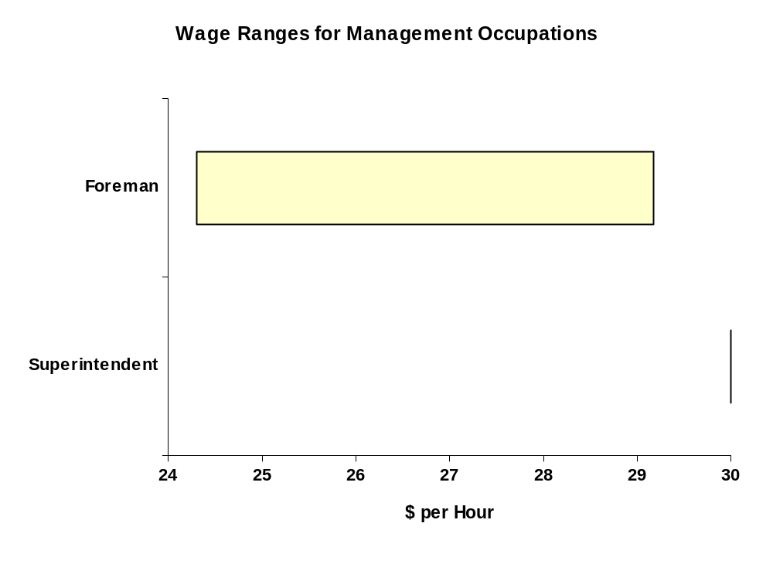
Source: Interviews, union sources

Superintendent
Almost exclusively paid salaries, full-time, year round.
A company vehicle (pickup truck) is usually provided, all expenses paid.
Generous bonuses are common, as are benefits/pension plans.
In our interviews, RKA found a spread of salary compensation, from $55-60,000 per year, up to around $110,000. The variations are due to negotiated salaries based on years of experience, scope of responsibility, and the company/setting where the wage is negotiated. Maintenance companies are on the lower end of the scale, and that is the sector where overlaps with foreman responsibilities tend to be most noticeable; definition of the term “superintendent” does not always precisely match the definition for the construction sector.
Variations aside, we heard a solid consensus that the average range for superintendents is from the low $70,000 range up to $90,000, with $100,000 not uncommon.

Foreman
Shop Foreman (Mechanics)
Foreman (Carpenters)
Researching the wages of foremen can be very complex. They are almost invariably hourly-paid employees (under the collective agreement in unionized companies) and subject to the same seasonality, with periods of significant overtime, and periods of layoff, as the rest of the hourly workforce.
In general we were told that foremen earn only “a dollar or so an hour” above the trades which they supervise, although they invariably have also a company pickup truck, all expenses paid. Collective agreements typically give foremen 10 percent above the rate of the highest paid worker they supervise at a given time.
When we asked for estimates of annual incomes by interviewees, we heard figures of $40,000, $50,000 and even $60,000, (plus the pickup truck) -- always for about a 10-month year. With the 12-month working year that is becoming more common, especially in the south of the province, we would expect to see commensurate higher averages.

Grademen and Heavy Equipment Operators
Grademan
Excavator operator
Dozer or "cat" operator
Bobcat operator
Hoe or backhoe operator
Grader operator
Loader operator
Packer Operator

Figure 6
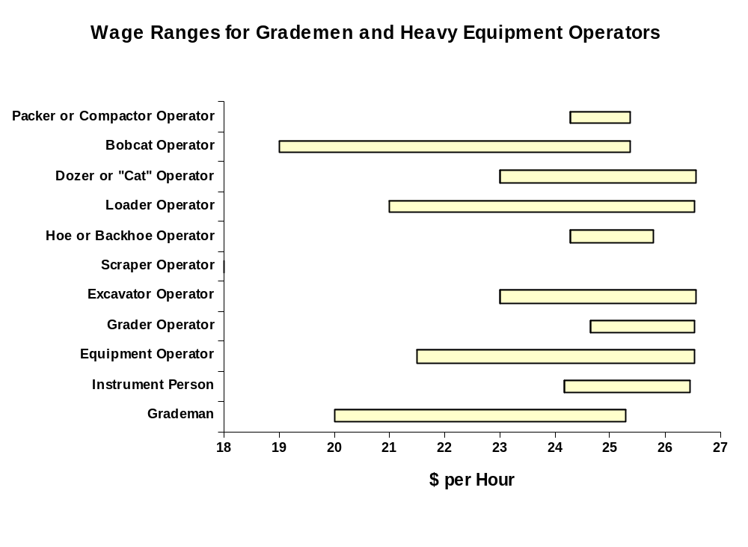
Source: Interviews, union sources
Re Scraper Operators: During RKA’s interviews, we did not hear of scraper operators (perhaps because of the self-selection of companies who accepted our offers of interviews). Consequently, Scraper Operator is a late addition to this report. However, the data shows that wages for scraper operators are in keeping with those for Hoe or Backhoe Operator.

Asphalt Lay-down Occupations
Paver Operator
Screed Operator
Raker
Roller Operator (Breakdown rollers, rubber-tired rollers, finish rollers)

Figure 7 (next page)
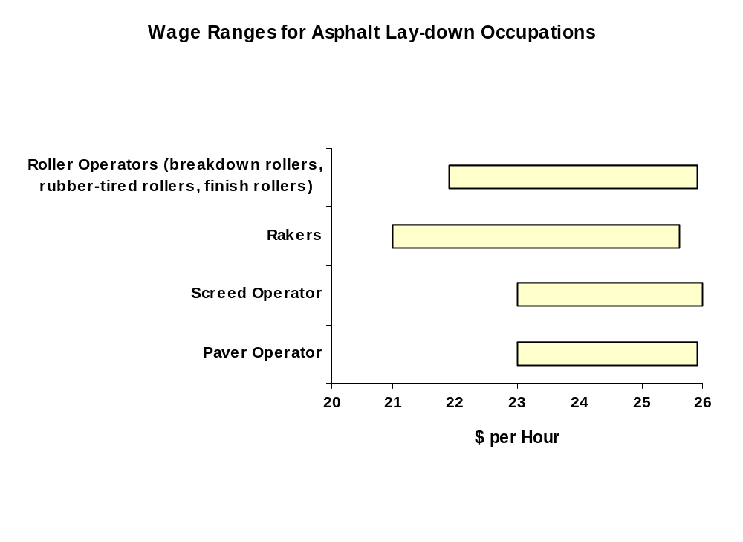
Source: Interviews, union sources

Sealcoating
Sealcoating Personnel: spreader operator, spotter

Figure 8 (next page)
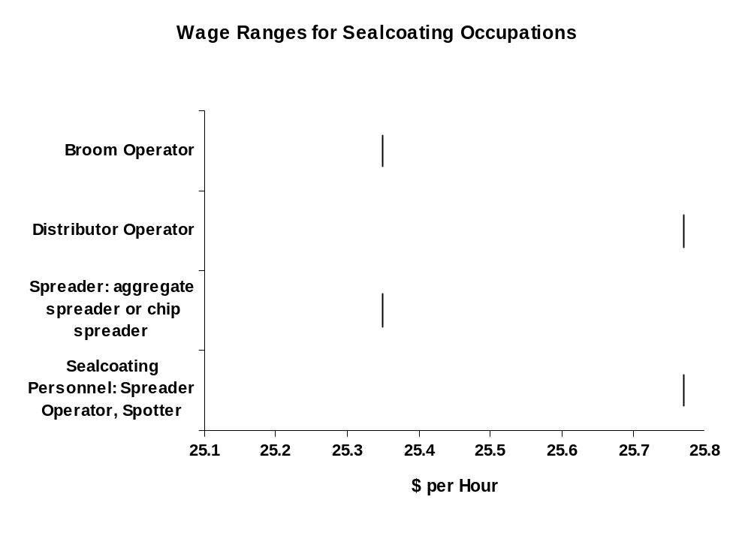
Source: Interviews, union sources

Asphalt Recycling
Pre-Heater Operator
Asphalt Grinder Operator
Reclaimer or Reclaim Operator

Figure 9 (next page)
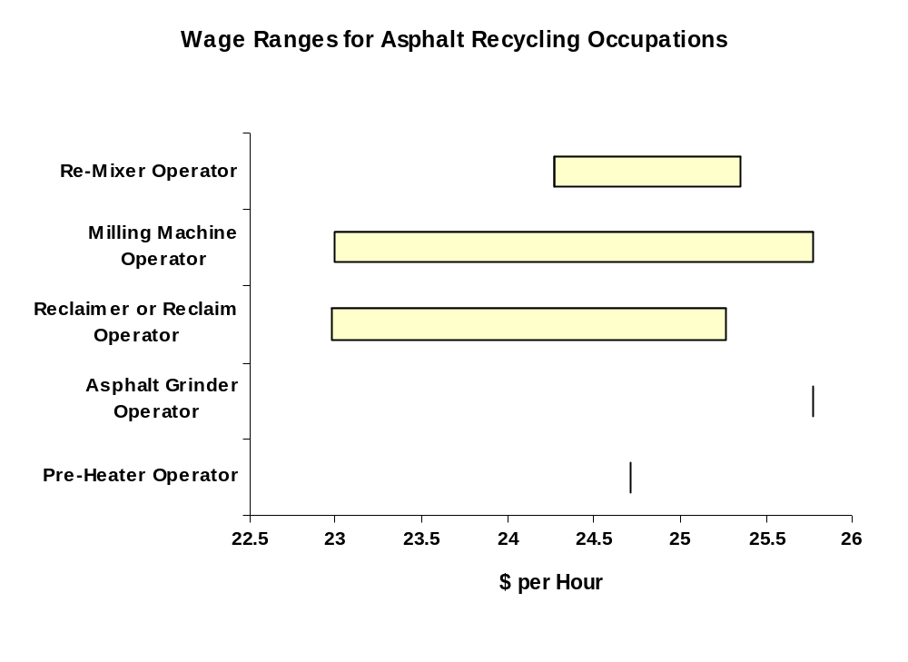
Source: Interviews, union sources

Plant Operators and related
Asphalt Plant Operator (apprenticeable)
Crusher Operator (crusher plant or asphalt plant)
Wash Plant Operator
Groundman

Figure 10 (next page)
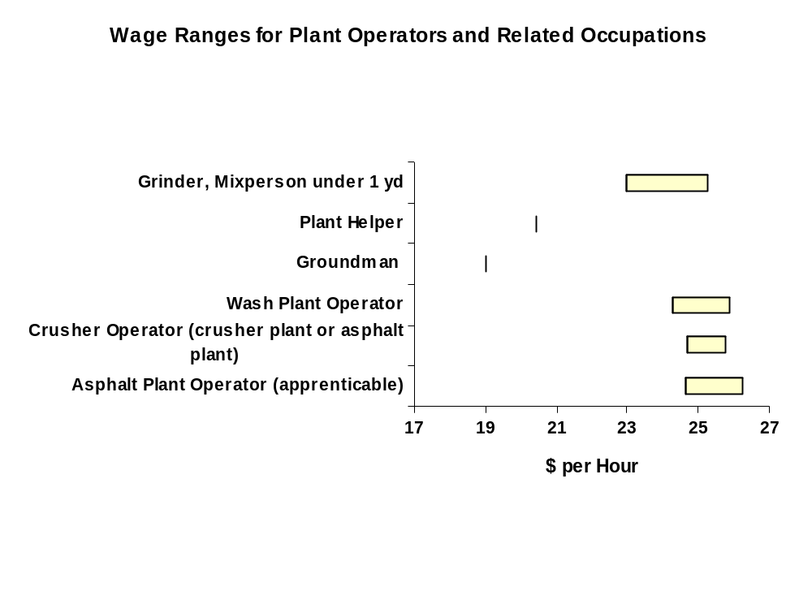
Source: Interviews, union sources

Pipelaying Occupations
Pipeshooter
Pipelayer

Figure 11 (next page)
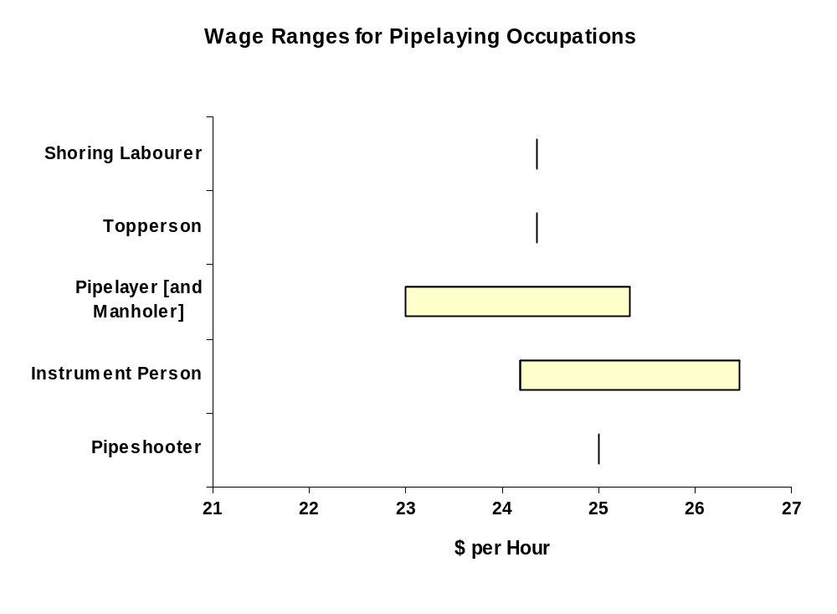
Source: Interviews, union sources

Truck Drivers
Truck Driver
Truck Driver up to 5 Tons
Truck Driver Multi Axle

Figure 12 (next page)
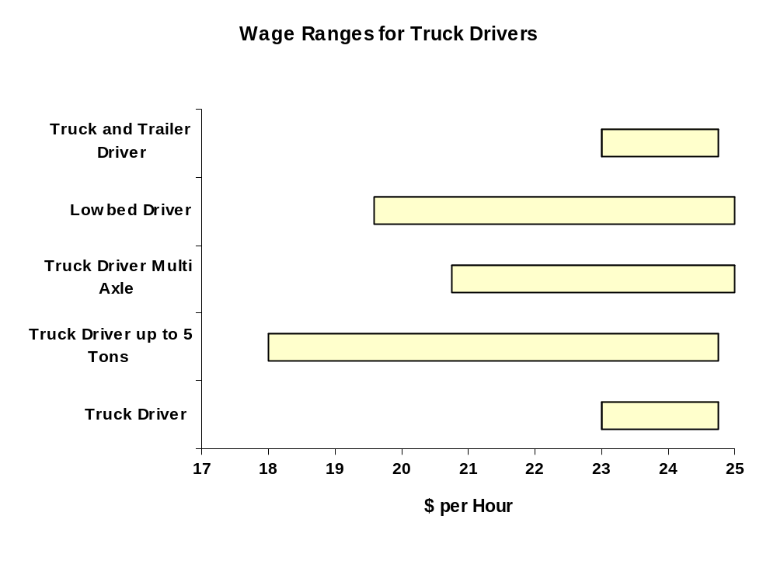
Source: Interviews, union sources

Specific to Highway and Bridge Maintenance Group
Piledrivers and Bridgeworkers (Bridgeman)
Shouldering Trailer Operators

Figure 13 (next page)
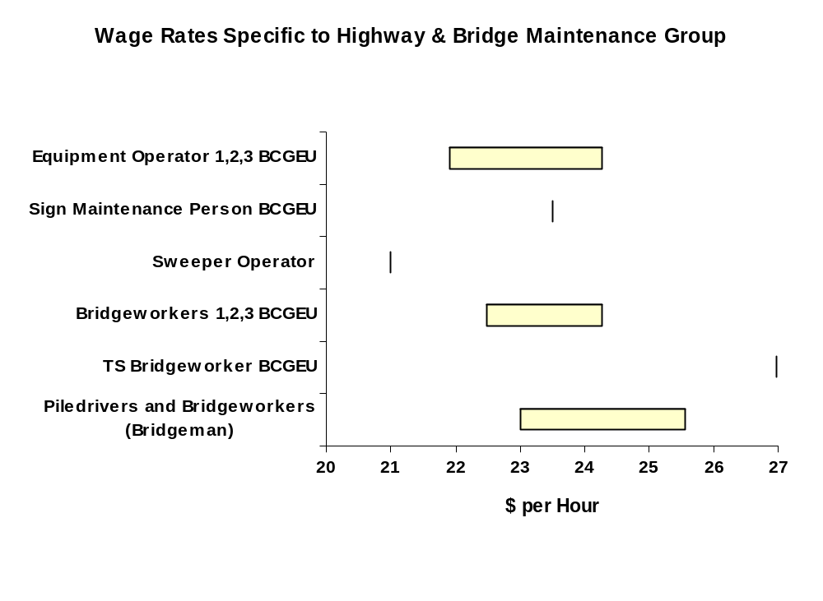
Source: Interviews, union sources

Crane and Similar Operators
crane operator (apprenticeable)
dredging operator

Figure 14 (next page)
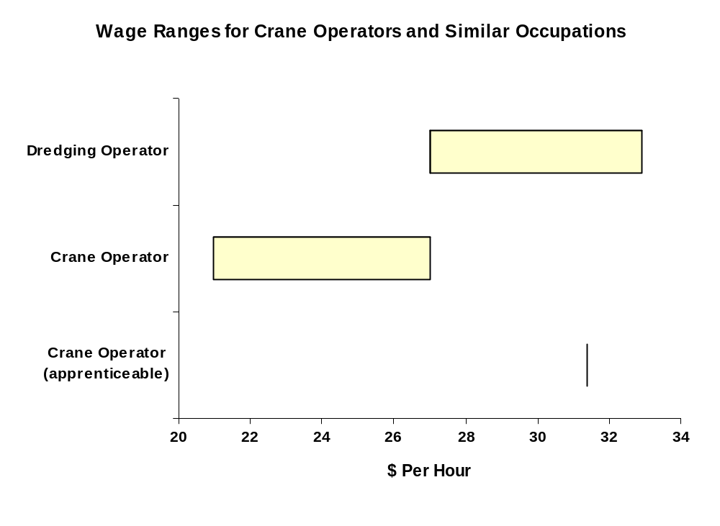
Source: Interviews, union sources

Concrete Related
cement mason
curb machine operator

Figure 15 (next page)
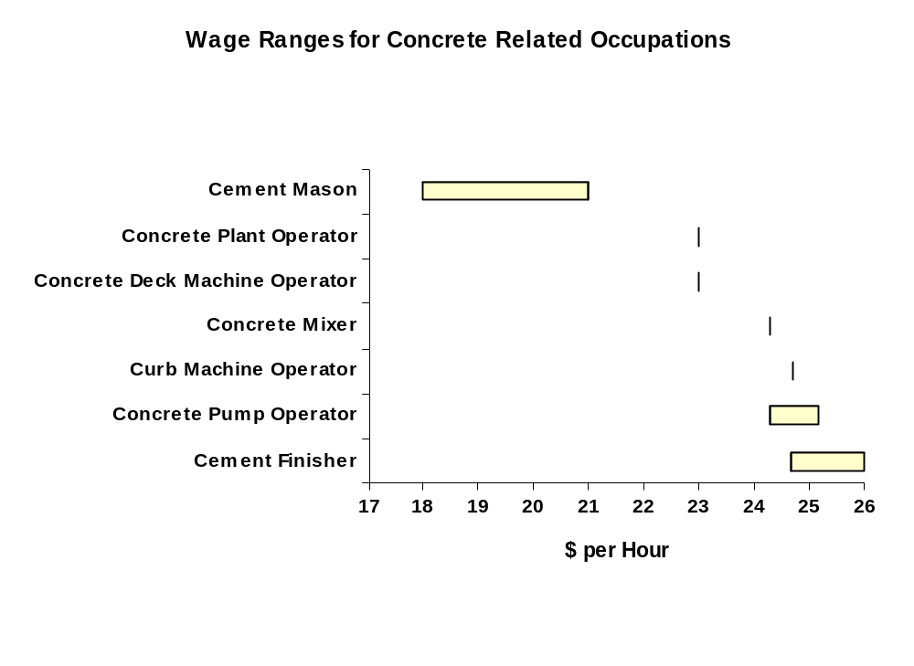
Source: Interviews, union sources

Warehouse
warehouseperson

Figure 16 (next page)
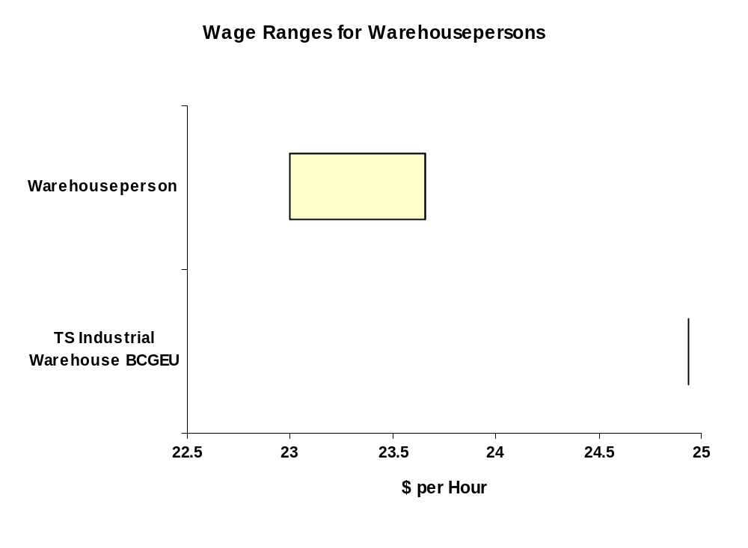
Source: Interviews, union sources

Marine
tugboat captain
deckhand

Figure 17 (next page)
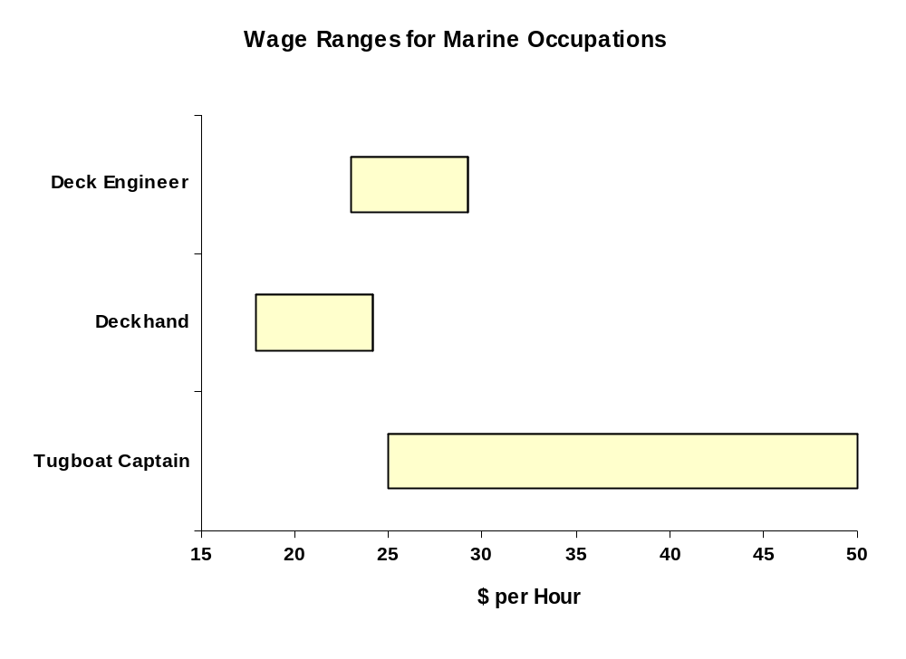
Source: Interviews, union sources

Others
ironworker (steel rebar placer)
No wage information available.

Drillers and Scalers

Figure 18 (next page)
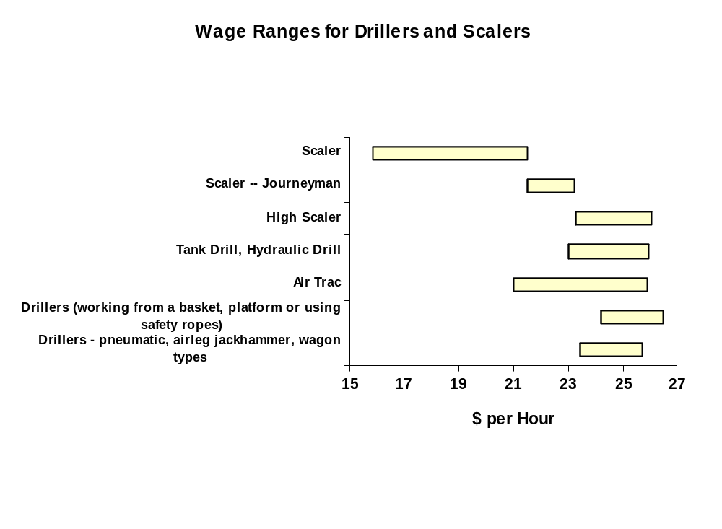
Source: Interviews, union sources

Blasters and Stabilization Occupations
Figure 19:
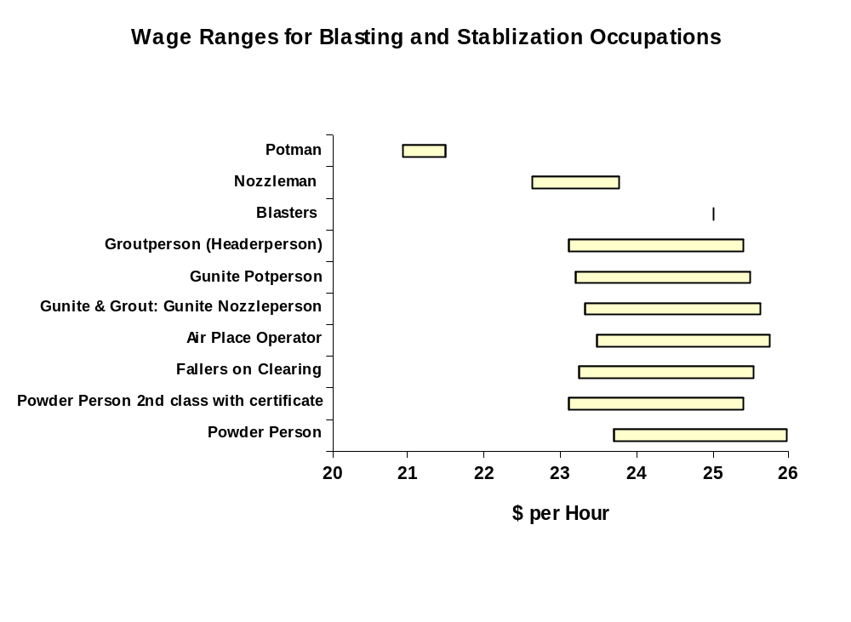
Source: Interviews, union sources

Other Skilled Trades

Heavy Duty Mechanic
Carpenter
Plumber
Electrician
Welder

Figure 20:
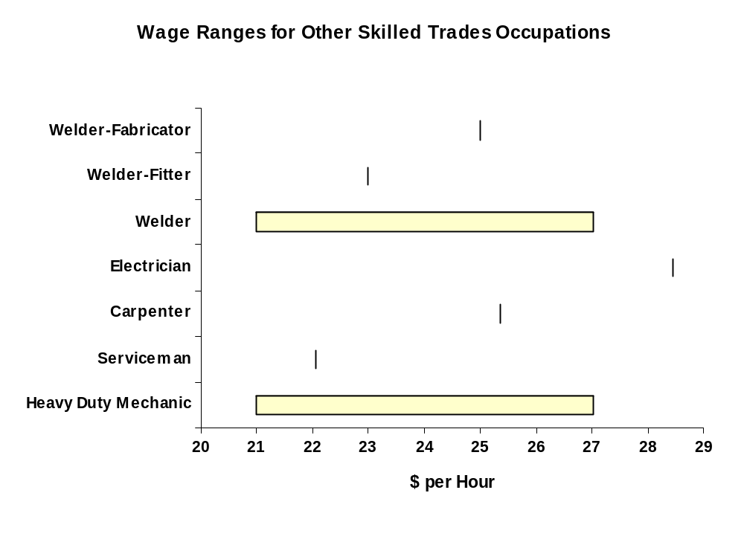
Source: Interviews, union sources

Labourers
Small Tool Operator

Figure 21 (next page)
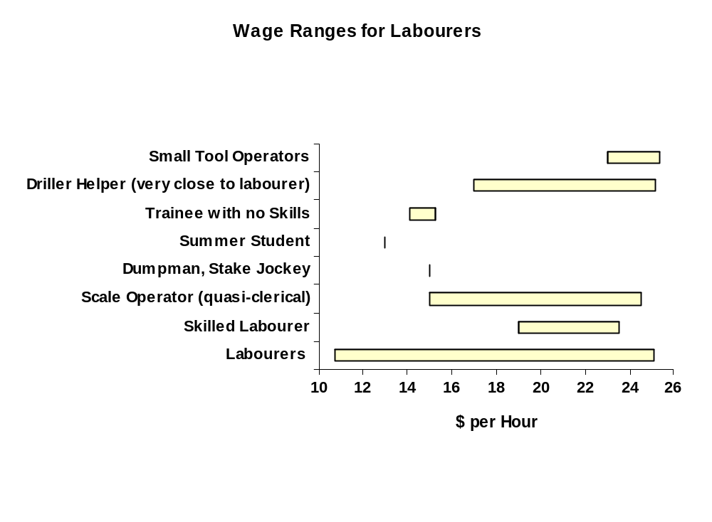
Source: Interviews, union sources

Traffic Control (flagger)
Figure 22:
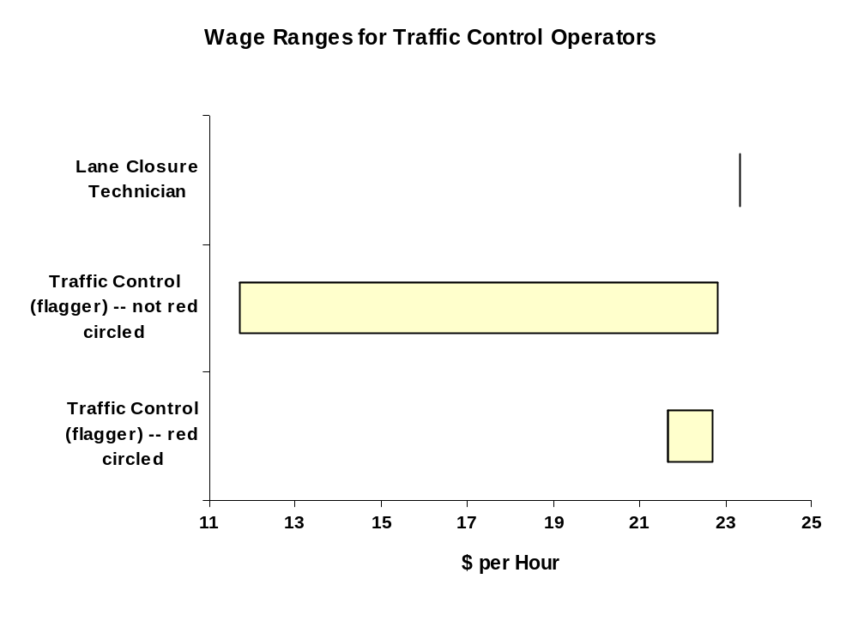
Source: Interviews, union sources

Training Requirements
In interviews with managers and workers in the road building and heavy construction industry, we found very few strict training requirements.
They are as follows:
- Class 1 driver’s license with air endorsement, or Class 3 with air, needed by most heavy equipment operators, truck drivers and other tradespeople who need to drive equipment trucks to and from worksites.
- Virtually everyone in the industry is required to drive at some time, so a Class 5 license is the bare minimum.
- Mandatory training for apprenticeable occupations, notably bridgeman, asphalt plant operator, crane operator, ironworker, mechanic, carpenter, electrician, plumber, welder.
- Mandatory Workers Compensation Board certification for blasters
- Mandatory courses in traffic control for flaggers
There is near-unanimous agreement that some other types of training are necessary, and are usually provided by companies:
- Safety and site orientation
- Hazardous products and WHMIS (Workplace Hazardous Materials Information System) training, also mandated by Workers Compensation Board
Apart from those, training is usually voluntary on the part of
- companies (to provide for workers) or
- workers (to seek out, e.g. by applying to unions)
The traditional and still most common method of training personnel in the industry is experience on the job. There are many ways to describe the method: “hands on”, “actual experience”, “from within”, “in-house”, “coming up through the ranks”.

Training Techniques
The time-tested and best techniques for training are seen as:
- Identifying workers with potential to learn,
- mentoring them,
- exposing them to extra challenges and extra opportunities,
- sometimes absorbing the cost of lost productivity.
The industry’s trust in “actual” experience as opposed to theoretical, or formal, or classroom situations, is well-established.
Foremen are the key players in this system for training workers and they in turn are mentored by superintendents who identify them for future promotion. Foremen are central to imparting knowledge, ideas and techniques to trainees; but so are experienced workers (for instance equipment operators).
A common practise is said to be teaming an inexperienced operator with an experienced one. They can observe each other’s work, remain in touch by 2-way radio – and the mistakes of the inexperienced one can be corrected on the site.
Training from within, coming up through the ranks, was the way that the vast majority of our interviewees gained their skills, even those who may have had post-secondary education (e.g. in civil and structural engineering technology) or who entered the field through personal contacts such as family members.
Those who receive more formal training, such as union-organized schools, or private-sector training schools, are considered to be only trained in “the basics” and still need to put in their “actual” or “hands-on” time on the job in order to be properly trained.
One exception mentioned fairly frequently was a recent trend towards hiring BCIT civil and structural graduates to a management position, such as superintendent. Even these, however, take on various assignments (typically quality control management, or estimating) – and ideally, put in some labouring time on job-sites to get real experience before they can be considered functional in the industry.
So in many ways the industry still looks to the “entry level” worker as its ideal recruit, someone perfectly suited to learning the industry from the ground up, coming up through the ranks.
In this sense, it is a certain background and upbringing that have given the candidate the training and needed “life skills”. Often the ideal recruit was described as a young person, open to learning and intelligent, with a mechanical interest and aptitude. Several of the managers we interviewed were former “farm kids”; and a “farm kid” was sometimes described to us as a person likely to be an ideal recruit.
With the above limitations, there is respect in the industry for what more formal training can accomplish. Theory, the “basics”, and in particular the increasingly valued academic skills (written communication, mathematics, management techniques, quality methods) are seen to be very well taught in formal training settings.

Training Availability at Present
During Interviews, a number of sources of training were mentioned, which are listed below. This list is not complete. It is a compilation of training we were told about during our research, including internet listings, and our interviews:
Various colleges, such as Malaspina University College, and private schools
- for Class 3 and Class 1 Driver’s licenses, and air endorsement
Gold Seal national certification (from the Canadian Construction Association)
- for superintendents
BCIT
- Apprenticeship training, e.g. bridgeworkers
- Surveying; senior level; geomatics engineer and technologists
- Civil and Structural Technology, particularly for superintendents, foremen
Supervisory Skills Course, public or private schools
- Project management courses
- scheduling courses,
- supervisory, such as “Effective Supervision”, colleges such as University college of the Cariboo; Thompson Rivers University, BCIT, UBC, etc.
- 2 or 3 private training firms geared to the construction sector.
- Dale Carnegie management course
- Upgrading for supervisory skills, all levels: community colleges, private training schools.
Academic Upgrades
- computer skills after hours courses: community colleges, BCIT, UBC, etc.
- Mathematics, English and similar courses: same sources
Courses by Construction Assn of BC, Roofers, ICBA, (Road Builders) BC Safety Net
Accepted Traffic Control Person training (for flaggers)
- As of January, 2005, only accepted training courses will be recognized by WCB. Accepted training courses are those put on by trainers who in turn have been trained and authorized by Master Trainers of the BC Safety Network. To date, there are 170 instructors in BC, in municipalities, private training and flagging companies, and construction companies. The Traffic Control Person training is a 2-day course. 6500 flaggers have been trained since June 2003.
- Best Practices for Rock Scaling: training material available for use in the rock scaling and slope stabilization industry.
- Training for BC Road Construction & Maintenance Safety Network Certificate of Recognition (COR), Worksite Partnership Program (WPP)
Particular In-House Training mentions
- Courses for maintenance company workers in: avalanche safety, air brakes refresher courses, transportation of dangerous goods, winter awareness for ploughing, abraders.
- 1st aid, Transportation of Dangerous goods, given by: CLAC, Ministries, Schools (colleges, private schools)
- Have an in-house operator trainer, full-time. Team up with Finning to put on 1-2 week operator training program. (Maintenance company)
- have done a 3-4 day course, QMF; quality management
- ISO training
- the odd in-company course on pavers, screeds, etc.
Equipment Manufacturers
- Curb machine training: Gomaco; Ida Grove, Iowa, USA.
- Manufacturers of paving equipment, rollers, grinders, crushers, reclaiming equipment. BLOWOX, Cedar Rapids, Caterpillar
- Bosch Rexra hydraulics.
- An alternative approach is to bring a technical rep. to the site, for seminars and training demonstrations
Private Training Schools for Operators
- “There are a couple of schools but only give 110 hours experience: one on Vancouver Island, the 115 union one, a private school south of Aldergrove; OTS. -- it costs 9500 dollars. ” [also mentioned as Otter Training School]
- “private trainer on the coast too who gave grader training; 3 day courses”
- “good private schools: one in Merritt, one in Kelowna; do a more complete job than unions. With union, company not allowed to specify”
Operator Training, Malaspina University College, Nanaimo
- Has fees similar to private schools
Unions (some mentions from interviewees)
- Pipeshooting and grading with Labourers Local 1611
- “Teamsters 213 have a driver training unit”
- CLAC has package for Pipe and Grademen
- Labourers Union 1611 has grade foreman course; should be pushed by the industry. That, or BCIT; good sources of the surveying knowledge.
- CLAC has a driver training program; touch-on equipment
- CLAC has computer sessions, 4 hours.
- took 4 year course for plant operations and QC and knowledge of gravel through operating engineers 115, Haney; difficult to get into.
Training Listed by Unions: Operating Engineers Local 115
- Asphalt Lay-Down Entry Level 3 week course (Paver, Screed, Rollers)
- Mobile Crane Operator Apprenticeship, 3 Levels (compulsory for apprentices in BC)
- WHMIS – 3 hours
- Rubber Tired Backhoe 7 week course
- Excavator Operator 7 week course
- Other Operator Training – sometimes offered
- Forklift Certification 1 day course
- Deckhand (short course)
- Grade and Stakes (short course)
- Rigging (short course)
- Welder (short course)
- Welder Certification
Training Listed by Unions: Local 1611, Construction and Specialized Workers’ Training Society
- Survey
- Grade
- Rigging
- Concrete Placement
- Forklift
- Fall protection
- Confined space entry
- Gas testing
- Sparkwatch
- Lane closure
- Flagging
- Traffic control
- Bobcat operator
- High scaling
- Respirator
- Mine rescue
- Hydraulic drill training
- Rakerman
Training Listed by Unions: CLAC
- Workplace Leadership Series
- Work and Life: Personal Improvement Seminars
- Carpenter TQ Challenge Course
- BC Construction Safety Training System (BC CSTS)
- Basic Rigging
- Blueprint Reading
- Cardiopulmonary Resuscitation
- Chain Saw Safety
- Confined Space
- Dealing with Anger
- Dealing with Conflict
- Drug and Alcohol (Awareness and Policy Development)
- Fall Protection
- Giving Presentations
- Gradeperson Training
- Joint Health and Safety Committee Training
- Listening Skills
- Microsoft Access
- Microsoft Excel
- Microsoft Outlook
- Microsoft PowerPoint
- Microsoft Word
- Money Management - Budgeting
- Nutrition
- Paving and Site Preparation Conference
- Pipelayer Training
- Positive Change
- Quality Customer Service
- Stress Management
- Time Management
- Transportation Conference
- Transportation of Dangerous Goods (TDG)
- WCB Occupational First Aid Level One
- Workplace Hazardous Materials Information System (WHMIS)
- Workplace Leadership Series
- Workplace Personality Styles

Sources of Skilled Workers

On-the-Job Training
As we have seen in the sections on occupations and training, the industry view about sources of workers is “we get untrained people, and we train them”.
The assumed – and preferred – source of skills is time spent in a company: on-the-job training and experience. The assumed source of new skills resources for most positions is new entrants. (For more senior positions, the supply is assumed to depend on the inflow of new entrants to more junior positions).
“Entry level” can apply to young people who start as manual shovellers and are identified for their potential. It may also apply to those who have been to a school of some kind, whether Civil and Structural Engineering, or holding a university degree, or a training program for equipment operators. “We train them.” The consensus is that everyone who is really skilled must be trained within the industry.
Less common is the opportunity to hire people already skilled – skills that were acquired within the industry, at other companies. But even those people are thought to need, at least, an orientation to the particular practices and requirements of the new employer. Having an “open mind” to this was described to us as important in these new entrants.
Given that training new entrants remains the basic model for skill development in the industry, where do the new entrants come from?

The Pool of New Entrants
Based on RKA’s extensive interviews with managers and workers, these are the sources for new entrants to the industry’s workforce:
- Class 3 with air endorsement (or Class 1 with air) Driver’s License holders
  - looking for their first driving job, or
  - with some driving experience in other industries
- Younger people who are unemployed or underemployed (they want higher wages), who have “entry level” skills or attributes (see section “Skill Requirements”) and who are:
  - high school graduates, or
  - college undergrads, or
  - (more rarely) post-secondary graduates; BCIT or university graduates, usually entering management but sometimes entering via the working level with the rest of the new entrants
- people of various ages who get exposure to the industry by working in a closely related field, e.g. qualified flaggers
- Older people with experience in other related fields, e.g.
  - Drivers in other industries
  - operators from other industries,
  - tradesmen with related skills.
- People only slightly older, into their 30s, choosing to move to the industry from unrelated industries or occupations
In the latter category, we learned of entrants who came from:
- restaurant ownership,
- computer sciences work,
- farming,
- various semi-skilled jobs, and
- a fully qualified mechanic who went into driving.
The mechanic considered that he could earn more money in his home area, in a field where he did not have the expense of supplying his own mechanics’ tools, and so entered driving, then construction. He has in common with all the others the motivation of the money to be earned in the industry.
Another common factor is the driver’s license, which has about equal weight with physical capacity for labouring, in new entrants’ traits.
Entry level workers such as labourers who show promise are often encouraged by foremen to get a Class 3 or Class 1 Driver’s License, or to apply for union training in equipment operating. Either way, the workers usually need to pay for their driver’s license upgrades.

Development of Staff Within Companies
The large majority of interviewees were perplexed and distressed by the fact that the industry has not been filling up with new entrants, and especially young people, for many years now, a fact that is confirmed by the findings in “Supply Projection”, ahead. Nor are new entrants filling up the industry now (see “labourers” and “new entrants” shortages in Chapter 3, section “Supply of Skills and Workers”). Many draw a logical connection with the prevalent training pattern: how can we be training if we do not have new people coming in?
Interviewees speculate about what discourages new entrants, whether it is
- the uncertainty of seasonal work or the requirement to travel for work, or
- outdoor working conditions, or
- the uncertainty of having enough hours, or
- too many hours, particularly in a busy season like summer
- the attraction of “computers” as a way to earn a living, instead of traditional occupations
Some even wonder if the wages are not attractive enough. Wages are high compared to other industries, but these concerns are usually voiced in relation to higher wages for those who enter trades, i.e., a choice of apprenticeable trade such as electrician or welder would pay more. Or for someone willing to relocate and do similar work, even for equipment operators, it is possible to make more money in mining, logging or the oil patch. Some even question if there is a perhaps a tendency for the industry to mistreat workers.
Interviewees (excepting the maintenance sector) point to a big surge in work opportunities for the industry, now and increasingly in the future.
There is near consensus on the need to identify and to hang on to workers in the coming years. Even the maintenance sector is part of that consensus.

Training, Including Schools
Schools mainly do partial training for skills needed in the industry; (other than apprenticeable), very brief periods of relevant classroom or “formal” training.
Other providers (see list in “Training Availability At Present”, above) mainly do similar training; the most “hands-on” are union or private courses in equipment operating, which are generally said to be very preliminary, “only the basics”, needing to be completed by learning on the job over a period of 3-4 years.

Other Sources
Other sources of new entrants include:
- Immigration, a traditional source for construction workers in the past,
- In-migration, likewise a traditional source as provincial economies wax and wane,
- Multi-cultural communities of the province, including visible minorities, for the most part not a traditional source,
- aboriginals, a source that is receiving recent attention,
- women, likewise not a major traditional source

Supply of Skills and Workers
The following Table, compiled from RKA’s interviews, shows what industry members told us about occupations in good supply, moderately short supply, and severely short supply.
These findings are as complete as we could make them, given that we invited every company to speak to us, but some companies chose not to. It is possible, therefore, that they may have known of shortages which did not get recorded here.
The two main divisions are for the construction and maintenance sectors within the industry.
The geographic areas within each industry are:
LM – Lower Mainland
VI – Vancouver Island
I – Interior
N – North
Shortages are indicated as being M (moderate) or S (severe), according to what interviewees told us.
Other occupations were considered to be in fairly good supply. However, a good supply is not a surplus, and future demand could quickly transform some of the occupations into shortage situations (just as unexpected downturn would eliminate shortages).
Table 4 Supply of Workers by Geographic Area, Severity of Shortages, in Construction and Maintenance Sectors
 | Construction Sector |  |  |  | Maintenance Sector
Occupation | LM | VI | I | N | LM | VI | I | N
Operations Manager |  |  |  |  |  |  | M | M
Estimator
Superintendent | M | S |  | M |  |  | S | S
Foreman | S | S | M | M |  |  | M | S
Grademan | S | M | M
Equipment Operator | M |  | M |  |  |  | M | M
Grader Operator | S | S | S |  |  |  | S | S
Excavator Operator | S | S | S |  |  |  |  | S
Scraper Operator
Hoe, Backhoe Operator | M | M | S
Loader Operator | S
Bulldozer Operator | S
Bobcat Operator |  |  | S
Packer Operator |  | M |  |  |  |  | M
Paver Operator | S | S | S
Screedman | S | S | S | M
Asphalt Raker | S | S | M
Roller Operator | S | S | S
Sealcoaters
Asphalt Recycling Pre-heater Operator
Asphalt Grinder Operator |  |  | S
Reclaimer Operator
Asphalt Plant Operator | M | M | M | M
Crusher Plant Operator |  | S
Wash Plant Operator
Groundman
Pipeshooter | S
Pipelayer | S | S
Truck Driver | M | S |  |  |  |  | M | M
Bridgeman | M |  |  |  |  |  | M | S
Plough, Snowblower & other Highway Maint. Operator
Signman
Crane Operator | M
Dredge Operator | S
Concrete Pump Operator
Cement Mason | S | M
Curb Machine Operator |  | S
Nozzleman – Potman |  | M | M
Warehouseman
Tugboat Captain | M
Deckhand | M
Marine Engineer
Marine Surveyor | S
Surveying Technician
Ironworker | M
Driller | S | M | M
High Scaler |  |  | S
Blaster | M |  | M
Heavy Duty Mechanic | S |  | M |  |  |  | S | S
Serviceman
Carpenter | S | M
Plumber
Electrician
Welder | S
Labourer | S | S |  |  |  |  | S | S
Small Tool Operator | M
Flagger
Scale Operator
“Entry Level” | S | M | M | M |  |  | S | S
Source: RKA
In the above table, Labourers account for a wide variety of workers not classified elsewhere. In addition, note that “Entry Level” is not an occupation, but a category that interviewees apply to new workers. Most often they use it to refer to younger or inexperienced workers, which can mean labourers. But not always. In the maintenance sector, for example, “auxiliary” or casual workers begin part time, and they may be skilled as drivers, operators, etc.

Changes Affecting Skill Requirements

Market Changes
RKA’s interviews asked about change in the road building and heavy construction industry. The changes causing the greatest concern, however – greater than any changes to individual skill requirements – are those of supply and demand:
- The onset of a great boom (discussed in Chapter 3, “Economic Conditions Affecting the Industry”) following years of downturn
- Demographic changes in the workforce (see “Economic Factors affecting the industry”), very little growth in population, rapid growth in demand for workers (see “Supply Projections” ahead)

Maintenance Sector Changes
Besides those, the most-mentioned changes in the maintenance sector are fundamental provincial government-led changes to contracting, including wage cuts and mandated workforce reductions, which are seen to worsen the age imbalance in the workforce by discouraging both recruitment of new entrants and retention.
To bring about cost-cutting and workforce reduction, maintenance companies are not starting apprentices. The overall trend of its recruitment and training patterns would logically appear to be heading to a disappearance of its skilled workforce about when the current (10-year) contract cycle ends.

Computerization
A change frequently mentioned is that computers are having an impact on the work and skill requirements of foremen, superintendents and management levels:
- Reporting, including “time cards” and other personnel information are more computerized
- Scheduling, documentation and quality control techniques are all computerized
- Workload is also increasing because of more possibilities for reports and data manipulation via computers
- Computer learning is an added time pressure for many foremen/managers whose skills are yet not highly developed

Skills and Technological Change
Administrative computer use aside, RKA asked about technological change, a factor that is making revolutionary changes to jobs in many industries. The answers we got show that, while technological change has been felt in the industry, there has not been a lot of significant change in skill requirements:
- Technological change in general has meant more comfort, safety, health, and ease of operation of heavy equipment
- Technological change to controls has varied the skills somewhat in operators, but for younger workers and most older workers the learning is moderately easy
- In future, a move to GPS-controlled truck dispatches, which will allow constant tracking of the whereabouts of trucks/equipment, is expected to affect the maintenance sector, improving managers’ control abilities and replacing manual reporting systems for truck and equipment operators
- Applications of laser technology, e.g. for grademan / pipeshooter, may have some labour-saving impacts
- Technological advances can also work to the detriment of skills, e.g., allowing less-skilled people to work on a site who, when problems arise, may not have the basic math skills to understand or solve the problems
- Many of the impacts of technological change may have already been felt; some interviewees observed that nothing much is new on the horizon
- Sometimes the literature accompanying technological change is more exacting, leading to the need for higher literacy among workers
- Processes and materials are becoming more technical, along with more stringent pollution controls, etc. Those, combined with non-technological changes (below) prompted one interviewee to comment,”I can see the day coming when everybody in a trade needs a couple of years of post-secondary.”

The Impact of Expense on Training
Whether through technological improvement or other factors, there have been great increases in the expense of equipment, which has a negative impact on training, e.g.
- The closing of high school trade shops
- Reluctance of companies to use expensive equipment in training, which is seen as “non-productive” wear and tear

Non-technological changes – Quality control processes
Apart from technology, many interviewees identified a significant change in the jobs: the downloading of quality control processes and documentation to contractors.
Formerly more of the documenting and quality management processes were performed by the client, i.e. often governments. One manager said “we have always done this” (i.e. managed quality)—but the formal documentation of quality management is new. Paperwork for the industry has increased. New duties, and sometimes new skill requirements, have fallen upon managers, and there have been some impacts on workers as well. As one worker lamented, “those with computers seem to be conspiring to keep us from getting to our real work.”

Non-technological changes – Liability
Several superintendents and foremen described recent legal changes which they say place more legal liability on them for mishaps on a worksite. Some comments:
- “One reason it is hard to find good foremen is [that] for a little extra pay, you take on a lot more responsibility and liability. The government has many new regulations these days to say you are basically liable for everything - that scares a lot of people. “
- “industry is more prone to public scrutiny and lawsuits than it was when government did the maintenance work itself”
- “Six years ago the government made supervisors / superintendents criminally liable for people hurt on the job. The onus is on you to prove you were diligent. Why would I want to be a supervisor and take the liability for the negligence of an employee?”
For these reasons and others causing job pressures, we heard about reluctance of some workers to take on the responsibilities of foreman.

Computers and Youth
Last, a great many interviewees speculated that the larger impact of technological change in society (computers and their dominance) has affected labour supply, leading to a scarcity of youth having an interest in entering the industry.

Supply Projections
In this section, we will explore statistical data available pertaining to potential future supply of labour in the construction industry. First, we will examine data pertaining to projected labour demand in key occupational groups in the BC road building and heavy construction industry.
In labour demand projection analysis, we look at two components that make up the demand:
- Employment growth due to increase or decline in economic activities is one component, and is referred to as net growth.
- The other component refers to attrition, the need for the workforce to replace those who have left the labour force due to retirement or attending school or other reasons.
For this purpose, we provide occupational analysis instead of concentrating on the industry. While industry analysis reveals where the strength and weakness of the general economy lies and is usually the basis for any employment projections, it covers too broad a range of occupational groups within itself which makes it difficult to draw meaningful conclusions about one specific type of occupation. Occupational analysis provides information on occupations which are comprised of individuals performing similar activities, and allow comparisons in areas such as age, education achievements, compensation and so on. That is why we have chosen employment demand analysis for this report.
As shown in section “Occupations in the Industry” occupations in the road building and heavy construction industry are quite diverse, some unique to the industry while others are found in many other sectors of the economy. For the purposes of this report, we focus on these key occupational groupings represented in this industry: Construction Managers (National Occupational Classification, or NOC, 0711), Contractors and Supervisors - Heavy Construction Equipment Crews (NOC 7217), Heavy Equipment Operators (Except Crane) (NOC 7421), and Construction Trades Helpers and Labourers (NOC 7611).
2001 Census data showed a workforce in this industry much older than the overall labour force.
Table 5 Age Distribution of Key Road Building and Heavy Construction Occupations in BC, 2001
National Occupational Classification | Employed Labour Force in All Industries, 2001 | Employed Labour Force in Construction Industry, 2001 | Average Age | % Under 35 | % 35-54 | % 55 & Over
Total Employed Labour Force | 1,884,000 | 106,230 | 40 | 35% | 52% | 13%
A371.0711 Construction Managers | 8,500 | 7,350 | 45 | 17% | 65% | 18%
H017.7217 Contractors and Supervisors Heavy Construction Equipment Crews | 3,000 | 1,725 | 45 | 16% | 64% | 19%
H611.7421 Heavy Equipment Operators (Except Crane) | 8,800 | 4,545 | 43 | 26% | 59% | 16%
H821.7611 Construction Trades Helpers and Labourers | 11,200 | 8,540 | 35 | 51% | 42% | 8%
Source: 2001 Census, Statistics Canada
As such, attrition needs are expected to account for a large percentage of the overall labour demand projections. During our interviews, an ageing workforce was commented on extensively and repeatedly by our interviewees. Interviewees were near-unanimous in identifying the ageing of the workforce, in particular as follows:
- Retirement rate high and growing as the “baby boom” dominating the industry ages
- Average ages of workers identified as from around 40 years and up,
- A generally recognized failure of the industry to bring in young people.
Some interviewees made a logical connection with the industry’s recruitment and training pattern, asking how the industry can possibly be doing any training if it does not have new people coming in.
Based on the Canadian Occupational Projections System (COPS), employment projections for these occupational groups are shown in the Table that follows.
Note that COPS projections were done without specific consideration to the 2010 Winter Olympic Games in Vancouver/Whistler. For that reason, we refer to openings derived from that model as “base openings”. In 2003, RKA conducted a study specifically aimed at capturing the incremental employment impact due to four major projects – the 2010 Games, the Vancouver Convention and Exhibition Centre expansion, Sea-to-Sky Highway upgrade, and the Richmond-Airport-Vancouver Rapid Transit Project. For the purposes of our analysis, we have included a column showing the incremental impact on labour demand (a ratio showing the incremental demand as a percentage of total openings in the base model). Finally in the Table, we show estimates of total labour demand for these key road building and heavy construction occupations.
Table 6 Occupational Demand Projections, 2001 to 2011
National Occupational Classification | Employed 2001 | Employed 2011 | 2001-2011 Average Annual Growth | 2001-2011 Total Base Openings | Attrition as % of Total Base Openings | Incremental Increase as % of Total Base Openings | Estimated Total Labour Demand
All Occupations | 1,942,364 | 2,238,900 | 1.4% | 695,867 | 57.4% | 14.1%
A371.0711 Construction Managers | 9,531 | 11,226 | 1.7% | 4,109 | 58.8% | 23.1% | 5,059
H017.7217 Contractors and Supervisors in Heavy Construction Equipment Crews | 3,331 | 3,863 | 1.5% | 1,431 | 62.8% | 19.5% | 1,710
H611.7421 Heavy Equipment Operators (Except Crane) | 9,132 | 10,087 | 1.0% | 3,071 | 68.9% | 19.3% | 3,664
H821.7611 Construction Trades Helpers and Labourers | 11,545 | 12,143 | 0.5% | 2,414 | 75.2% | 38.5% | 3,344
Source: COPS, RKA
COPS projections indicate that all major occupational groups for road building and heavy construction will experience positive employment growth between 2001 and 2011. Amongst these occupations, Construction Managers and Contractors and Supervisors in Heavy Construction Equipment Crews are expected to experience higher than average annual employment growth over the same period.
With the addition of incremental employment demand due to the four major construction projects in the province – the 2010 Games, the Vancouver Convention and Exhibition Centre expansion, Sea-to-Sky Highway upgrade, and the Richmond-Airport-Vancouver Rapid Transit Project – total labour demand in these occupational groups will be even higher. For example, total demand for Heavy Equipment Operators over the 2001-2011 period is expected to be 3,664, or about 370 per year.
Note, of course, that not all total labour demand shown in this Table will fall within the road building and heavy construction industry, as other sub-sectors of the construction industry and other industries in the economy place their demand on the same set of occupations as well. However, these figures do provide an indicator of the overall demand for these occupational groups, for which the road building and heavy construction is competing.
On the supply side, we present statistical information available pertaining to population growth in the province. We show estimated share of selected age groups in the population, namely,
- 15-24 year-olds,
- 25-44 year-olds, and
- 45-64 year-olds,
from 1971 to 2004. We also show population growth in these age groups over the same period. Finally, we show projections in the same categories into the year 2031.
This information is presented in the following three charts. In each, the bars represent share of the population of a specific age group, and the jagged line represents percentage change over time.

Figure 23 (next page)
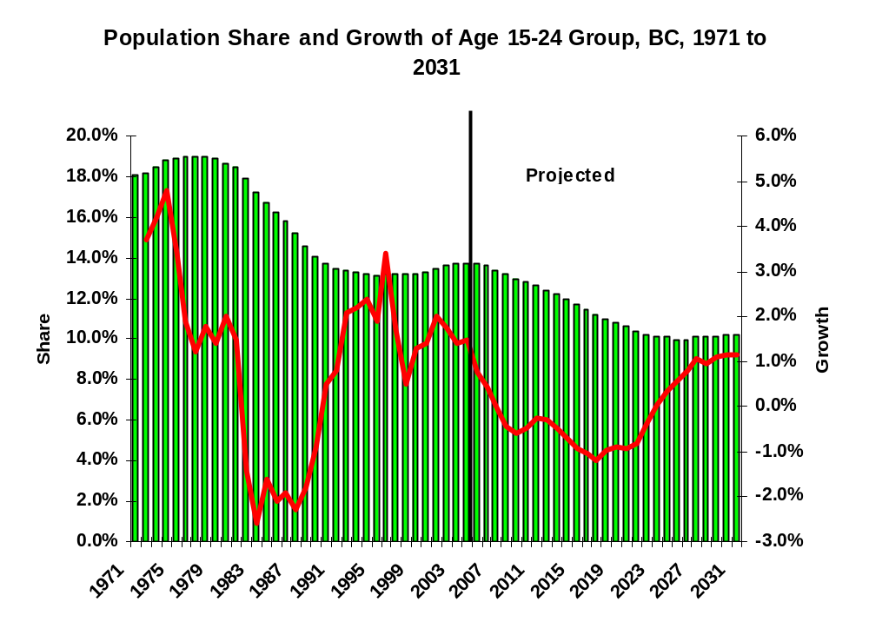
Source: estimates – Statistics Canada; projections – BC Stats 04/12 Forecast
Figure 24:
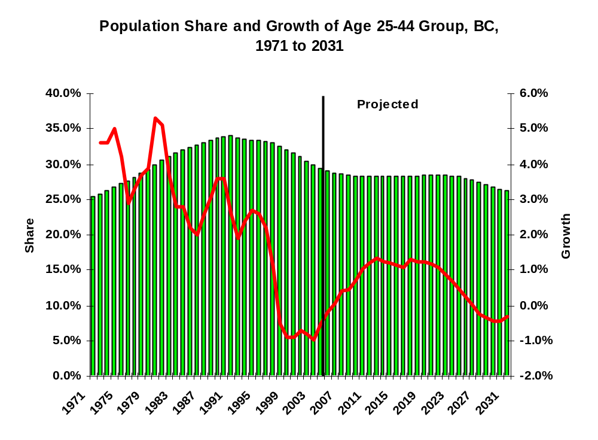
Source: estimates – Statistics Canada; projections – BC Stats 04/12 Forecast
Figure 25:
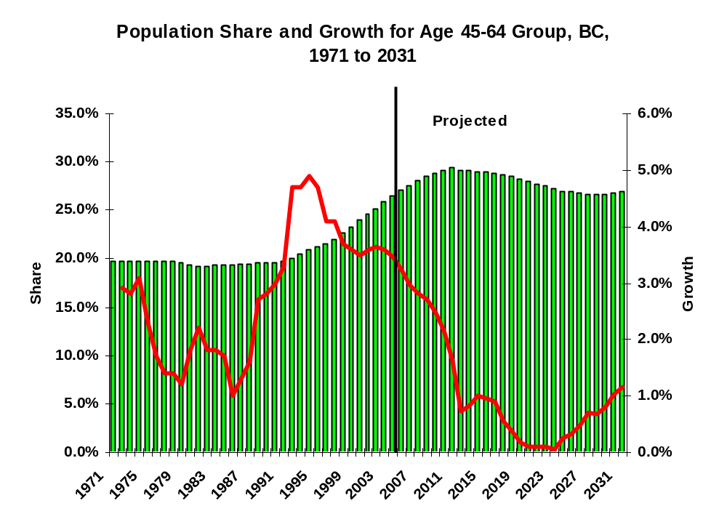
Source: estimates – Statistics Canada; projections – BC Stats 04/12 Forecast
During our interviews, we have been informed that main sources of skilled labourers and equipment operators are unskilled young people who acquire their skills through on the job training and classroom training provided by unions and equipment manufacturers.
To ensure a continuing supply of newcomers to the industry, the industry must face a declining population share of the 15-24 year-olds in the future up to year 2031. Further, annual population growth between 2008 and 2022 is projected to be declining.
The third chart showing population share and growth of the age 45-64 year-olds further emphasizes the point of an ageing workforce. For many in the road building and heavy construction, retirement may even come earlier than the norm for the overall workforce because of some unique features of the industry: physical demand, the requirement to travel to where work is located, the requirement to work in sometimes adverse weather conditions, and seasonal work, just to name a few.
Two potential sources of labour supply for the construction industry require some further analysis here. The first source is immigrants in the construction labour force, and the other is visible minorities.
In past decades, immigrants from Europe moved into construction in large numbers. In recent years, however, very few immigrants indicate an intention to enter the industry. From Census data in 1991, 1996 and 2001, we show the percentage of immigrants in these key road building and heavy construction occupations.
Table 7 Representation of Immigrants in the Labour Force and Construction Occupations, British Columbia, 1991, 1996, and 2001
National Occupational Classification | 1991 | 1996 | 2001
All Occupations | 24.8% | 25.9% | 27.1%
A371.0711 Construction Managers | 29.8% | 27.3% | 25.6%
H017.7217 Contractors and Supervisors in Heavy Construction Equipment Crews | 15.5% | 13.0% | 15.7%
H611.7421 Heavy Equipment Operators (Except Crane) | 11.8% | 8.7% | 9.8%
H821.7611 Construction Trades Helpers and Labourers | 17.8% | 16.6% | 18.2%
Source: Census, Statistics Canada
In all these occupational groups, representation of immigrants is lower than their counterparts in the non-immigrant workforce, with the exception of Construction Managers in 1991. Also, a trend of declining shares of immigrants in these construction occupations over this decade can be observed.
Visible minorities have not always been an important source of labour supply in the construction industry. From Census data in 1991, 1996 and 2001, we show the percentage of visible minorities in these key road building and heavy construction occupations.
Table 8 Representation of Visible Minorities in Labour Force and in Construction Occupations, British Columbia, 1991, 1996 and 2001
National Occupational Classification | 1991 | 1996 | 2001
All Occupations | 13.7% | 16.3% | 19.7%
A371.0711 Construction Managers | 8.0% | 11.4% | 11.1%
H017.7217 Contractors and Supervisors in Heavy Construction Equipment Crews | 3.2% | 3.6% | 5.7%
H611.7421 Heavy Equipment Operators (Except Crane) | 2.7% | 1.6% | 3.6%
H821.7611 Construction Trades Helpers and Labourers | 7.7% | 8.1% | 10.7%
Source: Census, Statistics Canada
From Census data shown above, we observe that all these key road building and heavy construction occupations are under-represented by visible minority groups. However, unlike the situation with immigrants, data here do indicate that visible minority representation in these occupational groups is rising during the past decade.

Ideas for Addressing Skill Shortages
RKA’s interviews asked about ways that people entered the industry, gained skills, and got trained. As we have seen in several preceding sections, skills of new entrants are developed mostly on the job. But we heard many comments, both voluntary and in answer to our questions, on training and development of staff.
A summary of interviewees’ ideas about training is included as Appendix A to this report. The material is fairly extensive, and for the most part it led interviewees to make recommendations, which we summarize next. The ideas about training can also be seen interview-by-interview in the database accompanying this report, called interviewcomments.xls, which is a major source for RKA’s findings.

Recommendations from Interviewees
When RKA spoke to people in the industry, we asked for their suggestions and recommendations on addressing skill shortages. We captured 123 recommendations from them. They came at the problem from a great variety of ways, and their ideas reach into many areas.
It was possible to group the recommendations according to some common themes.

Urgency
A sense of urgency was implied in many responses; several made the point as a stand-alone recommendation: the need to “act quickly” [about shortages], “speedy action”. “To plan ahead is essential for an industry -- years ahead. Would almost say it is too late if you haven't taken steps already to deal with coming shortages”.

Promotion / Informing the Public
Clearly there is a general view that industry jobs are not known or understood outside the industry. The most frequently-made recommendations: to promote careers in the industry to the general public, and to inform the public about its promising future, its wage levels, and the reasons why industry jobs can be fulfilling.
A number of respondents suggested advertising campaigns, including:
- Promotions and public relations emphasizing that “many of us love the work. Tell people that if they came they would like it.”
- Aiming material at young people but also at their parents, who might undervalue the industry
- “feel-good” commercials such as governments sometimes use.
- Aim promotion as young as those in Grade 10-11, that these jobs are available with wages well paid
- Emphasize the message that “if you are willing to work hard, there is a lot to be gained; e.g., with overtime pay, an average worker can earn $28 per hour.”
- Invest well in promotional activity: “[the industry] needs to spend money to make money”
A further insight was that promotional efforts can even target new entrant workers. In an atmosphere of uncertainty, while a foreman may have identified a promising worker, the worker may not know it. “Sometimes we don’t tell them this, and they’re gone”.
Another recurring idea was to put on seminars or day-fairs and equipment demonstrations (similar to Local 115’s annual “rodeo”), to show the public what the industry does and what jobs are available.

Promotion / Demonstration In the Schools
Around half of the recommendations on promoting careers and informing people centred on high school age youth. These ideas involve direct contact with students, bringing them together with industry people and equipment, as well as “transforming” parents’ and educators’ attitudes:
- “Career Challenge” for young people; organize tours
- Model high school intervention on “Project Heavy Duty”. Take Grade 11 and 12 students with an interest in heavy machinery and construction; arrange for them to spend days at mills, crushers, construction sites; let them operate equipment
- Operating Engineers local 115 should go to schools to promote and inform on careers
- Bring in some young people, explore which route they want to take, e.g. plant operator or paver operator -- let them see the site and the paycheque!
- Learn from Europe; start kids deciding on entering the field from Grade 10 or so
- Educate the educators, that it is not the case that everyone has to be in computer, or at a desk, to make a living.

Association Action / Responsibility
Many respondents looked to industry-wide action as a solution, particularly in view of the cost / benefit calculations a single company makes about training expenses vs. workers’ freedom to leave. Ideas about joint action often pointed to the BC Road Builders and Heavy Construction Association:
- The Association has to talk sector-wide about worrisome human resource issues
- on a company level you can't do anything to address the crisis of labour supply: it can only be addressed at the industry level.
- through the Association, a universally accessible training program to address shortages; benefits to companies include affordability, security, freedom of choice
- joint development of modular training packages we could deliver in-house; DVD or Power Point format. Company can control it ourselves for our own needs. We have laptops, overheads, trainers -- don't have the content. In-house delivery avoids travel costs.
- Open training up to everybody (not just union members). Organize it through the infrastructure of road building companies.
- Look to high schools as well as colleges for hiring

Association Action / Responsibility Jointly with Others
A related group of recommendations called for joint action with other bodies: government, unions, schools.
Some ideas about working with unions:
- Co-op programs for youth, training-oriented, jointly funded by contractors and unions
- Union membership drive to offer training to more people
- Work with the union. We don't have any input in the union training system because it's “their” system.
- Collective agreements should leave more control with employer where to spend the training dollar.
- consider a link between training schools / companies for seat time on equipment

Some ideas about working with government:
- Should be more money spent on training; government and industry together; Industry-wide is good, not single-company driven.
- training effort not all public sector -- has to be some joint effort; industry has to step up.
- Simplest way, cost-effective, is apprenticeship plan even with provincial government, rather than relying on unions: an organization to administer it, subsidized by government.
- Lower starting wages in apprenticeships
- UI or welfare should cover part of the costs of training.
- Draw young people into the industry with subsidized training wages, like 30 years ago
- Success of Roadbuilders Safety Network is a model
Some ideas about working with the school system:
- Apprentice programs to promote the interest and sense of what the opportunities are
- Arrange with schools to allow pre-apprenticeship, on the job training to check out occupations
- From Grade 10, a path to apprenticeship and trade schools too
- school system should get young kids in a hands-on situation; note the joystick-like operation of construction equipment

Some ideas about government (and also Terasen, the natural gas utility) as customer, aimed at a longer and more predictable work-year for retaining staff:
- Sometimes it's the system (of letting the work out) that slows us down, keeps us from starting; it curtails productivity
- Consistency in the amount of work available from the Ministry
- get provincial government to organize it so that the season is longer, to promote stability for roadbuilding sector.
- more of a 10 year plan that we could rely on would make it easier to attract and retain people.
- Ministry could help by opening the season up more, i.e., longer contracting season (sealcoating company)

Some Ideas about Improving Training Practices
Some recommendations were for changes to, or more spending on, current training methods, including:
- investment in equipment used for training purposes (pays for itself in better care and maintenance of working equipment)
- Invest longer in training: take 5-6 months and do a thorough job. Good private schools exist; companies could pay
- more training closer to non-metro. With long travel to union training courses now, opportunities get passed up
- companies set up training sites or maybe tandems with equipment, e.g. loader available to try out. Would help identify good prospects for training.

Recommendations on Training Content
A good number of respondents chose the subject areas of training to emphasize when they made their recommendations:
- More training for graders, loaders, asphalt plant operators
- More of “existing union courses, which are good”
- Ensure training for all occupations with skills shortages (see chapter 3, “Supply of Skills and Workers”).
- Raking
- Roller operators
- A snow plough operator training school
- “you need math and English for everything”; geometry, trigonometry, algebra
- train management and foremen in new computer work. Current courses have to be lengthened and improved.
- for foremen / managers; more teambuilding; how to deal with problems; BCIT courses in time management, “people skills”

Certification: Ideas and Stipulations
Many respondents recommended, on their own, the use of certification for more occupations in the industry. However, in RKA’s interviews there was also a question on certification. A majority of respondents liked the idea, for reasons such as:
- Apprenticeship might be an inducement to entering the industry
- More staggered wage scales; allowing us to pay kids just out of high school 60 percent, which is reasonable but not allowed now
- Ability to attract really qualified people, e.g. from BCIT
- Inducement for staff to stay
However many had particular points to suggest, or stipulations accompanying their endorsements of certification:
- less classroom and more on-site experience
- evaluation by employers not by governments
- work-related classroom content; e.g. the present Bridge Worker apprenticeship needs 3rd year courses about actual work processes: cutting and welding have insufficient emphasis; no actual fixing of bridge components.
- work out a program to protect the company from losing journeymen they have invested in
- the method of demonstrating competency is best to assess workers: how does the product look? How efficient is the worker doing it? Test / assessment is the job itself -- how well it ends up being done. Clean surface, level, etc.
- industry-staged tests, certified by fellow workers.

Improving Practices within Companies
Many recommendations targeted improving the practices within companies, to encourage recruitment and development of workers with potential:
- Industry should become proactive with education of the workforce and identifying those with promise.
- Companies should promote courses (e.g. Grademan course by Local 1611) to workers
- Managers need to allow foremen and others the resources, including time, for training: “companies need to realize that skimping on training to save dollars costs them in the long run. The rate of re-do in maintenance is bad.”
Some other recommendations about facing up to the costs of developing workers:
- “We say the local 115 courses, 6-8 weeks do not give enough hands-on experience. We don’t want to hire them. However, if you don’t hire them they will never have enough experience. That's a catch 22.”
- With formal accreditation – employers may have to pay the more qualified workers higher wages
Recommendations focusing on training:
- a longer probationary period for people in training
- taking advantage of off-season conditions to do training for skills needed in the busy season

Recommendations for more transparency and communication:
- the industry needs more clarity in dealing with workers, including entry level. If you are thinking of making someone foreman, make it clear upfront; surprises and lack of clarity are not good for the prospect or those around him.
- People (and foremen) should tell you more than they do; explain more
- CLAC has senior and junior pipelayer, grade foreman – but there is no clear explanation of when / why a junior gets to be a senior [it appears to be an arbitrary decision of management]
- “[new entrants] want to be valuable, not stand around. But you have to tell them what to do. Tell them what to do when there's nothing else to do. It may be “common sense”, but not if nobody ever told it to you before.”
Recommendations on Supervisory and Personnel practices:
- “Even on the job, we should inform them we see they have a future. We don't tell them this, and they're gone”
- recognize needs of the young and inexperience (can't expect the same as from experienced workers)
- Teach the foremen how to be more patient with unskilled workers. This attitude needs to start at the top, work down.
- strongly encourage workers to get training (good opportunities / downtime slip by because of inertia)
A few interviewees recommended the purchase of better equipment for retention of workers and better work outcomes.

Wages and Incomes
A number of recommendations were for changes to wages and incomes. There were calls for simply more money:
- Recruiting more from schools such as trades programs and universities. Paying more. Make it more appealing.
- [for young people] have incentives to convince them why they should get their hands dirty vs. computers.
- ensure our ability to match better wage offers
- bonus plans for salaried people to enhance motivation
- for maintenance sector (see “Maintenance Sector Changes”, above) address wage reductions’ impact on staffing
There were also calls for innovative measures to give workers steadier or more predictable annual incomes:

- tie together sectors of industry, e.g., concrete / paving / maintenance to span the seasons (already happens on an informal basis)
- Work on annualizing pay (a consistent paycheque throughout the year).

Immigration and Relocation

A few respondents suggested turning to other countries as a source of skills, or to other parts of Canada such as Ontario and Quebec. It was mentioned, however, that Newfoundland and Central Canada, as well as Alberta, already have brisk activity in the sector, which may make those sources less promising. Migration within the province was acknowledged. A few generalized that “Asian immigrants by and large don’t want to be in construction”; one suggested that “the next source may be Central and South America.” A few noted the under-representation of visible minorities in the industry’s workforce.

Original / Isolated Ideas
The following recommendations involved alternate sources of workers, and getting by with fewer workers:
- adoption of labour saving technology
- small increases in representation of BC’s multicultural [visible minority] populations would mean thousands of new entrants to the industry’s workforce
- Hire from halfway houses.

Traditional Approach; More of It
Some people’s suggestions remained conservative, amounting to firmer resolve, or “beefing up” of practices already in place. While not proposing any drastic new action, however, they echo some of the same themes:
- Open up the doors to young fellows and just start them. In a few days you'll see if they'll cut it or not.
- Best way to recruit people is word-of-mouth, via friends
- keep trying to recognize good people, nurture them as best we can
- Getting in young blood, is the bottom line. Somebody to come up behind us.
- soon companies will be doing their own training [i.e. whatever other training goes on outside]
- of the construction-minded, we will have to aim to attract the stay-at-homes, people for whom stability in our area is worth earning less money than they could by travelling north, etc.
- Unions should train more, so they are able to supply skilled workers; company and union should co-operate more.

Chapter 4 Summary of Findings & Conclusions
In this report, we have examined human resources of the road building and maintenance, as well as the heavy construction sector of the economy in BC along with the group that provides supply and services to these sectors. Representatives of all of the members of the BC Road Builders and Heavy Construction Association, which represents 185 firms that pay over 70% of the wages in the industry, as well as a number of non-Association member companies, were invited to participate in the study. In all 90 representatives from 38 companies were interviewed. Interviews were also conducted with representatives from unions and industry associations. Not only owners and business managers were interviewed, but we ensured that representatives from different staff levels – superintendents, foremen, tradespeople, and skilled and unskilled workers – were well covered in our interviews. These people were asked about the type of occupations available, the main tasks and responsibilities, their future employment needs, and about the changing skill requirements for workers in the industry.
The industry is highly influenced by economic cycles and government funding. The provincial industry experienced very little growth in the late nineties but has rebounded strongly beginning in 2002. In the near future, up to at least 2010, the industry is expected to show strong demand due to a number of major capital projects underway. Industry representatives are now expressing a need to recruit workers in several key areas.
Ageing of the workforce and a potential shortage of qualified equipment operators, skilled tradespeople, and entry level labourers is a pressing issue in this industry. Industry representatives expect especially significant growth in the Lower Mainland over the next couple of years. Areas outside of the Lower Mainland are also expecting to see growing opportunities for workers from the local area. These processes are adding to the demand for new workers in various trades.
The industry faces a challenge in recruiting young people into the sector. It is important to communicate to young people that jobs in the industry are increasingly technical and professional careers that are well-compensated and in need of young recruits. Individuals who are interested in pursuing a career in construction in general are urged to visit their guidance counsellor, local construction association or local trade union representative.
We have also examined other issues related to recruitment and retention of skilled workers for the industry. Seasonal nature of the work, inconsistency of the availability of work, multi-skilling, technological changes, wages and compensation, existing training availability and techniques, and other factors have been thoroughly explored and discussed throughout the report. We also learned about a number of national and local initiatives that aim at providing better training to those who are new to the industry, and these are presented in our report as well.
Finally, we will now turn to presenting our recommendations on how to address potential skill shortages and recruitment and retention of skilled workers for the industry.

Chapter 5 Recommendations
Clearly there are two areas of need for action to address skill shortages in the industry.
The first is specific occupations which are experiencing severe shortages. But training for these takes time, and any plan for improvement in human resource management has to be over the somewhat longer term. There is no time to waste in designing and implementing training strategies to supply the skills the industry needs.
The second area is the shortage of new entrants, as opposed to skills. There is considerable testimony that it is actually this shortage that underlies the specific occupational shortages. Again, it needs to be addressed in the somewhat longer term.
Our recommendations try to deal with the somewhat longer term, while acknowledging the need for rapid action on specific priority occupations.
Our recommendations follow:
- Address the high costs of skills training to individuals and the (perceived) high cost to companies: create a joint human resources fund from contributions by member companies, to be operated transparently to underwrite costs of industry-wide training programs. Invite partners to join in the initiative and contribute to the fund, i.e. unions, provincial government, others, while companies still substantially support the fund.
- Use a joint human resources fund to do a promotional campaign, career days, and similar initiatives (see campaign description, Notes below).
- Build on the general support we saw in the industry for certification by designing a certification program (see some possible occupations, Notes below), recognizing such benefits as:
- introducing the use of objective quality standards in evaluating qualifications
- bringing a clearer identification to groups of occupations in the industry which may lack a public relations profile;
- enhancing the public image of the industry and its jobs
- Do more research on the viability of certification programs, studying the idea quickly but in depth, and taking into account concerns such as those that appear in the “Recommendations from Interviewees” section as “Certification: Ideas and Stipulations.”
- In designing any program of certification, adopt measures that people in the industry have endorsed, and which are in keeping with known industry practices and preferences, such as:
- Demonstration testing
- Testing in industry settings, with industry evaluators, rather than in formal or institutional contexts
- Shorter, more job-specific, job-relevant training, including apprenticeship classroom training which is relevant
- Give consideration to the large visible minority population of the province, and to women, as a potential source of new entrants to the industry.
- Consider developing a plan for annualizing pay (a consistent paycheque throughout the year) for workers who earn a yearly income in less than a full year (e.g. 10 months on, 2 months off)
- A low cost initiative to engage high school students, teachers and parents in either apprenticeship or industry recruitment: an initiative funded by the Association (or joint human resources fund) to establish strong contacts with the career and vocational counselling system; use their advice and their help in achieving goals. (But carry out reasonable market research first; see below)
- A low cost initiative to facilitate internal training by companies: develop modular training packages (DVD – see the “Association Action” recommendation in “Recommendations from Interviewees”) funded by Association (or joint human resources fund) for use by companies—both for apprenticeship training and non-apprenticeship. (But carry out reasonable market research first; see below)
- A low cost initiative to get a more predictable / longer contracting season: use Association funding to work to convince government contracting departments and others to let contracts on a schedule more supportive of the industry. (See “Recommendations from Interviewees”)
- A low cost initiative to evaluate and implement some of the respondents’ recommendations: publish and invite discussion, or get an industry group to evaluate, the recommendations from the respondents to this study, noting that many of them can be done within companies. (Use newsletter or website.)
- In a joint initiative with unions, approach government(s) re changing the high school system to a) permit early identification of apprenticeship vocational goals, b) create programs combining academic excellence and a construction trades outcome, because as this study indicates, they are not mutually exclusive
- “Market Research” recommendation: Carry out reasonable market research before undertaking any given initiative, i.e. do not assume that any “good idea”, including these recommendations, will have an uptake among companies: part of the cost of each initiative should be proper evaluation first, among its intended users.
- Mount a campaign to create sharp awareness in influential people, of the potential human resource crisis faced by the industry which, if not managed, could jeopardize strategies for success in other industries, and in the economy in general.
- As an aspect of that campaign (previous recommendation) make serious attempts to gain help and support from government and from other industries, in solving the potential human resources crisis in the industry.
- A program of increased self-awareness and analysis, within management of the industry, of its own traditional and favoured approach to training and human resources development (in general terms, heavily based in up-through-the-ranks and informal mentoring) – and of how changes in the economy, or in hiring levels, can affect the outcomes of the system.

Notes

2. Campaign Description: Promotional campaign addressed at teachers, youth and parents informing them of the opportunities for high earnings, long-term employment prospects and little known advantages of the road building and heavy construction industry. Aspects like; outdoor activity, fitness, variety and challenge of work, comfort of modern equipment, aesthetic and social contributions of construction projects. Consider using lateral thinking in the approach to such a campaign, surprising the audience with the features of work in the industry that are promoted, or using surprising public figures to communicate the message. Consider addressing negative perceptions that may exist, such as perceptions that the industry may be closed to outsiders (outside of established industry families, unions, gender, cultural or racial groups, etc.) In such a campaign, the “image” of the industry might be addressed, both in terms of the challenges and variety that it offers, and in terms of the way of life of industry people, how much they have in common with the rest of the community, etc.

3. Some possible occupations for certification:
a) For each occupation or grouping, an assessment process leading to pre-employment training. Formal training plan for several occupations or groupings of occupations that are related:

Grademan and equipment operating:
Recognizing the group of occupations as related, and the value of multi-skilled workers; also allows for alternate choices (e.g. ultimately specializing in a particular discipline, grademan or operator of equipment such as excavator or grader)

Asphalt lay-down:
Recognizing the group of occupations as related, and the value of multi-skilled workers; also allows for alternate choices (e.g. ultimately specializing in a particular discipline, screedman or operator of asphalt equipment or, possibly, rakerman)

Plant operation (apprenticeable now):
Develop new programs in relation to this existing one.

Maintenance and repair operators, foremen in Maintenance sector companies:
Recognizing the group of occupations as related, and the particular challenges of scheduling, inspecting and investigating, management of cyclical events in the maintenance setting.

Pipeshooter or Pipe Foreman and Pipelayers
Recognizing the group of occupations as related, and the value of multi-skilled workers; also allows for alternate choices (e.g. ultimately specializing in a particular discipline, pipe foreman or operator of equipment such as excavator or backhoe)

Bridgeworker (apprenticeable now):
Develop new programs in relation to this existing one.

Crane Operators (apprenticeable now):
Develop new programs in relation to this existing one.

b) Building a broad base of capabilities and background knowledge in a foreman, taking into consideration the very high value that the industry places on detailed technical knowledge of many trades in its management personnel. Also contributes to the efficiency of having a multi-skilled workforce, another value of the industry.

In this example the outcome of the program could be foreman, moving towards superintendent as a career goal. The program could cycle the candidate through a variety of skill areas (e.g. grading and equipment operating, pipelaying, asphalt specialties), resulting perhaps in a designation in one particular foreman specialty.

Appendix A -- A Summary of Interviewees’ Ideas about Training
A Summary of Interviewees’ Ideas about Training
general
Almost without exception, interviewees told us about
- the importance of training, and
- the need for more training to develop skills for the industry’s survival
Government and Institutional
The government’s role has been quite minor for this industry. People pointed out the omission, or made comparisons, such as that “the government gives money to technology training for kids”—maybe helping to lure them away from construction trades—while ignoring the “huge earning potential” of this industry.
High schools
A tremendous number of respondents discussed the high school system, suggesting an increased emphasis on giving high school students:
- More information on the roadbuilding / heavy construction industry
- More exposure to it
- a presentation of the industry with a more positive “spin”
These ideas often turned into recommendations (see next section).
This focus on the high schools was made:
- sometimes in the light of the past: “Opportunities were greater 40 years ago – trade schools were more available then”;
- often paired with criticism of the promotion of computers in the schools, which is considered to be blind, unthinking, and detrimental to interest in construction
The Costs of Training
The very high cost of training for many jobs was attributed to very expensive equipment, discouraging both
- training in industry (unproductive time is an added cost factor here) and
- the purchase of training by individuals (even a driver’s license upgrade is expensive, from $1500-3000: costs for very basic operator training on top of that can run to $12,000)
Improving Existing Training practices
Ideas included:
- Shorter, more job specific training even within apprenticeship programs
- More hands-on experience incorporated into training
- more training on individual pieces of equipment; “even a one-day loader course is a huge asset”
- “experience” as the best teacher, even if schools are beefed up
- Staging of wages after early stages of training (e.g. schools), to recognize the length of time it takes to become fully skilled
- Linking in-company training to some obligation by the worker to remain
Unions as trainers
- General recognition that unions are doing the bulk of formal training in the system
- Appreciation of the quality of much of union training
- Quality concerns raised by some
- Not accessible to employer controls / input
- Employers must pay “double” if they choose to buy outside training
Certification
RKA asked what people thought of formal certification of some kind, for some occupations. The following are typical of comments we heard:
- Go for the formal certification way. These days in high schools in vocational training there is a lot of attention on carpenters and heavy duty mechanics, but none at all in equipment operators.
- It would be nice to have formal standards set up across the industry for my job. (For a grademan/pipeshooter) CLAC offers some training too preliminary. But people are not qualified to lay pipes, e.g., for the kind of training they received.
- Giving formal certification to experienced workers will be great. Formal certification for operating engineers is good. Need to incorporate more field trips, watching how others work, being familiar with different types of conditions, into training process. Even undergrad engineering programs should have this type of co-op components to allow for learning the job through a couple years of work.
- Certification? It might work though not sure how to do it. Cost of training. Need to sign a contract to stick around at least 6 months. Operating Engineers say after 3000 hours you're considered a Journeyperson
- apprenticeship and other clear paths would improve the optics for young people; the hard work is leading somewhere; e.g. "apprentice grademan" instead of "labourer".
Companies’ role
A lot of commentary focused on companies’ responsibility to do more, and pay more, in terms of training. Most of these comments came as recommendations, and they can be seen as part of the Recommendations from Interviews Section.

Appendix B – Recommendations from Interviewees
Approximately 123 Recommendations from Interviewees, Grouped but Unedited

Need for Speed

- speedy action; solve training problem; unions have a resp.
- industry has always depended on someone else training - or importing from afar, which amounts to the same. That wont' work now
- We (industry) have to help ourselves to get through this. Companies have to do more--push unions, push government. Need to act QUICKly or the next 3-4 years will be a disaster.

Promotion / Informing the Public
- educate people to what the future is, wages and opportunities in the industry, and benefits as well as challenge, of seasonality
- Bring in some young people, see which route they want to take -- plant op. or paver op. etc. Find those who want to do the work. Have incentives to convince you why you should get dirty vs. computers.
- promote; you need to spend money to make money really aggressive approach to recruitment needed: consider BC "feelgood" commercials applied to our industry
- Industry needs to be more proactive in communication with the general public about the good career and advancement opportunities in the industry.
- Industry needs to put enough information to let people know there are careers in these jobs, career advancement opportunities.
- Inform people; they don't know there is a future in the industry. Even on the job, we should inform them we see they have a future. We don't tell them this, and they're gone
- Work in this industry is very hard - a lot of people want to work but not necessarily want to work really hard to earn their money. The road work is seasonal and you move around a lot. But you can pull in a good paycheque to support a family without a lot of skills. That's a message that should be sent out.
- Need better advertising to promote the industry. Get the message to people - if you are willing to work hard, there is a lot to be gained. E.g., with overtime pay, an average worker can earn $28 per hour.
- Opportunities are there: how to get people to know that?? It seems self-evident. An idea: take all the computers out of schools. A publicity campaign: "We're looking for some good hard-working people willing to reap handsome rewards."
- Somehow need to promote the industry. There is this stigma that you only do these kinds of manual, handling tools types of job when you can’t go to university to get a good paying job. Sure we need financial managers, but do we need so many of them? Need to educate the parents too. There is a career you can make out of this, and you have a chance of moving up the ladder.
- Continue to attract young people to the industry - some prefer office jobs, others not aware of career opportunities in the industry. Also wages/benefits could be an issue. But these young kids may not be aware of the pay within the industry.
- Bring in more young people.
- Get the message out to young people about opportunities in this industry.
- --promotion
- remember that some people love this work -- outdoors, lack of paperwork; the tasks, the environment, have a strong appeal for some. ["I hate to retire."]
- many of us love the work. Tell people that if they came they would like it.
- The Association should have seminars or day fairs to encourage young people. Bring equipment in, show them everything to do with paving and rolling, and tell them they should get Cl. 1or 3 and air brakes licenses.

Promotion / Demonstration In the Schools
- Young people career challenge. Conception out there that constuction is physical labour, not appealing to young people. Start in high school.Joint venture; organize tours. Project Heavy Duty. Take gr. 11 and 12, in PG and LM, interest in heavy machinery and construction; get logging, mills, crushers, construction companies; spend days there; let them op. equpt. Open their eyes: not coop work necessarily. Career fair. Promote exposure.
- For workers, operating engineers union has a duty to go to schools to advertise to let school kids see that the industry needs technical people, and not the kind of people not suitable for the industry
- we need to transform the education and parental attitudes to construction and trades. Learn from Europe; start kids deciding on entering the field from Grade 10 or so. Don't wait til grade 12 and have people dabble around in post-secondary before entering the field.
- start at a very young age with kids; don't lead them to think that computer labs are all there is. It is not the case that everyone has to be in computer, or at a desk, to make a living.
- more exposure of the industry to students in high schools so they know about the industry.
- Problem is better addressed at high school. A real missed opportunity-- lots of good opportunities for half the population to go into trades. Set up schools to allow pre-apprenticeshiip, on the job training to check out occupations. Identify aptitude and desire. From Grade 10, a path to apprentice and trade schools too. We used to clamour for high-tech, everything had to be university. But BCIT and such are much better for finding better jobs. 2 [implicit] evaluate the situation for maintenance companies at the end of contracts: perhaps no workers left?
- Make work more attractive to young people. HS students not aware of opportunities available from this industry. Education industry itself is not helping to let their kids know about these opportunities.
- Look to high schools as well as colleges as sources
- Industry needs to be selling to young people, as young as those in Grade 10-11, that these jobs are available with wages well paid. Not only professionals can obtain high paying jobs. Trades should be treated well and respected. Trades people should have pride in their work.
- training programs starting right in high school, early as grade 10. Apprentice programs to get the interest and sense of what the opportunities are.
- bring them on site -- e.g. earlier in high school bring kids, let them see the site and the paycheque!
- School system should get young kids in a hands-on situation; note the joystick-like operation of construction equipment.two-handed joysticks; seems to be taking over. But let them see the difference between reference to a monitor and reality--where you hope you don't kill anybody!

Association Action, Responsibility

- The Association has to talk sector-wide about worrisome human resource issues, supply issue quandary
- on a company level you can't do anything to address the crisis of labour supply: it can only be addressed at the industry level.
- Through BC RoadBuilders a universally accessible training program to address shortages; else all will steal from one another. Also, some companies unwilling to invest in training. Through joint effort (like Road Builders) can all afford it. Recommend the development of a package we could deliver internally with our trainer in-house.DVD or a Power Point format. Modules. We have our own skilled, internal trainer to deliver it. Company can control it ourselves for our own needs.Compared to Minsitry Op. training guide of a few years ago (50,000 dollar grant). Good -- but there could be a better way to deliver it. we have laptops, overheads, trainers -- don't have the content.In-house delivery saves in lost time and travle and accommodation costs, and is controlled by companies, even independent-minded ones who would not participate in this study.
- we need training open to everybody (not just union members). Somehow would have to be through the infrastructure of owners of road building companies.
- Roadbuilders association has got to take the responsibility of training. Start from the young kids.
Association Action, Responsibility Jointly with Others
- . Co-op programs, jointly funded by contractors, unions, eg. operating engineers, are good ways to train. Multitasking is important.
- Union should train more. When you phone union they should be able to have the qualified ones. Company and union should coorperate more.
- Simplest way, cost-effective, is apprenticeship plan even with prov. Government, rather than relying on unions. Some type of organization that administers it. If companies just start training and spend more money on it, get subsidized by government.
- Road Builders should get big companies to discuss and agree.
- training effort not all public sector -- has to be some joint effort. Industry has to step up.
- Do the training right within the company, or right within the industry.
- Should be more money spent on training: government and industries. INdustry-wide is good, not single company driven.
- UI or welfare should cover part of the costs of training.
- consider a link schools/companies for seat time.
- license the union people. Work with the union. People that come out of the hiring halls they say are experienced, turns out they are not sometimes. We don't have any say in the union training system because it's their system.
- Coll. Agreements should leave more control with employer where to spend the training dollar.
- Sometimes it's the system (of letting the work out) that slows down, keeps us from starting; it curtails productivity. [in this case, natural gas company not the ministry]
- Consistency in the amount of work available from the Ministry.

Improving Practices within companies

- Industry should become proactive with education of workforce and identifying those with promise.
- To plan ahead is essential for an industry -- years ahead. Would almost say it is too late if you haven't taken steps already to deal with coming shortages
- People should tell you more than they do; explain; foremen, etc.
- Also, employers actually like it the way it is - no formal accreditation - as they are afraid of having to pay the more qualified workers higher wages
- Teach the foremen how to be more patient with unskilled. Attitude needs to start at the top, work down.
- the industry needs more transparency and more clarity in dealing with workers, including entry level. If you are thinking of making someone foreman, make it clear upfront; surprises and lack of clarity not good for the prospect or those around him.
- We don't have any real formal explanations for how junior gets to be senior.CLAC has senior and junior pipelayer, grade foreman[oh, not training but apprenticeship stages: when does junior become senior; industry has no real formal explanation for the boundary]
- companies should realize that new guys want to be valuable, not stand around. But you have to tell them what to do. Like tell them what to do when there's nothing else to do. It may be common sense, but not if nobody ever told it to you before.
- Management should allow us to do at least the minimum training we deem necessary, as foremen. Training is really sacrosanct and should be seen as such.
- companies need to realize that skimping on training to save dollars costs the company in the long run. The rate of re-do in maintenance is bad.
- Need to buy decent equipment. The outcome of the work would be a whole lot better.
- Our industry has to be experienced. Need to be able to distinguish those who just to want to earn wages from those making a career.
- Training by operating engineers union, 6-8 weeks courses, in the past does not give enough hands-on experience. We don’t want to hire them when they dont have enough experience. However, if you dont hire them they will never have enough experience. That's a catch 22. Overall, need to have more work available.
- good equipment to work on is needed.

Certification: Stipulations and Ideas
- Labourers union has grademan course: company should push it. Apprenticeship might be an inducement to get people to consider the industry
- More staggered wage scales; kid out of h.s. we should be able to pay 60 percent; we can't because not recognized apprenticeship.
- if certif/apprent, less classroom, more on-site exper; and evaluation by employers not by govts.
- can only stress the apprenticeship/training program. 2 years of carpentry, probably excellent. In the third, would be wonderful to work on actual bridge stuff. Cutting and welding have a lack of due emphasis. Actual fixing of bridge components.
- If training by company and you're afraid they'll leave, work out a program to protect the company from that.
- Since the industry does not require formal accriditation in this job, companies can't attract really qualified people say from BCIT. Even when they do hire someone from BCIT, the cut-throat nature of the industry means you may be working one day and the next day you are laid off. So they never end up working in this industry for long.

Traditional approach; more of it
- Open up the doors to young fellows and just start them. In a few days you'll see if they'll cut it or not.
- Best way to recruit people is via friends. And it seems to work.
- (see shortage comments in "supply"); we need to bring in people and train. In slow times, the union halls full, no one can get in the industry. Use word of mouth to get people in
- keep trying to recognize good people, nurture them as best we can
- Getting in young blood, is the bottom line. Somebody to come up behind us.
- [implicitly, manpower planning, and explicitly] more training
- soon companies will be doing their own training.
- re certification? There is no type of training like on-the-job training.
- of the construction-minded, we will have to aim to attract the stay-at-homes, people for whom stability in our area is worth earning less money than they could by travelling north,etc
- need a lot more younger people.

Immigration and relocation

- more immigration to solve the worker supply problem -- both skilled and trainees
- Those born in Canada don't aspire to construction. Immigration a source. Asian immigrants by and large don't want to be in construction. The next source may be Central and South America.
- Attract people in areas of the province where there is less work – relocate them. Even looking at immigrants.
- recruit from Ontario and Quebec.
Special measures and programs, including government programs

- Figure out a way to get young people into the industry. Figure something out with government, eg. Like subsidized training wages of 30 years ago. Get kids interested in this line of work.
- More apprenticeship program set up with possibly a lower starting rate (?).
Focus on Training
- There should be a longer probationary period for people to train. (see comments in "training")
- more training. Take advantage of summer conditions to do training for winter. More attention to training management
- you need to spend money to make money. Industry owes it to itself to train

Ways to Spend more dollars on training

- investment in training on equipment is well worhwhile. Better care, maintenance, keep things running smoothly. Union type courses are very good.

- Suggestion: take 5-6 mos. And do a thorough job. Good private schools exist. Companies would pay for workers to go to good private schools. But don't want to pay twice (once to union, once for private training).

- The main thing is, need more training, and need to get it closer. Have to drive off-island to union training courses now. Guys will pass things up. Also, company needs to push the guys to do training. Good opportunities/downtime slip by because they don't go after training.
- It would be good if company(ies) had training sites or maybe a tandem available with equipment, eg loader available for someone to try. If they don't like it,quit. Helps to identify who is good prospect for training.

Training Recommendations:
- More courses for graders, loaders, asphalt plants. More union courses, which are good
- Need to ensure training by groups named. Unions have to put out a membership drive to offer training to more people. If training not done by providers (unions) may have to take on training ourselves. Success of Roadbuilders Safety Net is a model
- the method of demonstrating competency is best to assess workers: how does the job look? How efficient is the worker doing it?
- courses should be available -- raking.
- recommend a snow plough operator training school
- The final test/assessment is the job itself -- how well it ends up being done. Clean surface, level, etc.
- legitimate accreditation through industry-staged tests, certified by fellow workers.
- School training a very good idea for: raking; roller guys
- we use regularly [implicitly recommend or endorse] a guidelines book we have compiled. Uses the old MoH one, the recent roadbuilders one -- compiled from different sources. a useful tool.
- you need math and english for everything

Supervisory, personnel practices, Informing, Training in companies
- (duplicate)Inform people; they don't know there is a future in the industry. Even on the job, we should inform them we see they have a future. We don't tell them this, and they're gone
- Attention to wages. Attention to training needs. Attention to special needs of young people in terms of training and development (can't expect same as from experienced workers)

Wages and Incomes
- mainly wage issues: ensure ability to match better offers; try to treat employees respectfully, ensure steady hours of work; stable lifestyle; bonus plans for salaried people to enhance motivation
- wage cuts issue is the barrier to getting new people into the industry: has to be fixed
- tie together aspects of industry, eg concrete/paving/maintenance to span the seasons to keep workers
- get provincial government to organize it so that the season is longer, to promote stability for roadbuilding sector.
- more of a 10 year plan that we could rely on would make it easier to attract and retain people.
- Work on annualizing pay (a consistent paycheque throughout the year).
- if we can find our people work in the winter (through a contractor in the maintenance industry) or get our staff to do winter overhauls, helps us retain staff. 2. Ministry could help by opening the season up more, i.e., longer contracting season -- and even do more sealcoating as it has proven to save dollars; put off the need for repaving 5 or 10 more years
- Recruiting more from schools such as trades programs and universities. Paying more. Make it more appealing. Find the ones who want to be in the industry. Offer them career opportunities.

Emphasis on the Financial Needs of entrants
- make it easier to get into school for trades.
- make training affordable to young people [if you want to attract young people to operating occupations]

Administrative techniques training
- More time needs to be invested in training management and foremen in new computer work. Current courses have to be lengthened and improved.

- for foremen/managers; more office-type training; computers; more teambuilding; dealing with problems. [see comments in "training"]
- we need some more education; reading and writing; to understand the literature on the machine, etc. 2. Maybe courses from BCIT for supervisors, in time management, people skills.
- For superintendents, take basic courses from technical schools, but really have to emphasize practical experience

- For those already on the job, need to learn more mathematics skills - geometry, trigonometry, algebra.

Original / isolated ideas

- adoption of labour saving technology
- small increases in representation of BC’s multicultural [visible minority] populations would mean thousands of new entrants to the industry’s workforce
- Hire from halfway houses.
- We need computer geeks who are labourers.

Superintendent and foreman categories include specialty foremen and superintendents: carpentry foreman, asphalt foreman, road foreman, and in the maintenance sector, bridge superintendent, road superintendent.
Moderate shortage for supply and service sector companies in the Lower Mainland
These sources include: the Canadian National Occupational Classification 2001 (NOC 2001) and NOC Career Handbook – Second Edition, the American Dictionary of Occupational Titles (DOT), material from the major unions for the industry, BC WorkFutures: British Columbia Occupational Outlooks (http://workfutures.bc.ca ), and The BC Industry Training Authority website (http://www.itabc.ca/index.php) .
For the purposes of estimation here, we have included 100% of employment in “Engineering Construction”, 100% of “Construction Management”, and 100% of “Site Preparation Work”. This would represent over-estimation to some extent as some components within these categories may not belong to activities by companies as represented by the Road Builders and Heavy Construction Association. On the other hand, we have not included any employed in “Support Activities in Road Transportation”. The net impact is therefore probably minimal.
Industry classification in this graph uses the 2002 North America Industry Classification System (2002 NAICS). One of the differences between 1997 and 2002 NAICS is that businesses engaged in “site preparation” are now classified under Prime Contracting in 2002 NAICS. See http://www.statcan.ca/english/Subjects/Standard/concordances/naics02-to-naics97.htm for comparison.
See http://www.fin.gov.bc.ca/qrt-rpt/qr04/Q2_04.pdf page 47 for major capital projects.
One interviewee said: “Maintenance contracts are all set up so that the core number of employees will be 50 percent less at the end than at the start of the contract”. Another interviewee said: “Where there used to be 19 in a crew, down to 13. We have cut a third of manpower in the last two years”.
Accompanying this report is a database of comments taken from RKA’s interviews. It is called interviewcomments.xls and is the main source for RKA’s findings on many topics in this report.
Occupational Health and Safety Regulations: “Only the holder of a valid blaster's certificate issued by the Board or acceptable to the Board is permitted to conduct or direct a blasting operation, and then only if the work involved is within the scope of that certificate.” -- http://regulation.healthandsafetycentre.org/s/Part21.asp#SectionNumber:21.5
Also certified by WCB, BC Safety Network is the only organization authorized to certify flaggers. See Road Builders Safety Network, Traffic Control Person Training; http://www.safetynetwork.bc.ca/jetspeed/portal/template/TCP_Standard.jsp
Accompanying this report is a database of comments taken from RKA’s interviews. It is called interviewcomments.xls and is the main source for RKA’s findings on many topics in this report.
Superintendent and foreman categories include specialty foremen and superintendents: carpentry foreman, asphalt foreman, road foreman, shop foreman, and in the maintenance sector, bridge superintendent, road superintendent.
Moderate shortage for supply and service sector companies in the Lower Mainland
Accompanying this report is a database of comments taken from RKA’s interviews. It is called interviewcomments.xls and is the main source for RKA’s findings on many topics in this report.
Global Positioning System
The grouping 7422 Public Works Maintenance Equipment Operators contains snow plough operators, etc.; unfortunately it also includes many municipal workers and non-construction workers such as garbage truck drivers, city street cleaner operators and sewer cleaner operators, so we have omitted it for our purposes here.
The complete list of recommendations from our interviews can be seen in Appendix B, both in their original, random state, and grouped into topics.
The name of an initiative of this kind that was actually mounted in the northern BC
An initiative by industry in partnership with Workers Compensation Board, one of whose products is agreed-upon Traffic Control Person Training; see http://www.safetynetwork.bc.ca/jetspeed/portal/template/TCP_Standard.jsp
Accompanying this report is a database of comments taken from RKA’s interviews. It is called interviewcomments.xls and is the main source for RKA’s findings on many topics in this report.
Current fees at Malaspina University College, Nanaimo; (see http://applied.mala.bc.ca/progframe.php?programID=65). Interviewees quoted similar fees for private schools
These recommendations can be also found throughout the original source, the database of comments taken from RKA’s interviews which accompanies this report. It is called interviewcomments.xls and is the main source for RKA’s findings.

